Simulation Interoperability
Standards Organization
(SISO)

Standard for:
Military Scenario Definition Language (MSDL)

SISO-STD-007-2008 v1.0

10 July 2008

Prepared by:

Military Scenario Definition Language
Product Development Group

Copyright © 2008 by the Simulation Interoperability Standards Organization (SISO), Inc.
P.O. Box 781238
Orlando, FL 32878-1238, USA
All rights reserved.

Permission is hereby granted for SISO developing committee participants to reproduce this document for purposes of SISO product development activities only. Prior to submitting this document to another standards development organization for standardization activities, permission must first be obtained from the SISO Standards Activity Committee (SAC). Other entities seeking permission to reproduce this document, in whole or in part, must obtain permission from the SISO Executive Committee (EXCOM).

SISO EXCOM
P.O. Box 781238
Orlando, FL 32878-1238, USA

Revision History

Version | Section | Date | Description
SISO-STD-007-2008 | All | 7/10/2008 | NEW
TABLE OF CONTENTS
1 Introduction 9
1.1 Purpose 9
1.2 Scope 9
1.3 Objectives 9
1.4 Intended Audiences 9
1.5 Acknowledgements 10
2 References 11
2.1 SISO References: 11
2.2 Other References: 11
2.3 Bibliography: 11
3 Definitions 13
4 Acronyms and Abbreviations 14
5 Military Scenario Definition Language (MSDL) 15
5.1 MSDL Concepts 15
5.1.1 Planning and Execution 15
5.1.2 Reality and Intelligence 15
5.1.3 Element Identification & Reference 15
5.2 MSDL Content 16
5.3 Schema Structure 16
5.3.1 Files and namespaces 16
5.3.2 MSDL Design Approach 17
5.3.3 Style & Diagram Notation 17
6 msdl:MilitaryScenario Element 20
6.1 msdl:MilitaryScenarioType/ScenarioID Element 20
6.1.1 modelID:modelIdentificationType/name Element 23
6.1.2 modelID:modelIdentificationType/type Element 23
6.1.3 modelID:modelIdentificationType/version Element 23
6.1.4 modelID:modelIdentificationType/modificationDate Element 23
6.1.5 modelID:modelIdentificationType/securityClassification Element 23
6.1.6 modelID:modelIdentificationType/releaseRestriction Element 23
6.1.7 modelID:modelIdentificationType/purpose Element 23
6.1.8 modelID:modelIdentificationType/applicationDomain Element 23
6.1.9 modelID:modelIdentificationType/description Element 24
6.1.10 modelID:modelIdentificationType/useLimitation Element 24
6.1.11 modelID:modelIdentificationType/useHistory Element 24
6.1.12 modelID:modelIdentificationType/keyword Element 24
6.1.13 modelID:modelIdentificationType/poc Element 24
6.1.14 modelID:modelIdentificationType/reference Element 26
6.1.15 modelID:modelIdentificationType/other Element 26
6.1.16 modelID:modelIdentificationType/glyph Element 26
6.1.17 modelID:modelIdentificationType/any Element 26
6.2 msdl:MilitaryScenarioType/Options Element 26
6.2.1 msdl:OptionsType/MSDLVersion Element 27
6.2.2 msdl:OptionsType/OrganizationDetail Element 27
6.2.3 msdl:OptionsType/ScenarioDataStandards Element 28
6.3 msdl:MilitaryScenarioType/Environment Element 29
6.3.1 msdl:EnvironmentType/ScenarioTime Element 30
6.3.2 msdl:EnvironmentType/AreaOfInterest Element 31
6.3.3 msdl:EnvironmentType/ScenarioWeather Element 36
6.3.4 msdl:EnvironmentType/METOC Element 46
6.4 msdl:MilitaryScenarioType/ForceSides Element 51
6.4.1 msdl:ForceSidesType/ForceSide Element 51
6.5 msdl:MilitaryScenarioType/Organizations Element 53
6.5.1 msdl:OrganizationsType/Units Element 54
6.5.2 msdl:OrganizationsType/Equipment Element 68
6.6 msdl:MilitaryScenarioType/Overlays Element 75
6.6.1 msdl:OverlaysType/Overlay Element 75
6.7 msdl:MilitaryScenarioType/Installations Element 76
6.7.1 msdl:InstallationsType/Installation Element 76
6.8 msdl:MilitaryScenarioType/TacticalGraphics Element 81
6.8.1 msdl:TacticalGraphicsType/TacticalGraphic Element 81
6.9 msdl:MilitaryScenarioType/MOOTWGraphics Element 92
6.9.1 msdl:MOOTWGraphicsType/MOOTWGraphic Element 92
7 Data Types 98
7.1 Simple Type msdl:enumAirFormationType 98
7.2 Simple Type msdl:enumAnchorPointType 98
7.3 Simple Type msdl:enumBaseAffiliation 98
7.4 Simple Type msdl:enumCombatEffectivenessType 98
7.5 Simple Type msdl:enumCommandRelationshipType 99
7.6 Simple Type msdl:enumCommunicationNetType 99
7.7 Simple Type msdl:enumCommunicationServiceType 99
7.8 Simple Type msdl:enumCoordinateSystemType 99
7.9 Simple Type msdl:enumEchelon 100
7.10 Simple Type msdl:enumForceOwnerType 100
7.11 Simple Type msdl:enumFormationLocationType 100
7.12 Simple Type msdl:enumFormationType 101
7.13 Simple Type msdl:enumFrameShapeModifierType 101
7.14 Simple Type msdl:enumGroundFormationType 101
7.15 Simple Type msdl:enumModelResolutionType 102
7.16 Simple Type msdl:enumMOPPLevelType 102
7.17 Simple Type msdl:enumOrientationType 102
7.18 Simple Type msdl:enumOverlayType 103
7.19 Simple Type msdl:enumReinforcedReducedType 103
7.20 Simple Type msdl:enumSubsurfaceFormationType 103
7.21 Simple Type msdl:enumSupportRelationType 103
7.22 Simple Type msdl:enumSupportRoleType 103
7.23 Simple Type msdl:enumSurfaceFormationType 104
7.24 Simple Type msdl:enumSymbolClassType 104
7.25 Simple Type msdl:enumSymbologyStandardType 104
7.26 Simple Type msdl:enumWeaponControlStatusType 104
7.27 Simple Type msdl:boolean 105
7.28 Simple Type msdl:floatCartesianValue9_3 105
7.29 Simple Type msdl:floatCompassDegrees3_3 105
7.30 Simple Type msdl:floatElevationAGL6_2 105
7.31 Simple Type msdl:floatLatitudeLongitude3_3 105
7.32 Simple Type msdl:floatSpacing4_3 105
7.33 Simple Type msdl:floatSpeed6_2 106
7.34 Simple Type msdl:floatUTMEasting9_2 106
7.35 Simple Type msdl:floatUTMNorthing9_2 106
7.36 Simple Type msdl:integerMGRSEasting5 106
7.37 Simple Type msdl:integerMGRSNorthing5 106
7.38 Simple Type msdl:integerMGRSPrecision1 106
7.39 Simple Type msdl:integerPriorityToSupport1 107
7.40 Simple Type msdl:integerQuantity9 107
7.41 Simple Type msdl:integerSequence6 107
7.42 Simple Type msdl:patternForceSymbolID15 107
7.43 Simple Type msdl:patternInstallationSymbolID15 108
7.44 Simple Type msdl:patternMETOCSymbolID15 108
7.45 Simple Type msdl:patternMGRSGridSquare2 108
7.46 Simple Type msdl:patternMOOTWSymbolID15 108
7.47 Simple Type msdl:patternTacticalGraphicSymbolId15 108
7.48 Simple Type msdl:patternTimeDTG20 109
7.49 Simple Type msdl:patternTimeDTGRelative20 109
7.50 Simple Type msdl:patternUTMGridZone3 109
7.51 Simple Type msdl:patternUUID32 109
7.52 Simple Type msdl:patternUUIDRef32 110
7.53 Simple Type msdl:text20 110
7.54 Simple Type msdl:text21 110
7.55 Simple Type msdl:textDatum8 111
7.56 Simple Type msdl:textEquipmentType24 111
7.57 Simple Type msdl:textIdentifier64 111
7.58 Simple Type msdl:textIFF5 111
7.59 Simple Type msdl:textName255 111
7.60 Simple Type msdl:textSpecialC2HQ9 112
7.61 Complex Type modelID:securityClassificationType 112
7.62 Complex Type modelID:String 112
7.63 Simple Type modelID:ApplicationDomainEnumerations 112
7.64 Simple Type modelID:ApplicationDomainUnion 112
7.65 Simple Type modelID:glyphTypeEnumerations 113
7.66 Simple Type modelID:glyphTypeUnion 113
7.67 Simple Type modelID:nonEmptyString 113
7.68 Simple Type modelID:OMTypeEnumerations 113
7.69 Simple Type modelID:OMTypeUnion 113
7.70 Simple Type modelID:POCTypeEnumeration 113
7.71 Simple Type modelID:POCTypeUnion 114
7.72 Simple Type modelID:referenceTypeEnumerations 114
7.73 Simple Type modelID:referenceTypeUnion 114
7.74 Simple Type modelID:SecurityClassificationEnumeration 114
7.75 Simple Type modelID:SecurityClassificationUnion 114
7.76 Simple Type jc3iedm:AngleOptionalTypeRangeAngle7_4 114
7.77 Simple Type jc3iedm:DatetimeOptionalTypeFix18 114
7.78 Simple Type jc3iedm:DimensionMandatoryType12_3 115
7.79 Simple Type jc3iedm:DimensionOptionalType12_3 115
7.80 Simple Type jc3iedm:QuantityOptionalType8_4 115
7.81 Simple Type jc3iedm:RateOptional4_1 115
7.82 Simple Type jc3iedm:RateOptional8_4 116
7.83 Simple Type jc3iedm:RatioOptionalTypeRangeRatio6_5 116
7.84 Simple Type jc3iedm:RatioOptionalTypeRangeRatio7_6 116
7.85 Simple Type jc3iedm:TemperatureTypeRangeTemperature5_1 116
7.86 Simple Type jc3iedm:AffiliationGeopoliticalCode 116
7.87 Simple Type jc3iedm:AtmosphereInversionLayerCode 120
7.88 Simple Type jc3iedm:AtmosphereTemperatureGradientCode 120
7.89 Simple Type jc3iedm:CloudCoverAverageCoverageCode 121
7.90 Simple Type jc3iedm:CloudcoverCategoryCode 121
7.91 Simple Type jc3iedm:IcingCategoryCode 121
7.92 Simple Type jc3iedm:IcingSeverityQualifierCode 121
7.93 Simple Type jc3iedm:LightCategoryCode 121
7.94 Simple Type jc3iedm:LightMoonPhaseCode 122
7.95 Simple Type jc3iedm:MilitaryOrganisationTypeServiceCode 122
7.96 Simple Type jc3iedm:NuclearYieldGroupCode 122
7.97 Simple Type jc3iedm:ObjectItemHostilityStatusCode 123
7.98 Simple Type jc3iedm:PrecipitationCategoryCode 123
7.99 Simple Type jc3iedm:VisibilityCategoryCode 123
7.100 Simple Type jc3iedm:WindAirStabilityCategoryCode 124
7.101 Simple Type jc3iedm:WindAltitudeLayerCode 124
7.102 Simple Type jc3iedm:WindCategoryCode 125

LIST OF FIGURES

Figure 1: Planning to Execution 15
Figure 2: Mandatory Elements Notation 18
Figure 3: Optional Element and Attribute Notation 18
Figure 4: Expandable Element 18
Figure 5: Compositors Notation 19
Figure 6: Complex Type Notation 19
Figure 7: msdl:MilitaryScenario Element Structure 20
Figure 8: msdl:MilitaryScenario/ScenarioID Element Structure 22
Figure 9: modelID:modelIdentificationType/keyword Element Structure 24
Figure 10: modelID:modelIdentificationType/pocType Element Structure 25
Figure 11: modelID:modelIdentificationType/reference Element Structure 26
Figure 12: msdl:MilitaryScenarioType/Options Element Structure 27
Figure 13: msdl:OptionsType/OrganizationDetail Element Structure 27
Figure 14: msdl:OptionsType/ScenarioDataStandards Element Structure 28
Figure 15: msdl:ScenarioDataStandardType/SymbologyDataStardard Element Structure 28
Figure 16: msdl:ScenarioDataStandardType/CoordinateDataStandard Element Structure 29
Figure 17: msdl:MilitaryScenarioType/Environment Element Structure 30
Figure 18: msdl:EnvironmentType/AreaOfInterest Element Structure 31
Figure 19: msdl:RectangleAreaType/UpperRight Element Structure 31
Figure 20: msdl:CoordinatesType/CoordinateData Element Structure 32
Figure 21: msdl:CoordinatePointType/MGRS Element structure 33
Figure 22: msdl:CoordinatePointType/UTM Element Structure 35
Figure 23: msdl:CoordinatePointType/GDC Element Structure 35
Figure 24: msdl:CoordinatePointType/GCC Element Structure 36
Figure 25: msdl:EnvironmentType/ScenarioWeather Element Structure 37
Figure 26: msdl:ScenarioWeatherType/Atmosphere Element Structure 38
Figure 27: msdl:ScenarioWeatherType/CloudCoverItems Element Structure 39
Figure 28: msdl:CloudCoverItemTypes/CloudCover Element Structure 40
Figure 29: msdl:ScenarioWeatherType/Icing Element Structure 41
Figure 30: msdl:ScenarioWeatherType/LightItems Element Structure 41
Figure 31: msdl:LightItemsType/Light Element Structure 42
Figure 32: msdl:ScenarioWeatherType/Precipitation Element Structure 43
Figure 33: msdl:ScenarioWeatherType/VisibilityItems Element Structure 43
Figure 34: jc3iedm:Visibility Element Structure 44
Figure 35: msdl:ScenarioWeatherType/WindItems Element Structure 44
Figure 36: msdl:WindItemsType/Wind Type Structure 45
Figure 37: msdl:EnvironmentType/METOC Element Structure 46
Figure 38: msdl:METOCType/METOCGraphic Element Structure 47
Figure 39: msdl:METOCGraphicType/Disposition Element Structure 49
Figure 40: msdl:METOCGraphicType/AnchorPoints Element Structure 49
Figure 41: msdl:AnchorPointsType/AnchorPoint Element Structure 50
Figure 42: msdl:AnchorPointType/Anchor Element Structure 50
Figure 43: msdl:MilitaryScenarioType/ForceSides Element Structure 51
Figure 44: msdl:ForceSidesType/ForceSide Element Structure 51
Figure 45: msdl:ForceSideType/Associations Element Structure 52
Figure 46: msdl:AssociationType/Association Element Structure 53
Figure 47: msdl:MilitaryScenarioType/Organizations Element Structure 54
Figure 48: msdl:OrganizationsType/Units Element Structure 54
Figure 49: msdl:UnitsType/Unit Element Structure 55
Figure 50: msdl:Unit/Type/UnitSymbolModifiers Element Structure 57
Figure 51: msdl:UnitType/CommunicationsNetInstances Element Structure 58
Figure 52: msdl:CommunicationNetInstancesType/CommunicationNetInstance Element Structure 59
Figure 53: msdl:UnitType/Status Element Structure 59
Figure 54: msdl:UnitType/Disposition Element Structure 60
Figure 55: msdl:FormationPositionType/FormationPosition Element Structure 61
Figure 56: msdl:OwnFormationType/OwnFormation Element Structure 62
Figure 57: msdl:OwnFormationType/FormationData Element Structure 63
Figure 58: msdl:UnitType/Relations Element Structure 64
Figure 59: msdl:UnitRelationsType/ForceRelation Element Structure 64
Figure 60: msdl:ForceRelationType/ForceRelationData Element Structure 65
Figure 61: msdl:ForceRelationDataType/CommandRelation Element Structure 65
Figure 62: msdl:UnitRelationsType/SupportRelations Element Structure 66
Figure 63: msdl:SupportRelationTypes/SupportRelation Element Structure 66
Figure 64: msdl:UnitRelationType/OrganicRelation Element Structure 67
Figure 65: msdl:OrganicRelationType/OrganicRelationData Element Structure 67
Figure 66: msdl:UnitType/Model Element Structure 68
Figure 67: msdl:OrganizationsType/Equipment Element Structure 68
Figure 68: msdl:EquipmentType/EquipmentItem Element Structure 69
Figure 69: msdl:EquipmentItemType/EquipmentSymbolModifiers Element Structure 70
Figure 70: msdl:EquipmentItemType/CommunicationNetReferences Element Structure 71
Figure 71: msdl:CommunicationNetReferencesType/CommunicationNetReference Element Structure 72
Figure 72: msdl:EquipmentItemType/Disposition Element Structure 72
Figure 73: msdl:EquipmentItemType/Relations Element Structure 73
Figure 74: msdl:EquipementRelationsType/HoldingOrganization Element Structure 74
Figure 75: msdl:OwnerType/OwnerData Element Structure 74
Figure 76: msdl:/EquipmentItemType/Model Element Structure 75
Figure 77: msdl:MilitaryScenarioType/Overlays Element Structure 75
Figure 78: msdl:OverlaysType/Overlay Element Structure 76
Figure 79: msdl:MilitaryScenarioType/Installations Element Structure 76
Figure 80: msdl:InstallationsType/Installation Element Structure 77
Figure 81: msdl:InstallationType/InstallationSymbolModifiers Element Structure 79
Figure 82: msdl:InstallationType/AssociatedOverlays Element Structure 80
Figure 83: msdl:AssociatedOverlaysType/OverlayHandles Element Structure 81
Figure 84: msdl:MilitaryScenarioType/TacticalGraphics Element Structure 81
Figure 85: msdl:TacticalGraphicsType/TacticalGraphic Element Structure 82
Figure 86: msdl:TacticalGraphicType/SymbolClassData Element Structure 84
Figure 87: msdl:SymbolClassDataType/PointSymbolModifiers Element Structure 85
Figure 88: msdl:SymbolClassDataType/LineSymbolModifiers Element Structure 86
Figure 89: msdl:SymbolClassDataType/AreaSymbolModifiers Element Structure 88
Figure 90: msdl:SymbolClassDataType/BoundarySymbolModifiers Element Structure 89
Figure 91: msdl:SymbolClassModifierType/NBCEventSymbolModifiers Element Structure 90
Figure 92: msdl:SymbolClassDataType/TaskSymbolModifiers Element Structure 91
Figure 93: msdl:MilitaryScenarioType/MOOTWGraphics Element Structure 92
Figure 94: msdl:MOOTWGraphicsType/MOOTWGraphic Element Structure 93
Figure 95: msdl:MOOTWGraphicType/MOOTWSymbolModifiers Element Structure 95
Figure 96: msdl:MOOTWGraphicType/Disposition Element Structure 97

Introduction
The Military Scenario Definition Language (MSDL) is an XML-based language designed to support military scenario development that provides the modeling and simulation community with:
A common mechanism for verifying and loading military scenarios.
The ability to create a military scenario that can be shared between simulations and C4I devices.
A way to improve scenario consistency between federated simulations.
The ability to reuse military scenarios as scenario descriptions are standardized throughout the Army, Joint, and international communities and across simulation domains, e.g. training exercise, analysis, etc.

Purpose
MSDL is defined using an XML schema. Compliance with the MSDL XML schema defined in this specification will permit simulations to generate military scenarios where each scenario consists of either the initial state or a state snapshot. Future versions of the standard are expected to include additional organizational structures, electronic order of battle information, targeting information, and data structures to hold the planned activities of the organizations and entities defined within the scenario.

Scope
This standard defines the MSDL language in terms of an XML schema, including element relationships, data types and boundary constraints, and the associated business rules of each element and its attribution. The MSDL language standard is intended to grow and evolve over time.

Objectives
The primary objective of this standard is to provide the mechanism that permits simulations to utilize the MSDL schema to develop and reuse military scenarios across MSDL compliant simulations and scenario generation tools.

Intended Audiences
The primary audience for this document is the Modeling & Simulation community. Other communities of interest, although not the intended primary audience, are encouraged to leverage the standard military scenario description language described here for use in their domains.

Acknowledgements

This document was created as a community effort by the Military Scenario Definition Language (MSDL) Product Development Group (PDG). This PDG was chartered by the Simulation Interoperability Standards Organization (SISO) Standards Activity Committee (SAC) in March 2006. This document would not have been possible without the hard work and dedicated efforts of the following individuals:

Product Development Group Officers

COL John “Buck” Surdu (Chair)
Per Gustavsson (Co-Chair)
Rob Wittman (Vice Chair)
Ken Peplow (Secretary)
Jim Montgomery (SAC TAD)

Drafting Group Team

Jeff Abbott (Co-Editor)
Rob Wittman (Co-Editor)
Francois Gagnon
Mike Fraka
Kenneth Peplow
Curt Blais
Kevin Gupton
Tram Chase
Stanley Levine
Stephanie Sornatale
Charlie Budde
Dave Prochnow
Beth Loftus
Erik Borgers

Balloting Group

Jeff Abbott | Scott Johnston
Matt Archer | Robert King
Jane Bachman | James Kogler
Blake Barlow | Lee Lacy
Emmet Beeker | Jeremy Lanman
Curtis Blais | Stan Levine
Dave Braut | James McCall
Charles Budde | Ryan McKeon
Bruce Carlton | Jonathan Prescott
Daniel Cerys | David Prochnow
Virginia Dobey | Eshan Rajabally
Francois Gagnon | Graham Shanks
Kevin Gupton | Susan Solick
Per Gustavsson | Eugene Stoudenmire
Carl Hein | John Surdu
Mike Hieb | Andreas Tolk
Frank Hill | Robert Wittman
Kyle Isakson

References

SISO References:
 | Document Number | Title
1 | SISO-STD-003-2006 | Base Object Model (BOM) Template Specification, Approved 8 May 2006
2 | SISO-STD-003-1-2006 | Guide for BOM Use and Implementation, Approved 8 May 2006

Other References:
 | Document Number | Title
1 | MIL-STD-2525B, 30 January 1999, w/Change 1, 1 July 2005 | Defense Information Systems Agency, Department of Defense. MIL-STD-2525B, Common Warfighting Symbology.
2 | MIP JC3IEDM web site | JC3IEDM, Annexes, and .xsd Domain Values  http://www.mip-site.org/publicsite/04-Baseline_3.0
3 | NIMA TM 8358.1, 20 September 1990 | Datums, Ellipsoids, Grids, and Grid Reference Systems. Edition 1. US National Imagery and  Mapping Agency (NIMA)
4 | ISO 3166 | Geographic coding standard for coding the names of countries and dependent areas. International Organization for Standardization (ISO)
5 | FM 3-0 | Field Manual No. 3-0 Operations; HQ Department of the Army, Washington, DC, 14 June 2001. – Approved for Public Release Distribution Unlimited
6 | FM 5-0 | Field Manual No. 5-0 (101-5): Army Planning and Orders Production; HQ Department of the Army, Washington, DC, 20 January 2005. – Approved for Public Release Distribution Unlimited
7 | FM 100-7 | Field Manual No. 100-7 Decisive Force: The Army In Theater Operations.; HQ Department of the Army, Washington, DC, 31 May 1995. – Approved for Public Release Distribution Unlimited
8 | JP 1-02 | Joint Publication 1-02: Department of Defense Dictionary of Military and Associated Terms. 12 April 2001 (As Amended Through 04 March 2008) – Local reproduction is authorized and access to unclassified publications is unrestricted.

Bibliography:
 | Document Number | Title
1 | APP-6 | MILITARY SYMBOLS FOR LAND BASED SYSTEMS. NATO. July 1986
2 | SISO-ADM-002-2008 | SISO Policies and Procedures (P&P)
3 | SISO-ADM-003-2008 | SISO Balloted Products Development Process (BPDP)
4 | SISO-ADM-005-2004 | Policy for: The Style and Format of SISO documents
5 | SISO-PDG-PN-MSDL-2005-002-15 | MSDL Product Nomination
6 | XML World Wide Web Consortium (W3C) web site | XML Schema  http://www.w3.org/2001/XMLSchema http://www.w3.org/TR/xmlschema-1/).
7 | UN/CEFACT XML Naming and Design Rules | United Nations Centre for Trade Facilitation and Electronic Business (UN/CEFACT) XML Naming and Design Rules Version 2.0 of 17 February 2006

Definitions
COA | Coarse of Action:  A sequence of activities that an individual or unit may follow. (Army Planning and Orders Production, FM 5-0, Department of the Army, USA)
Intelligence: | 1. The product resulting from the collection, processing, integration, analysis, evaluation, and interpretation of available information.  2. Information and knowledge obtained through observation, investigation, analysis, or understanding. (Dictionary of Military and Associated Terms, Joint Publication 1-02, Department of Defense, USA)
METT-TC | Mission, enemy, terrain and weather, troops and support available, time available and civil considerations. The information that is gathered as part of the Intelligence Preparation of the Battlefield (IPB) process (Army Planning and Orders Production, FM 5-0, Department of the Army, USA).
MOOTW Graphics: | Military operations other than war graphics information captures and describes violent activities, locations, operations, and items. (MIL-STD-2525B)
Military scenario: | A specific description of the situation and course of action at a moment in time for each element in the scenario. The description of the scenario conveys reality (what is true about the situation, such as the forces identified as participants in the situation) and perceived reality (what is considered to be true based on intelligence information).

Acronyms and Abbreviations
BMNT | Begin Morning Nautical Twilight
BSO | Battle Space Object
COA | Course of Action
COP | Common Operational Picture
DIS | Distributed Interactive Simulation
EENT | End Evening Nautical Twilight
EXCOM | Executive Committee
GCC | Geocentric Coordinate
GDC | Geodetic Coordinate
IFF | Identification, Friend of Foe
JC3IEDM | Joint Command, Control, and Consultation Information Exchange Data Model
JCDB | Joint Common Database
MDMP | Military Decision Making Process
METT-TC | Mission, Enemy, Terrain and weather, Troops and support available, Time available and Civil considerations
METOC | Meteorology & Oceanography
MGRS | Military Grid Reference System
MIL STD | Military Standard
MOPP | Mission-Oriented Protective Posture
MOOTW | Military Operation Other Than War
MSDB | Military Source Database
MSDE | Military Scenario Development Environment
MSDL | Military Scenario Definition Language
M&S | Modeling & Simulation
MTO&E | Modified Table of Organization and Equipment
PDG | Product Development Group
POC | Point of Contact
SAC | Standard Activity Committee
SIF | Selective Identification Feature
SIMCI | Simulation to C4I Interoperability
SISO | Simulation Interoperability Standards Organization
UOB | Unit Order of Battle
UTM | Universal Transverse Mercator
UUID | Universally Unique Identifier
XML | Extensible Markup Language

Military Scenario Definition Language (MSDL)

MSDL Concepts
This section presents concepts that characterize MSDL.

Planning and Execution
As illustrated in Figure 1, an MSDL scenario represents an intermediate state or a link between the planning and execution for any number or type of military scenarios including training, analytical, and operational. It is independent of both the planning and execution systems to enable a broad range of interoperability and reuse.
For the planning and execution systems that do not directly support MSDL, scenarios must be converted between the alternative format and the standard MSDL format. Additionally, the conversion to the execution format may add information that the execution system requires.
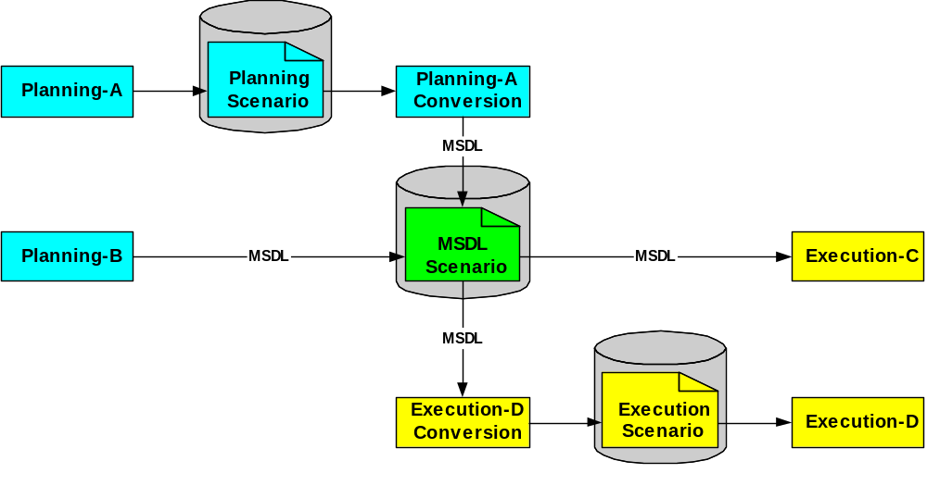
Figure 1: Planning to Execution

Reality and Intelligence
A scenario describes a battlespace containing elements that interact with each other. In support of these interactions, each element may have certain knowledge of the other elements in the scenario. The actual description of the elements is referred to as the reality aspect of the scenario because what it describes is the reality in the context of the scenario. These descriptions are exact and not the result of interpretation by the scenario elements. The description of the knowledge, however, is referred to as the intelligence aspect of the scenario and is specific to each scenario element’s knowledge of the battlespace. Multiple intelligence descriptions of a single element will exist in the intelligence context of the scenario since multiple other elements will have specific knowledge of that single element. These descriptions would represent the result of an intelligence gathering process performed by some real-world or simulated agents/actors prior to the execution of the scenario. As such, the intelligence descriptions are approximate derivations of the reality aspect values.

Element Identification & Reference
All primary elements in MSDL are identified by a Universally Unique Identifier (UUID).

MSDL Content
The MSDL specification has one root element called MilitaryScenario. It contains the following main elements or components: ScenarioID, Options, Environment, ForceSides, Organizations, Overlays, Installations, TacticalGraphics, and MOOTWGraphics. Some of the elements describe the reality aspect of the scenario while others describe the intelligence aspect.
The ScenarioID element provides the identification of the scenario and its purpose.
The Options element provides global parameters about the scenario and its content.
The Environment element describes the natural environment in which the execution is to occur.
The ForceSides element describes the structure of the forces and sides involved in the execution.
The Organizations element describes the structure of the units and equipment involved in the execution.
The Overlays element describes the logical overlays used to group the intelligence elements/instances in the scenario/execution.
The Installations element describes the detected installations as determined by the intelligence gathering process by each force, side or unit individually. The description of any corresponding actual instances, the reality aspect, is unspecified in this version of MSDL.
The TacticalGraphics element describes the tactical information as known by a particular force, side or unit individually. The description of any corresponding actual instances, the reality aspect, is unspecified in this version of MSDL.
The MOOTWGraphics element describes the detected MOOTW Graphics instances as determined by the intelligence gathering process by each force, side or unit individually. The description of any corresponding actual instances, the reality aspect, is unspecified in this version of MSDL.

Schema Structure
MSDL is defined using an XML schema that allows for format and content verification. The MSDL schema makes liberal use of specific schema restrictions (sequence, choice, and all) to the data structure of the scenario as well as element type definitions and boundary values including: max/min values, default values, patterns for string, uniqueness restriction on designations and keys.

Files and namespaces
The top-level schema MilitaryScenario.xsd specifies only one XML element, the MilitaryScenario element, as the base or root element of the MSDL schema. All other MSDL elements are declared within the globally declared complex types in the msdlComplexTypes.xsd schema and are bound to the “msdl” namespace. MSDL simple types are declared with msdlSimpleTypes.xsd and are bound to the “msdl” namespace. MSDL specific domain values are found in msdlCodes.xsd and are also bound to the “msdl” namespace.
Metadata describing the contents of an MSDL instance document are self contained within a ScenarioID element. The ScenarioID element reuses the ModelID element type as defined in SISO-STD-003-2006 Base Object Model to capture and store the metadata information. The MSDL schema imports and reuses the ModelID element as declared in the ModelID_v2006_FINAL.xsd schema.
The JC3IEDM specifies the minimum set of data that needs to be exchanged in coalition or multinational operations. It is intended to represent the core of the data identified for exchange across multiple functional areas and multiple views of the requirements. Toward that end, it lays down a common approach to describing the information to be exchanged in a command and control (C2) environment. Likewise, the MSDL schema definition reuses a number of meteorological and battlespace domain values as found in the JC3IEDM. These JC3IEDM domain values and meteorological data types and elements are defined in JC3IEDM-3.1-Codes-20061208.xsd and JC3IEDMMeteorological.xsd respectively. The MSDL schema imports both of these schemas.
Unless otherwise specified, the version 1.0 MSDL schema information is defined within the “urn:sisostds:scenario:military:data:draft:msdl:1” namespace and identified by the “msdl” prefix. The prefix “msdl” is used in the specification and is a suggested convention; however, it is not required to be used by users of the standard. MSDL imports two additional XML namespaces to define specific types and elements. These namespaces are “http://www.sisostds.org/schemas/modelID” identified with prefix “ModelID” and “urn:int:nato:standard:mip:jc3iedm:3.1:oo:2.0” identified with prefix “jc3iedm”.

MSDL Design Approach
Three types of business rules are encompassed within the MSDL specification: hierarchical element relationships, non-hierarchical element relationships, and element typing constraints. Both the hierarchical and element typing constraints are encompassed within the MSDL XML schema representation while the non-hierarchical element relationships are explained using text and ObjectHandles. Within sections 6 and 7, each element and type contains a description of its respective business rules.
Hierarchical element relationships are described using XML compositor elements of xs:all, xs:choice, and xs:sequence, and appropriate cardinality indicators of minOccurs and maxOccurs attributes. Hierarchical element relationships within a military scenario instance document can be validated against the MSDL schema using standard XML parsing utilities.
Non-hierarchical element relationships are described in several ways. The first is with the use of ObjectHandles to establish relationships between objects. The second is with text describing the relationship between or among instances of the elements such as the relationship with units to other units and to the ForceSide element. Text is also used to describe the relationship of standards selected to instance specific elements such as the dependency between selecting a coordinate designation and then populating the location details of specific units, entities, or graphics. While these business rules are specified in text, they are not currently validated.
Finally, type, boundary value, and enumeration-based constraints are classified as element typing constraints. Element typing constraints can also be validated within military scenario instance documents against the MSDL schema using standard XML parsing utilities.

Style & Diagram Notation
This section provides a summary of the style used to highlight MSDL elements within the text and to describe the graphical notation used within the figures. XMLSpy® Version 4.1 was used to generate all of the XML schema figures in this document as well as autogenerate the type tables within Section 7.

Style
To highlight the MSDL schema structure and definitions within this document the XML elements defined as part of the “MSDL” namespace are written using bold, italicized font. Elements or types imported from other namespaces are written in normal font.

Mandatory Elements
The rectangle indicates an element and the solid border indicates that the element is required (as shown in Figure 2). The absence of a number range indicates a single element (i.e. minOccurs=1 and maxOccurs=1). The element is bounded when numbers are specified under the rectangle (i.e. minOccurs=1 and maxOccurs=5). The element is unbounded when infinity sign is specified as upper bound under the rectangle (i.e. minOccurs=1 and maxOccurs=unbounded). The minimum occurrence value can be higher than one.
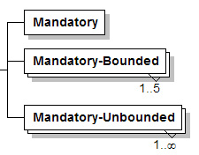
Figure 2: Mandatory Elements Notation

Optional Elements and Optional Attributes
The rectangle indicates an element, while the irregular octagon indicates an attribute. For either an element or an attribute a dashed border indicates that they are optional (as shown in Figure 3). The absence of a number range indicates a single element or attribute (i.e. minOccurs=0 and maxOccurs=1). The element or attribute is bounded when numbers are specified under the graphic (i.e. minOccurs=0 and maxOccurs=5). The element or attribute is unbounded when infinity sign is specified as upper bound under the graphic (i.e. minOccurs=0 and maxOccurs=unbounded).

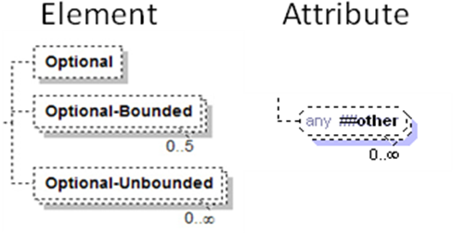
Figure 3: Optional Element and Attribute Notation

Expandable Element
As shown in Figure 4 a plus sign on the right side of an element indicates that the element contains child elements. When this appears in the diagrams, it means that the child elements are described somewhere else in the document.
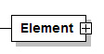
Figure 4: Expandable Element

Compositors
A compositor defines the order in which child elements occur. In Figure 5, there are three compositors: sequence, choice, and all. The elements defined within an xs:sequence compositor must appear in the defined order within an instance document. The elements declared within an xs:sequence compositor can either occur 0 or more times as set by the minOccurs and maxOccurs on the element declarations. The elements defined within an xs:choice compositor are mutually exclusive. This means that one and only one of the xs:choice’s immediate children can appear in the instance document. The elements defined within an xs:all compositor can appear in any order within an instance document. xs:all elements may be declared within a complexType or group and they may contain an element or annotion elements. Elements declared within an xs:all compositor can either occur 0 or 1 time as set by the minOccurs and maxOccurs on the element declarations.The compositors like the elements can be mandatory or optional and may be bounded or unbounded.
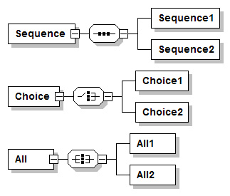
Figure 5: Compositors Notation

Complex Type
Complex types are shown as shaded boxes, as depicted in Figure 6, with the complex type name at the upper left of the shaded box. The complex type definitions used by MSDL are defined within the remainder of this specification. Keyword, keywordType, taxonomy and keywordValue below are provided only as an example.
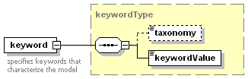
Figure 6: Complex Type Notation

msdl:MilitaryScenario Element
The msdl:MilitaryScenario element is the root of the MSDL specification. A graphical depiction, Figure 7, defines the msdl:MilitaryScenario as an XML xs:sequence compositor containing the elements described in the following subsections. The domain type is msdl:MilitaryScenarioType.
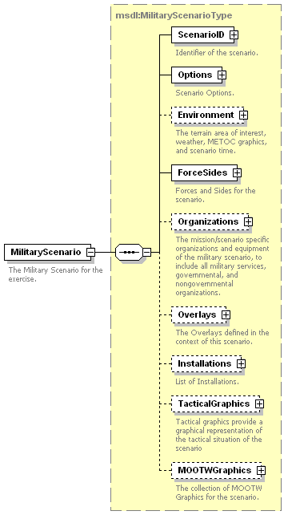
Figure 7: msdl:MilitaryScenario Element Structure

msdl:MilitaryScenarioType/ScenarioID Element
For every msdl:MilitaryScenarioType complex type there shall be one ScenarioID element. The ScenarioID defines the structure to hold military scenario metadata. The domain type is modelID:modelIdentificationType. The modelID:modelIdentificationType contains the optional attributes id:notes of type xs:IDREFS and id:idtag of type xs:ID. These optional attributes are defined and are consistently used within each element of the ModelID:modelIdentificationType. The id:notes attribute is used to provide a reference to notes that may be specified elsewhere in the schema; however, since the MSDL schema does not include a notes table this attribute will not be used. It is included here because the ScenarioID is being reused in its entirety from the SISO-STD-003-2006 (Base Object Model) standard. The id:idtag is used to create a unique id that can be referenced from other parts of the instance document or from outside the instance document, this is an optional attribute and is not required. ScenarioID is an xs:sequence compositor comprised of all the elements shown in Figure 8 and described in the subsequent subsections. The domain type is ModelID:modelIdentificationType.
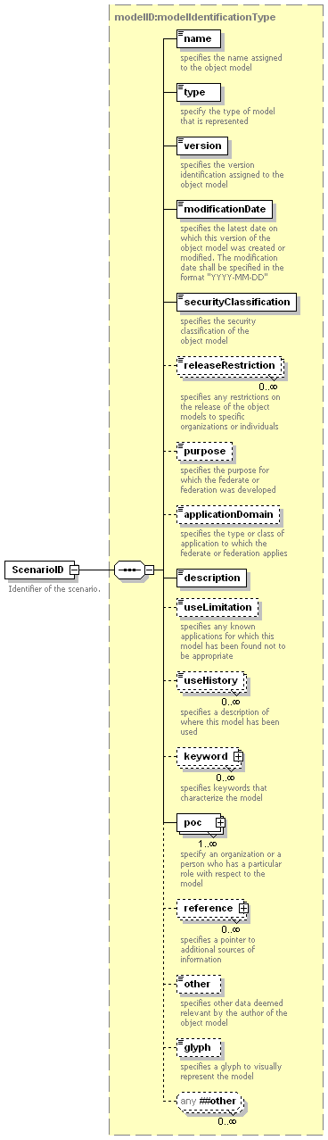
Figure 8: msdl:MilitaryScenario/ScenarioID Element Structure

modelID:modelIdentificationType/name Element
For every modelID:modelIdentificationType complex type there shall be one name element. The name element specifies the name assigned to the military scenario. The domain type is modelID:IdentifierType (extension of xs:NCName) and contains the optional attributes notes of type xs:IDREFS and idtag of type xs:ID.

modelID:modelIdentificationType/type Element
For every modelID:modelIdentificationType complex type there shall be one type element that follows the name element. The type element specifies the type of the military scenario that is represented. The domain type is modelID:modelType (extension of OMTypeUnion) and contains the optional attributes notes of type xs:IDREFS and idtag of type xs:ID.

modelID:modelIdentificationType/version Element
For every modelID:modelIdentificationType complex type there shall be one version element that follows the type element. The version element specifies the version identification assigned to the military scenario. The domain type is modelID:NonEmptyString (restriction of xs:string) with a minimum length of one and contains the optional attributes notes of type xs:IDREFS and idtag of type xs:ID.

modelID:modelIdentificationType/modificationDate Element
For every modelID:modelIdentificationType complex type there shall be one modificationDate element that follows the version element. The modificationDate element specifies the latest date on which this version of the military scenario was created or modified. It is an extension of type xs:date. The modificationDate shall be specified in the format “YYYY-MM-DD”, cannot be null, and contains the optional attributes notes of type xs:IDREFS and idtag of type xs:ID.

modelID:modelIdentificationType/securityClassification Element
For every modelID:modelIdentificationType complex type there shall be one securityClassification element that follows the modificationDate element. The securityClassification element specifies the security classification of the military scenario. The domain type is modelID:securityClassificationType (union of SecurityClassificationEnumeration and nonEmptyString) and contains the optional attributes notes of type xs:IDREFS and idtag of type xs:ID.

modelID:modelIdentificationType/releaseRestriction Element
For every modelID:modelIdentificationType complex type there shall be zero or more releaseRestriction element that follows the securityClassification element. The releaseRestriction element specifies any restrictions on the release of the military scenario to specific organization or individuals. The domain type is modelID:String (extension of xs:string) and contains the optional attributes notes of type xs:IDREFS and idtag of type xs:ID.

modelID:modelIdentificationType/purpose Element
For every modelID:modelIdentificationType complex type there shall be zero or one purpose element that follow the releaseRestriction element. The purpose element specifies the purpose for which the military scenario was developed. The domain type is modelID:String (extension of xs:string) and contains the optional attributes notes of type xs:IDREFS and idtag of type xs:ID.

modelID:modelIdentificationType/applicationDomain Element
For every modelID:modelIdentificationType complex type there shall be zero or one applicationDomain element that follows the purpose element. The applicationDomain element specifies the type or class of application to which the military scenario applies. The domain type is modelID:applicationDomainType (union of ApplicationDomainEnumerations and xs:string) and contains the optional attributes notes of type xs:IDREFS and idtag of type xs:ID.

modelID:modelIdentificationType/description Element
For every modelID:modelIdentificationType complex type there shall be one description element that follows the applicationDomain element. The description element specifies the description of the military scenario. The domain type is modelID:NonEmptyString (restriction of xs:string minimum length of 1) and contains the optional attributes notes of type xs:IDREFS and idtag of type xs:ID.

modelID:modelIdentificationType/useLimitation Element
For every modelID:modelIdentificationType complex type there shall be zero or one useLimitation element that follows the description element. The useLimitation element specifies any known application for which this military scenario has been found not to be appropriate. The domain type is modelID:String (extension of xs:string) and contains the optional attributes notes of type xs:IDREFS and idtag of type xs:ID.

modelID:modelIdentificationType/useHistory Element
For every modelID:modelIdentificationType complex type there shall be zero or more useHistory elements that follow the useLimitation element. The useHistory element specifies a description of where this military scenario has been used. The domain type is modelID:String (extension of xs:string) and contains the optional attributes notes of type xs:IDREFS and idtag of type xs:ID.

modelID:modelIdentificationType/keyword Element
For every modelID:modelIdentificationType complex type there shall be zero or more keyword elements that follow the useHistory element. The keyword element specifies keywords that characterize the military scenario. The keyword element is an xs:sequence compositor comprised of all the elements shown in Figure 9 and described in the subsequent subsections. The domain type is modelID:keywordType and contains the optional attributes notes of type xs:IDREFS and idtag of type xs:ID.
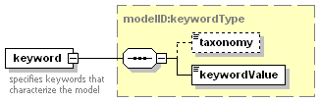
Figure 9: modelID:modelIdentificationType/keyword Element Structure

modelID:keywordType/taxonomy Element
For every modelID:keywordType complex type there shall be zero or one taxonomy element. The taxonomy element specifies the source of the keyword vocabulary, such as “Military warfare”. The domain type is modelID:String (extension of xs:string) and contains the optional attributes notes of type xs:IDREFS and idtag of type xs:ID.

modelID:keywordType/keywordValue Element
For every modelID:keywordType complex type there shall be one keywordValue element following the taxonomy element. The keywordValue element provides the word or concept describing the military scenario such as “Engagement”. The domain type is modelID:NonEmptyString (restriction of xs:string minimum length of 1) and contains the optional attributes notes of type xs:IDREFS and idtag of type xs:ID.

modelID:modelIdentificationType/poc Element
For every modelID:modelIdentificationType complex type there shall be one or more poc elements following the keyword element. The poc element specifies an organization or a person who has a particular role with respect to the military scenario. The domain type is modelID:pocType. It contains the optional attributes notes of type xs:IDREFS and idtag of type xs:ID. Poc is an xs:sequence compositor containing all the elements shown in Figure 10 and described in the subsequent subsections. The domain type is ModelID:pocType.
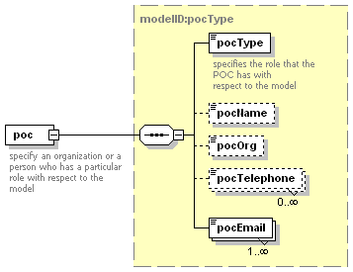
Figure 10: modelID:modelIdentificationType/pocType Element Structure

modelID:pocType/pocType Element
For every modelID:pocType complex type there shall be one pocType element. The pocType element specifies the role that the POC has with respect to the military scenario. The domain type is ModelID:pocTypeType (union of POCTypeEnumeration and nonEmptyString) and contains the optional attributes notes of type xs:IDREFS and idtag of type xs:ID.

modelID:pocType/pocName Element
For every modelID:pocType complex type there shall be zero or one pocName element following the pocType element. The pocName element specifies the name of the POC. The domain type is modelID:String (extension of xs:string) and contains the optional attributes notes of type xs:IDREFS and idtag of type xs:ID.

modelID:pocType/pocOrg Element
For every modelID:pocType complex type there shall be zero or one pocOrg elements following the pocName element. The pocOrg element specifies the name of the organization the POC is associated with. The domain type is modelID:String (extension of xs:string) and contains the optional attributes notes of type xs:IDREFS and idtag of type xs:ID.

modelID:pocType/pocTelephone Element
For every modelID:pocType complex type there shall be zero or more pocTelephone elements following the pocOrg element. The pocTelephone element specifies the POC’s telephone number. The POC’s telephone number should include the international dialing code. The domain type is modelID:String (extension of xs:string) and contains the optional attributes notes of type xs:IDREFS and idtag of type xs:ID.

modelID:pocType/pocEmail Element
For every modelID:pocType complex type there shall be one or more pocEmail elements following the pocTelephone element. The pocEmail element specifies the POC’s email address(es). The domain type is modelID:String (extension of xs:string) and contains the optional attributes notes of type xs:IDREFS and idtag of type xs:ID.

modelID:modelIdentificationType/reference Element
For every modelID:modelIdentificationType complex type there shall be zero or more reference element that follows the poc element. The reference element specifies the reference information for the military scenario. Reference is an xs:sequence compositor containing all the elements shown in Figure 11 and described in the subsequent subsections.
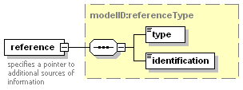
Figure 11: modelID:modelIdentificationType/reference Element Structure

modelID:referenceType/type Element
For every modelID:referenceType complex type there shall be one type element. The type element specifies the type of reference. It is of modelID:referenceTypeUnion (union of referenceTypeEnumerations and xs:string) and contains the optional attributes notes of type xs:IDREFS and idtag of type xs:ID.

modelID:referenceType/identification Element
For every modelID:modelIdentificationType complex type there shall be one identification element following the type element. The identification element specifies the reference title. It is an extension of xs:anyURI and contains the optional attributes notes of type xs:IDREFS and idtag of type xs:ID.

modelID:modelIdentificationType/other Element
For every modelID:modelIdentificationType complex type there shall be zero or one other element following the reference element. The other element specifies other data deemed relevant by the author of the military scenario. The domain type is modelID:String and contains the optional attributes notes of type xs:IDREFS and idtag of type xs:ID.

modelID:modelIdentificationType/glyph Element
For every modelID:modelIdentificationType complex type there shall be zero or one glyph element following the other element. The glyph element specifies a glyph to visually represent the military scenario. The domain type is glyphType. It contains the optional attributes notes of type xs:IDREFS, idtag of type xs:ID, height of type xs:short, width of type xs:short, and alt of type xs:string, and required attribute type of type glyphTypeUnion(union of glyphTypeEnumerations and xs:string).

modelID:modelIdentificationType/any Element
For every modelID:modelIdentificationType complex type there shall be zero or more any elements following the glyph element. The any element allows any element not specified in the schema to be added to the end of the ScenarioID element. The domain type is undefined. This element is a result of reuse of the SISO-STD-003-2006 BOM specification and is not recommended for use since the values used to populate it within an instance schema cannot be verified or validated.

msdl:MilitaryScenarioType/Options Element
For every msdl:MilitaryScenarioType complex type there shall be one Options element. The Options element is used to identify how task organizations are specified (entity or aggregate based), the data standards being used within the scenario, and any application specific options embedded within the scenario. The Options element is comprised of an xs:all compositor containing the elements shown in Figure 12 and described in the subsequent subsections. The domain type is msdl:OptionsType.
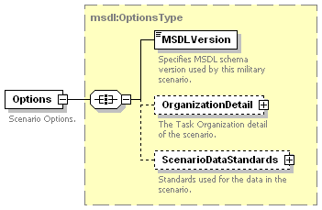
Figure 12: msdl:MilitaryScenarioType/Options Element Structure

msdl:OptionsType/MSDLVersion Element
For every msdl:OptionsType complex type there shall be one MSDLVersion element. The MSDLVersion specifies the MSDL schema version defining the military scenario. This element is intended to allow instance document users to verify the document version against the expected MSDL schema version. The domain type is msdl:textIdentifier64.

msdl:OptionsType/OrganizationDetail Element
For every msdl:OptionsType complex type there shall be zero or one OrganizationDetail element. The OrganizationDetail element specifies the task organization detail of the scenario including the unit and echelon aggregate information. The OrganizationDetail element, an xs:all compositor, is comprised of the elements shown in Figure 13 and described in the following subsections. The domain type is msdl:OrganizationalDetailType.
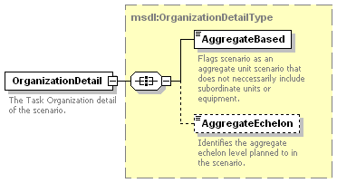
Figure 13: msdl:OptionsType/OrganizationDetail Element Structure

msdl:OrganizationDetail/AggregateBased Element
For every msdl:OrganizationDetailType complex type there shall be one AggregateBased element. The AggregateBased element indicates if the scenario is an aggregate unit scenario that does not necessarily include subordinate units. Setting the value to “true” indicates the scenario is aggregate-based, a “false” setting indicates an entity-based scenario. When the AggregateBased element is set to “true” the AggregateEchelon element, described in section 6.2.2.2, holds an echelon enumeration describing the minimum level of complete unit and equipment detail within the scenario document. There may be additional, but incomplete unit and equipment information, at the echelons below that described in the AggregateEchelon. The domain type is msdl:boolean.

msdl:OrganizationDetail/AggregateEchelon Element
For every msdl:OrganizationDetailType complex type there shall be zero or one AggregateEchelon element. The AggregateEchelon element specifies the aggregate echelon level planned to in the scenario. By convention the AggregateEchelon holds a value that is one echelon higher than is detailed within the task organization data. The domain type is msdl:enumEchelon.

msdl:OptionsType/ScenarioDataStandards Element
For every msdl:OptionsType complex type there shall be zero or one ScenarioDataStandards element. The ScenarioDataStandards element specifies the standards to be used throughout the military scenario document. It is an xs:all compositor comprised of the elements shown in Figure 14 and described in the following subsections. The domain type is msdl:ScenarioDataStandardsType.
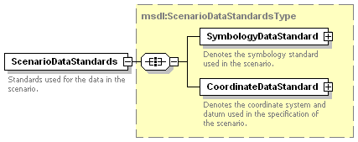
Figure 14: msdl:OptionsType/ScenarioDataStandards Element Structure

msdl:ScenarioDataStandardsType/SymbologyDataStandard Element
For every msdl:ScenarioDataStandardsType complex type there shall be one SymbologyDataStandard element. The SymbologyDataStandard element specifies the symbology standard, version, and revision used in the specification of the military scenario. It is an xs:all compositor comprised of the elements shown in Figure 15 and described in the following subsections. The domain type is msdl:SymbologyDataStandardType.
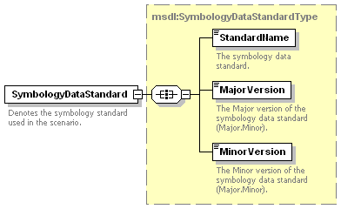
Figure 15: msdl:ScenarioDataStandardType/SymbologyDataStardard Element Structure

msdl:SymbologyDataStandardType/StandardName Element
For every msdl:SymbologyDataStandardType complex type there shall be one StandardName element. The StandardName element specifies the symbology standard used within the military scenario document. The domain type is msdl:enumSymbologyStandardType.

msdl:SymbologyDataStandardType/MajorVersion Element
For every msdl:SymbologyDataStandardType complex type there shall be one MajorVersion element. The MajorVersion element specifies the major version (major.minor) of the symbology standard used within the military scenario. For standards not using the major.minor naming convention the MajorVersion element should be populated with text describing the standard version first. Additional versioning information should be held in the MinorVersion element. The domain type is msdl:textIdentifier64.

msdl:SymbologyDataStandardType/MinorVersion Element
For every msdl:SymbologyDataStandardType complex type there shall be one MinorVersion element. The MinorVersion element specifies the minor version of the symbology standard used within the military scenario. The domain type is msdl:textIdentifier64.

msdl:ScenarioDataStandardType/CoordinateDataStandard Element
For every msdl:ScenarioDataStandardType complex type there shall be one CoordinateDataStandard element. The CoordinateDataStandard element specifies the coordinate standard and version used in the specification of the military scenario. The specification of the coordinate system is expected to be adhered to in all location specific detail of the associated objects/symbology included in the military scenario. The datum must be provided in order for location values to be unambiguously exchanged. The CoordinateDataStandard, an xs:all compositor, is comprised of the elements shown in Figure 16 and described in the following subsections. The domain type is msdl:CoordinateDataStandardType.
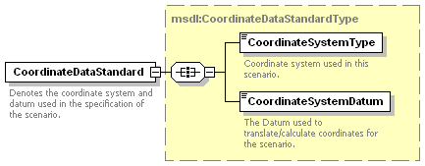
Figure 16: msdl:ScenarioDataStandardType/CoordinateDataStandard Element Structure

msdl:CoordinateDataStandardType/CoordinateSystemType Element
For every msdl:CoordinateDataStandardType complex type there shall be one CoordinateSystemType element. The CoordinateSystemType element specifies the coordinate system to be used within the military scenario for all location specific detail. The domain type is msdl:enumCoordinateSystemType.

msdl:CoordinateDataStandardType/CoordinateSystemDatum Element
For every msdl:CoordinateDataStandardType complex type there shall be one CoordinateSystemDatum element. The CoordinateSystemDatum element specifies the datum used to calculate coordinates. The domain type is msdl:textDatum8.

msdl:MilitaryScenarioType/Environment Element
For every msdl:MilitaryScenarioType complex type there shall be zero or one Environment element following the Options element. The Environment element describes the surroundings, at a synoptic level, of the military scenario. It includes the ScenarioTime, the scenario AreaOfInterest, the ScenarioWeather and the METOC information. The METOC element covers the Meteorological, the Oceanographical and the Space elements of the environment. Within these elements, it also covers some geographical elements (mostly the effects of the weather).
In this context, the Weather information appears in both the ScenarioWeather elements and the METOC elements. The ScenarioWeather elements describe the overall weather while the METOC elements describe the specific details. Because of this care must be taken to ensure consistency between the ScenarioWeather elements and the METOC elements when populating both forms within a scenario instance. The consistency of the scenario is assumed prior to the initialization of the applications.
Finally, environmental changes that occur during the course of the execution can be specified within the ScenarioWeather and the METOC information. The following list identifies the elements that influence the evolution of the environment.
- Atmosphere - InversionLayerCode and TemperatureGradientCode.
- Precipitation - Rate.
- Wind - AirStabilityCategoryCode, SpeedRate, NuclearYieldQualifierCode.
- METOCGraphic - DateTimeGroup and Speed.
The Environment element, an xs:all compositor, is comprised of the elements shown in Figure 17 and described in the following subsections. The domain type is msdl:EnvironmentType.
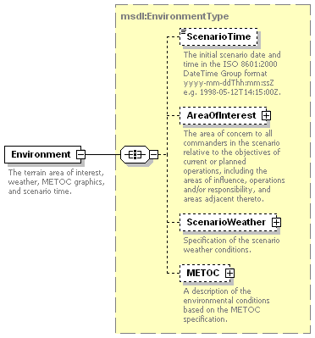
Figure 17: msdl:MilitaryScenarioType/Environment Element Structure

msdl:EnvironmentType/ScenarioTime Element
For every msdl:EnvironmentType complex type there shall be zero or one ScenarioTime element. The ScenarioTime element indicates the absolute simulation time at the start of the execution. The time of the execution start time is used when this element is not present. ScenarioTime is the reference for all relative times in the scenario. The domain type is msdl:patternTimeDTG20.

msdl:EnvironmentType/AreaOfInterest Element
For every msdl:EnvironmentType complex type there shall be zero or one AreaOfInterest element. The AreaOfInterest indicates a rectangular area where the scenario will occur. It is expected to include the areas of interest, influence, operation, etc. of all elements in the scenario. The msdl:RectangleAreaType complex type, an xs:all compositor, contains all the elements shown in Figure 18 and described in the subsequent subsections. The domain value is a pair of coordinates describing a rectangle area. The domain type is msdl:RectangleAreaType.
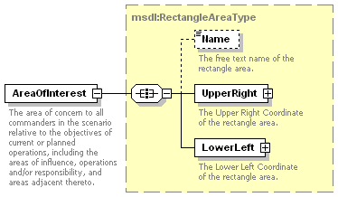
Figure 18: msdl:EnvironmentType/AreaOfInterest Element Structure

msdl:RectangleAreaType/Name Element
For every msdl:RectangleAreaType complex type there shall be zero or one Name element. The Name element specifies the free text name of the rectangle area. The domain type is msdl:Name255.

msdl:RectangleAreaType/UpperRight Element
For every msdl:RectangleAreaType complex type there shall be one UpperRight element. The UpperRight element defines the upper right coordinate of the rectangle area. The UpperRight, an xs:all compositor, is comprised of one and only one of the subelements shown in Figure 19 and described in the following subsections.The domain type is msdl:CoordinatesType.

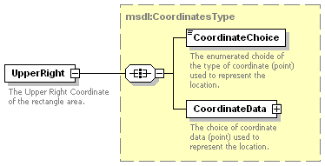
Figure 19: msdl:RectangleAreaType/UpperRight Element Structure

msdl:CoordinatesType/CoordinateChoice Element
For every msdl:CoordinatesType complex type there shall be one CoordinateChoice element. This element provides the type of coordinate used to represent the location. The domain type is msdl:enumCoordinatesSystemType.

msdl:CoordinatesType/CoordinateData Element
For every msdl:CoordinatesType complex type there shall be one CoordinateData element. This element provides the coordinate data of the location in the datatype specified by the CoordinateChoice element.
MSDL supports coordinate systems of MGRS, UTM, GDC, and GCC. Each coordinate element provides a choice of the coordinate system to be used. The intent of MSDL is that the choice correlates with the coordinate system specified in msdl:ScenarioDataStandardsType/coordinateDataStandard. For coordinates of MGRS, UTM, and GCC, the Datum shall be specified in a msdl:CoordinateDataStandardType/CoordinateSystemDatum element.

While real-world GCC values are not based on a Datum, in simulation GCC values are generated based on GDC values that have been applied to a Datum specific geoid/ellipsoid. Therefore, a GCC value cannot be correlated to a simulation environment, unless the original Datum has been specified.

The CoordinateData element, an xs:choice compositor, is comprised of one and only one of the subelements shown in Figure 20 and described in the following subsections. The domain type is msdl:CoordinatePointType.

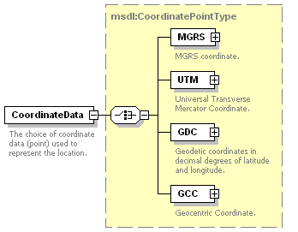
Figure 20: msdl:CoordinatesType/CoordinateData Element Structure
- msdl:CoordinatePointType/MGRS Element - For each msdl:CoordinatePointType complex type there shall be zero or one MGRS element. The MGRS element, an xs:all compositor, specifies the Military Grid Reference System (MGRS) coordinate and is made up of the child elements as shown in Figure 21. The domain type is msdl:MGRSType.
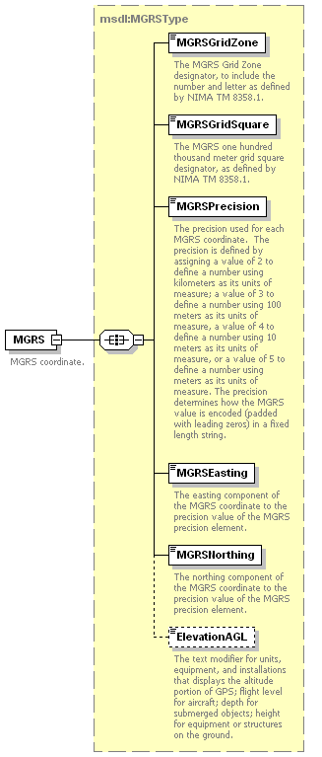
Figure 21: msdl:CoordinatePointType/MGRS Element structure
  - msdl:MGRSType/MGRSGridZone Element - For each msdl:MGRSType complex type there shall be one MGRSGridZone element. The MGRSGridZone element specifies the MGRS Grid Zone designator to include the number and letter as defined by NIMA TM 8358.1. The domain type is msdl:patternMGRSGridSquare2.
  - msdl:MGRSType/MGRSGridSquare Element - For each msdl:MGRSType complex type there shall be one MGRSGridSquare element. The MGRSGridSquare element specifies the one hundred thousand meter grid square designator as defined by NIMA TM 8358.1. The domain type is msdl:patternMGRSGridSquare2.
  - msdl:MGRSType/MGRSPrecision Element - For each msdl:MGRSType complex type there shall be one MGRSPrecision element. The MGRSPrecision element specifies the precision or scale of easting and northing values. MGRSPrecision can be assigned a value of 2 to define a number using kilometers as its units of measure; a value of 3 to define a number using 100 meters as its units of measure, a value of 4 to define a number using 10 meters as its units of measure, or a value of 5 to define a number using meters as its units of measure. The precision determines how the MGRS value is encoded (padded with leading zeros) in a fixed length string. The domain type is msdl:integerMGRSPrecision1.
  - msdl:MGRSType/MGRSEasting Element - For each msdl:MGRSType complex type there shall be one MGRSEasting element. The MGRSEasting element specifies the easting component of the MGRS coordinates to the precision value of the MGRS precision element. The domain type is msdl:integerMGRSEasting5.
  - msdl:MGRSType/MGRSNorthing Element - For each msdl:MGRSType complex type there shall be one MGRSNorthing element. The MGRSNorthing element specifies the northing component of the MGRS coordinates to the precision value of the MGRS precision element. The domain type is msdl:integerMGRSNorthing5.
  - msdl:MGRSType/ElevationAGL Element - For each msdl:MGRSType complex type there shall be zero or one ElevationAGL element. The ElevationAGL element specifies the altitude, in meters of a position for the flight level for aircraft; depth for submerged objects; height of equipment or structures on the ground. The domain type is msdl:floatElevationAGL6_2.
- msdl:CoordinatePointType/UTM Element - For each msdl:CoodinatePointType complex type there shall be zero or one UTM element. The UTM element, an xs:all compositor, specifies the Universal Transverse Mercator (UTM) coordinate and is made up of the child elements as shown in Figure 22. The domain type is msdl:UTMType.
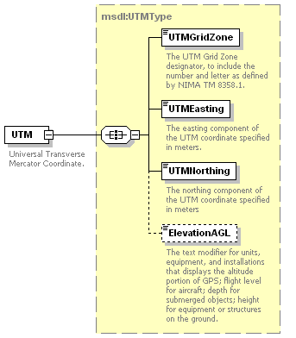
Figure 22: msdl:CoordinatePointType/UTM Element Structure
  - msdl:UTMType/UTMGridZone Element - For each msdl:UTMType complex type there shall be one UTMGridZone element. The UTMGridZone element specifies the UTM Grid Zone designator to include the number and letter as defined by NIMA TM 8358.1. The domain type is msdl:patternUTMGridZone3.
  - msdl:UTMType/UTMEasting Element - For each msdl:UTMType complex type there shall be one UTMEasting element. The UTMEasting element specifies the easting component of the UTM coordinate. The domain type is msdl:floatUTMEasting9_2.
  - msdl:UTMType/UTMNorthing Element - For each msdl:UTMType complex type there shall be one UTMNorthing element. The UTMNorthing element specifies the northing component of the UTM coordinate. The domain type is msdl:floatUTMNorthing9_2.
  - msdl:UTMType/ElevationAGL Element - For each msdl:UTMType complex type there shall be zero or one ElevationAGL element. The ElevationAGL element specifies the altitude, in meters of a position for the flight level for aircraft; depth for submerged objects; height of equipment or structures on the ground. The domain type is msdl:floatElevationAGL6_2.
- msdl:CoordinatePointType/GDC Element - For each msdl:CoordinatePointType complex type there shall be zero or one GDC element. The GDC element, an xs:all compositor, specifies the Geodetic Coordinate (GDC) and is made up of the child elements as shown in Figure 23. The domain type is msdl:GDCType.
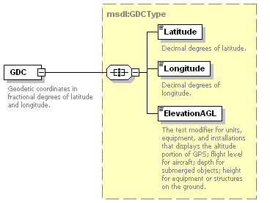
Figure 23: msdl:CoordinatePointType/GDC Element Structure
  - msdl:GDCType/Latitude Element - For each msdl:GDCType complex type there shall be one Latitude element. The Latitude element specifies the decimal degrees of latitude. The domain type is msdl:floatLatitudeLongitude3_3.
  - msdl:GDCType/Longitude Element - For each msdl:GDCType complex type there shall be one Longitude element. The Longitude element specifies the decimal degrees of longitude. The domain type is msdl:floatLatitudeLongitude3_3.
  - msdl:GDCType/ElevationAGL Element - For each msdl:GDCType complex type there shall be zero or one ElevationAGL element. The ElevationAGL element specifies the altitude, in meters of a position for the flight level for aircraft; depth for submerged objects; height of equipment or structures on the ground. The domain type is msdl:floatElevationAGL6_2.
- msdl:CoordinatePointType/GCC - For each msdl:CoordinatePointType complex type there shall be zero or one GCC element. The GCC element, an xs:all compositor, specifies the Geocentric Coordinate (GCC) and is made up of the child elements as shown in Figure 24. The domain type is msdl:GCCType.
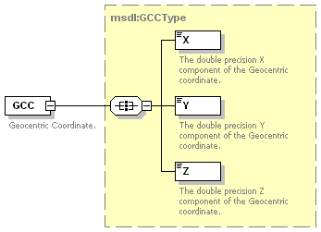
Figure 24: msdl:CoordinatePointType/GCC Element Structure
  - msdl:GCCType/X Element - For each msdl:GCCType complex type there shall be one X element. The X element specifies the double precision X component (in meters) of the Geocentric coordinate. The domain type is msdl:floatCartesianValue9_3.
  - msdl:GCCType/Y Element - For each msdl:GCCType complex type there shall be one Y element. The Y element specifies the double precision Y component (in meters) of the Geocentric coordinate. The domain type is msdl:floatCartesianValue9_3.
  - msdl:GCCType/Z Element - For each msdl:GCCType complex type there shall be one Z element. The Z element specifies the double precision Z component (in meters) of the Geocentric coordinate. The domain type is msdl:floatCartesianValue9_3.

msdl:RectangleAreaType/LowerLeft Element
For every msdl:RectangleAreaType complex type there shall be one LowerLeft element. The LowerLeft element defines the lower left coordinate of the rectangle area. The domain type is msdl:CoordinatesType as defined within section 6.3.2.2 for msdl:RectangleAreaType/UpperRight.

msdl:EnvironmentType/ScenarioWeather Element
For every msdl:EnvironmentType complex type there shall be zero or one ScenarioWeather element. The ScenarioWeather information provides a basic description of the initial weather conditions for the scenario. Unless otherwise specified or derived, the reference time is the scenario time; the reference location is the center of the scenario area of interest; the reference altitude is at the surface level; and the information applies to the entire scenario area of interest.
The ScenarioWeather is described by a combination of instances from seven types: jc3iedm:Atmosphere, jc3iedm:CloudCoverItems, jc3iedm:Icing, jc3iedm:LightItems, jc3iedm:Precipitation, jc3iedm:VisibilityItems, and jc3iedm:WindItems. The ScenarioWeather element, an xs:all compositor, is comprised of the elements shown in Figure 25 and described in the following subsections. The domain type is msdl:ScenarioWeatherType.
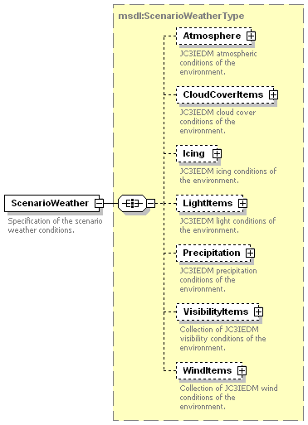
Figure 25: msdl:EnvironmentType/ScenarioWeather Element Structure

msdl:ScenarioWeatherType/Atmosphere Element
For every msdl:ScenarioWeatherType complex type there shall be zero or one Atmosphere element. The Atmosphere element specifies the JC3IEDM-based atmospheric conditions of the military scenario. The Atmosphere element, an xs:sequence compositor, contains all the elements shown in Figure 26 and described in the subsequent subsections. The domain type is jc3iedm:Atmosphere.
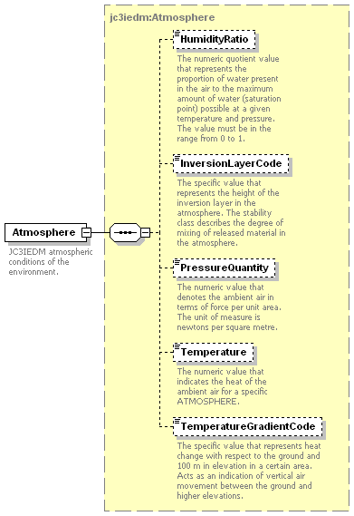
Figure 26: msdl:ScenarioWeatherType/Atmosphere Element Structure

jc3iedm:Atmosphere/HumidityRatio Element
For every jc3iedm:Atmosphere complex type there shall be zero or one HumidityRatio element. This value provides the numeric quotient value that represents the proportion of water present in the air to the maximum amount of water (saturation point) possible at a given temperature and pressure. The value shall be in the range from 0 to 1. The domain type is jc3iedm:RatioOptionalTypeRangeRatio6_5.

jc3iedm:Atmosphere/InversionLayerCode Element
For every jc3iedm:Atmosphere complex type there shall be zero or one jc3iedm2:InversionLayerCode element following the HumidityRatio element. This element provides the specific value that represents the height of the inversion layer in the atmosphere. The domain values are: A (Top inversion layer lower than 800 meters above ground); B (Top of inversion layer lower than 400 meters above ground); C (Top of inversion layer lower than 200 meters above ground). The domain type is jc3iedm:AtmosphereInversionLayerCode.

jc3iedm:Atmosphere/PressureQuantity Element
For every jc3iedm:Atmosphere complex type there shall be zero or one PressureQuantity element following the InversionLayerCode element. This element provides the numeric value that denotes the ambient air in terms of force per unit area. The unit of measure is newtons per square meter. Type domain type is jc3iedm:QuantityOptionalType8_4.

jc3iedm:Atmosphere/Temperature Element
For every jc3iedm:Atmosphere complex type there shall be zero or one Temperature element following the PressureQuantity element. This element provides the numeric value that indicates the heat of the ambient air. The domain is a real number exceeding -274, expressed in degrees Celsius. The domain type is jc3iedm:TemperatureTypeRangeTemperature5_1.

jc3iedm:Atmosphere/TemperatureGradientCode Element
For every jc3iedm:Atmosphere complex type there shall be zero or one TemperatureGradientCode element following the Temperature element. This element provides the specific value that represents heat change with respect to the surface and 100 m in elevation for the area specified within the AreaOfInterest. This element acts as an indication of vertical air movement between the surface and higher elevations. The domain values are: Neutral; Stable; Unstable; Not known. The domain type is jc3iedm:AtmosphereTemperatureGradientCode.

msdl:ScenarioWeatherType/CloudCoverItems Element
For every msdl:ScenarioWeatherType complex type there shall be zero or one CloudCoverItems element. The CloudCoverItems element specifies the JC3IEDM-based cloud cover conditions of the environment. The CloudCoverItems element, an xs:sequence compositor, is comprised of the elements shown in Figure 27 and described in the following subsection. The domain type is msdl:CloudCoverItemsType.
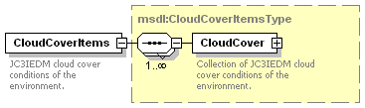
Figure 27: msdl:ScenarioWeatherType/CloudCoverItems Element Structure

msdl:CloudCoverItemsType/CloudCover Element
For every msdl:CloudCoverItemsType complex element there shall be one or more CloudCover elements. The CloudCover element specifies an instance or instances of the cloud cover conditions of the environment. Multiple CloudCover elements are allowed to support multiple layers of cloud cover. The Cloudcover element, an xs:sequence compositor, contains all the elements shown in Figure 28 and described in the subsequent subsections. The domain type is jc3iedm:CloudCover.
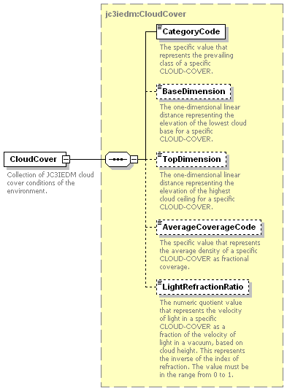
Figure 28: msdl:CloudCoverItemTypes/CloudCover Element Structure
- jc3iedm:CloudCover/CategoryCode Element - For every jc3iedm:CloudCover complex type there shall be zero or one CategoryCode element. This element provides the specific value that represents the prevailing class of a specific CloudCover. The domain values are: Clouds; Radioactive cloud; Smoke. The domain type is jc3iedm:CloudCoverCategoryCode.
- jc3iedm:CloudCover/BaseDimension Element - For every jc3iedm:CloudCover complex type there shall be zero or one BaseDimension element following the CategoryCode. This element provides the one-dimensional linear distance representing the elevation of the lowest cloud base for a specific CloudCover. The domain type is jc3iedm:DimensionOptionalType12_3.
- jc3iedm:CloudCover/TopDimension Element - For every jc3iedm:CloudCover complex type there shall be zero or one TopDimension element following the BaseDimension. This element provides the one-dimensional linear distance representing the elevation of the highest cloud ceiling for a specific CloudCover. The domain type is jc3iedm:DimensionOptionalType12_3.
- jc3iedm:CloudCover/AverageCoverageCode Element - For every jc3iedm:CloudCover complex type there shall be zero or one AverageCoverageCode element following the TopDimension. This element provides the specific value that represents the average density of a specific CloudCover as fractional coverage. The domain values are: 0/8; 1/8; 2/8; 3/8; 4/8; 5/8; 6/8; 7/8; 7-8/8; 8/8. The domain type is jc3iedm:CloudCoverAverageCoverageCode.
- jc3iedm:CloudCover/LightRefractionRatio Element - For every jc3iedm:CloudCover complex type there shall be zero or one LightRefractionRatio element following the AverageCoverageCode. This element provides the numeric quotient value that represents the velocity of light in a specific CloudCover as a fraction of the velocity of light in a vacuum, based on cloud height. This represents the inverse of the index of refraction. The value shall be in the range from 0 to 1. The domain type is jc3iedm:RatioOptionalTypeRangeRatio7_6.

msdl:ScenarioWeatherType/Icing Element
For every msdl:ScenarioWeatherType complex type there shall be zero or one Icing element. The Icing element, an xs:sequence compositor, contains all the elements shown in Figure 29 and described in the subsequent subsections. The Icing element specifies JC3IEDM-based accumulation of frozen water on the surface. The domain type is jc3iedm:Icing.
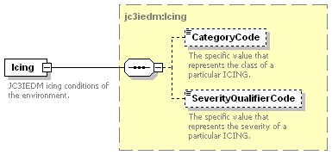
Figure 29: msdl:ScenarioWeatherType/Icing Element Structure

jc3iedm:Icing/CategoryCode Element
For every jc3iedm:Icing complex type there shall be zero or one CategoryCode element. This element specifies the class of Icing. The domain values are: Clear icing; Mixed icing; Rime icing. The domain type is jc3iedm:IcingCategoryCode.

jc3iedm:Icing/SeverityQualifierCode Element
For every jc3iedm:Icing complex type there shall be zero or one SeverityQualifierCode element following the CategoryCode. This element specifies the severity of Icing. The domain values are: Light; Moderate; Severe. The domain type is jc3iedm:IcingSeverityQualifierCode.

msdl:ScenarioWeatherType/LightItems Element
For every msdl:ScenarioWeatherType complex type there shall be zero or one LightItems element. The LightItems element specifies the JC3IEDM-based availability of natural illumination by type and time. The LightItems element, an xs:sequence compositor, is comprised of the elements shown in Figure 30 and described in the following subsection. The domain type is msdl:LightItemsType.
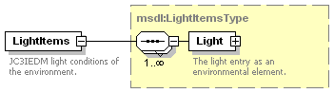
Figure 30: msdl:ScenarioWeatherType/LightItems Element Structure

msdl:LightItemsType/Light Element
The msdl:LightItemsType complex type specifies the light-related information within the military scenario. The Light element, an xs:sequence compositor, contains all the elements shown in Figure 31 and described in the subsequent subsections.
It is intended that the jc3iedm:Light information be consistent with the ScenarioTime and scenario AreaOfInterest information when these are present in a scenario.

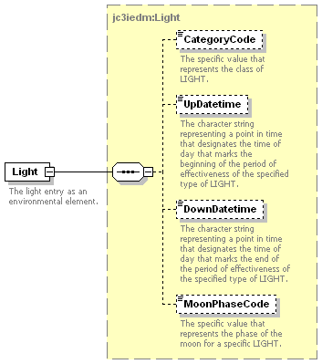
Figure 31: msdl:LightItemsType/Light Element Structure
- jc3iedm:Light/CategoryCode Element - For every jc3iedm:Light complex type there shall be zero or one CategoryCode element. This element specifies the value that represents the class of Light. The domain values are: Civil twilight; Darkness, Daylight; Moonlight; Nautical twilight. The domain type is jc3iedm:LightCategoryCode.
- jc3iedm:Light/UpDatetime Element - For every jc3iedm:Light complex type there shall be zero or one UpDatetime element following the CategoryCode. This element specifies the character string representing a point in time that designates the date and time of day that marks the beginning of the period of effectiveness of the specified type of Light. The domain type is jc3iedm:DatetimeOptionalTypeFix18.
- jc3iedm:Light/DownDatetime Element - For every jc3iedm:Light complex type there shall be zero or one DownDatetime element following the UpDatetime. This element specifies the character string representing a point in time that designates the date and time of day that marks the end of the period of effectiveness of the specified type of Light. The domain type is jc3iedm:DatetimeOptionalTypeFix18.
- jc3iedm:Light/MoonPhaseCode Element - For every jc3iedm:Light complex type there shall be zero or one MoonPhaseCode element following the DownDatetime. This element specifies the value that represents the phase of the moon for a specific type of Light. The domain values are: Full moon; New moon; Waning moon; Waxing moon. The domain type is jc3iedm:LightMoonPhaseCode.

msdl:ScenarioWeatherType/Precipitation Element
For every msdl:ScenarioWeatherType complex type there shall be zero or one Precipitation element. The Precipitation element specifies the JC3IEDM-based precipitation conditions of the environment. It is left to the user to ensure consistency between temperature and precipitation. The Precipitation element, an xs:sequence compositor, contains all the elements shown in Figure 32 and described in the subsequent subsections. The domain type is jc3iedm:Precipitation.
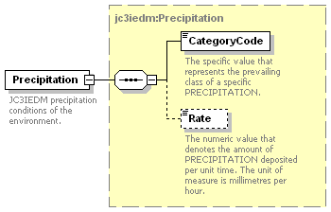
Figure 32: msdl:ScenarioWeatherType/Precipitation Element Structure

jc3iedm:Precipitation/CategoryCode Element
For every jc3iedm:Precipitation complex type there shall be zero or one CategoryCode element. This element specifies the value that represents the prevailing class of Precipitation. Example domain values are: Hail; No precipitation; Rain; Sleet; Snow. The domain type is jc3iedm:PrecipitationCategoryCode.

jc3iedm:Precipitation/Rate Element
For every jc3iedm:Precipitation complex type there shall be zero or one Rate element following the CategoryCode. This element specifies the numeric value that denotes the amount of Precipitation deposited per unit of time. The unit of measure is millimeters per hour. The domain type is jc3iedm:RateOptionalType4_1.

msdl:ScenarioWeatherType/VisibilityItems Element
For every msdl:ScenarioWeatherType complex type there shall be zero or one VisibilityItems element. The VisibilityItems element holds a collection of the JC3IEDM-based visibility conditions of the environment. The VisibilityItems element, an xs:sequence compositor, is comprised of the elements shown in Figure 33 and described in the following subsection. The domain type is msdl:VisibilityItemsType.
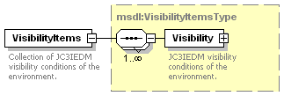
Figure 33: msdl:ScenarioWeatherType/VisibilityItems Element Structure

msdl:VisiblityItemsType/Visibility Element
For every msdl:VisibilityItemsType complex type there shall be one or more Visibility elements. The Visibility element specifies an instance or instances of the JC3IEDM-based visibility conditions existing within the environment. Visibility conditions may exist and vary by category code requiring multiple Visibility instances. It is intended that the Visibility element is derived from and consistent with the other Environment elements such as CloudCover and Precipitation that are included within the scenario document. The Visibility element, an xs:sequence compositor, contains all the elements shown in Figure 34 and described in the subsequent subsections. The domain type is jc3iedm:Visibility.
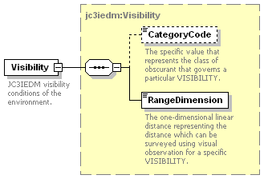
Figure 34: jc3iedm:Visibility Element Structure
- jc3iedm:Visibility/CategoryCode Element - For every Visibility complex type there shall be zero or one CategoryCode element. This element specifies the specific value that represents the class of obscurant that governs a particular Visibility. Example domain values are: Blowing snow; Fog/mist; Sandstorm; Smoke. The domain type is jc3iedm:VisibilityCategoryCode.
- jc3iedm:Visibility/RangeDimension Element - For every Visibility complex type there shall be one RangeDimension element following the CategoryCode. This element specifies the one-dimensional linear distance representing the distance that can be surveyed using visual observation for a specific Visibility. It is defined as the greatest distance in a given direction at which it is just possible to see and identify with the unaided eye (a) in the daytime, a prominent dark object against the sky at the horizon, and (b) at night, a known, preferably unfocused, moderately intense light source. After the visibility has been determined through the entire horizon circle, they are resolved into a single value of prevailing visibility. The domain type is jc3iedm:DimensionMandatoryType12_3.

msdl:ScenarioWeatherType/WindItems Element
For every msdl:ScenarioWeatherType complex type there shall be zero or one WindItems element. The WintItems element holds a collection of the JC3IEDM-based wind conditions of the environment. The WindItems element, an xs:sequence compositor, is comprised of the elements shown in Figure 35 and described in the following subsection. The domain type is msdl:WindItemsType.
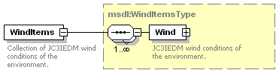
Figure 35: msdl:ScenarioWeatherType/WindItems Element Structure

msdl:WindItemsType/Wind Element
For every msdl:WindItemsType complex type there shall be one or more Wind elements. The Wind element specifies an instance or instances of the JC3IEDM-based wind conditions existing within the environment. Wind conditions may exist and vary by Categorycode and AltitudeLayerCode requiring multiple Wind instances. The Wind element, an xs:sequence compositor, contains all the elements shown in Figure 36 and described in the subsequent subsections.The domain type is jc3iedm:Wind.
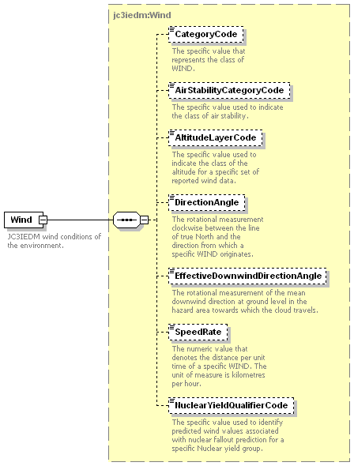
Figure 36: msdl:WindItemsType/Wind Type Structure
- jc3iedm:Wind/CategoryCode Element - For every Wind complex type there shall be zero or one CategoryCode element. This element specifies the value that represents the class of Wind. Example domain values are: Constant; Gusting; Squalls; Variable; Not known. The domain type is jc3iedm:WindCategoryCode.
- jc3iedm:Wind/AirStabilityCategoryCode Element - For every Wind complex type there shall be zero or one AirStabilityCategoryCode element following the CategoryCode. This element specifies the value used to indicate the class of air stability. Example domain values are: Simplified, unstable; Simplified, stable; Detailed, very unstable; Detailed, neutral. The domain type is jc3iedm:WindAirStabilityCategoryCode.
- jc3iedm:Wind/AltitudeLayerCode Element - For every Wind complex type there shall be zero or one AltitudeLayerCode element following the AirStabilityCategoryCode. This element specifies the value used to indicate the class of the altitude for a specific set of reported Wind data. Example domain values are: 2000 meters; 8000 meters; 14,000 meters; 30,000 meters. The domain type is jc3iedm:WindAltitudeLayerCode.
- jc3iedm:Wind/DirectionAngle Element - For every Wind complex type there shall be zero or one DirectionAngle element following the AltitudeLayerCode. The rotational measurement clockwise between the line of true North and the direction from which a specific Wind originates. The domain type is jc3iedm:AngleOptionalTypeRangeAngle7_4.
- jc3iedm:Wind/EffectiveDownwindDirectionAngle Element - For every Wind complex type there shall be zero or one EffectiveDownwindDirectionAngle element following the DirectionAngle. This element specifies the rotational measurement of the mean downwind direction at surface level in the hazard area towards which the cloud travels. The domain type is jc3iedm:AngleOptionalTypeRangeAngle7_4.
- jc3iedm:Wind/SpeedRate Element - For every Wind complex type there shall be zero or one SpeedRate element following the EffectiveDownwindDirectionAngle. This element specifies the numeric value that denotes the distance per unit time of a specific Wind. The unit of measure is kilometers per hour. The domain type is jc3iedm:RateOptionalType8_4.
- jc3iedm:Wind/NuclearYieldQualifierCode Element - For every Wind complex type there shall be zero or one NuclearYieldQualifierCode element following the SpeedRate. This element specifies the value used to identify predicted Wind values associated with nuclear fallout prediction for a specific Nuclear yield group. Example domain values are: ALPHA; BRAVO; CHARLIE; FOXTROT; GOLF. The domain type is jc3iedm:NuclearYieldGroupCode.

msdl:EnvironmentType/METOC Element
For every msdl:EnvironmentType complex type there shall be zero or one METOC element. The METOC element specifies the MIL-STD-2525B-based meteorological conditions of the environment. The specification included in this standard is based on the MIL-STD-2525B w/CHANGE 1 specification. APPENDIX C of MIL-STD-2525B w/CHANGE 1 provides most of the applicable descriptions. The METOC element, an xs:sequence compositor, is comprised of the elements shown in Figure 37 and described in the following subsections. The domain type is msdl:METOCType.
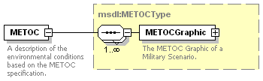
Figure 37: msdl:EnvironmentType/METOC Element Structure

msdl:METOCType/METOCGraphic Element
For every msdl:METOCType complex type there shall be one METOCGraphic element. The METOC element specifies the MIL-STD-2525B-based meteorological conditions of the environment. The specification included in this standard is based on the MIL-STD-2525B w/CHANGE 1 specification. The METOCGraphic element, an xs:all compositor, is comprised of the elements shown in Figure 38 and described in the following subsections. The domain type is msdl:METOCGraphicType.
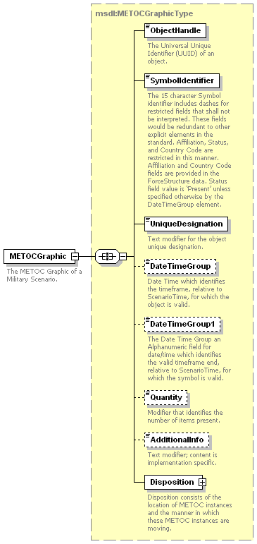
Figure 38: msdl:METOCType/METOCGraphic Element Structure

msdl:METOCGraphicType/ObjectHandle Element
For every msdl:METOCGraphicType complex type there shall be one ObjectHandle element. This element specifies the Universal Unique Identifier of a specific element. The domain type is msdl:patternUUID32.

msdl:METOCGraphicType/SymbolIdentifier Element
For every msdl:METOCGraphicType element there shall be one SymbolIdentifier element. This element specifies the type identifier of a specific METOC element. The domain is a METOC Symbol Identification Code (SIDC) from the symbology set specified by the SymbologyDataStandard of the Options. The 15 character SymbolIdentifier includes dashes for restricted fields that shall not be interpreted. These fields would be redundant to other explicit elements in the standard. Affiliation, Status, and Country Code are restricted in this manner. Affiliation and Country Code fields are provided in the ForceSide structure data. Status field value is ‘Present’ unless specified otherwise by the DateTimeGroup element. The Coding Scheme, position 1, shall be ‘W’ for METOC symbol identification. The domain type is msdl:patternMETOCSymbolID15.

msdl:METOCGraphicType/UniqueDesignation Element
For every msdl:METOCGraphicType element there shall be one UniqueDesignation element. This element specifies the character string providing a unique designation of a specific METOC element. The content is implementation specific. The domain type is msdl:text21.

msdl:METOCGraphicType/DateTimeGroup Element
For every msdl:METOCGraphicType element there shall be zero or one DateTimeGroup element. This element specifies the character string representing the time frame start, relative to the ScenarioTime, for which the METOC element is valid. The DateTimeGroup element allows multiple stages of a phenomenon to be specified. The UniqueDesignation element is used to link together these different stages. The ObjectHandle of the stages will be different but the UniqueDesignation will be the same. Because DateTimeGroup and DateTimeGroup1 represent the time frame of existance for the specific METOCGraphic element if either one is specified the other shall also be included in the instance document. The domain type is msdl:patternTimeDTGRelative20.

msdl:METOCGraphicType/DateTimeGroup1 Element
For every msdl:METOCGraphicType element there shall be zero or one DateTimeGroup1 element. This element specifies the character string representing the time frame end, relative to the ScenarioTime, for which the METOC element is valid. The DateTimeGroup1 element allows multiple stages of a phenomenon to be specified. The UniqueDesignation element is used to link together these different stages. The ObjectHandle of the stages will be different but the UniqueDesignation will be the same. Because DateTimeGroup and DateTimeGroup1 represent the time frame of existance for the specific METOCGraphic element if either one is specified the other shall also be included in the instance document. The domain type is msdl:patternTimeDTGRelative20.

msdl:METOCGraphicType/Quantity Element
For each msdl:METOCGraphic there shall be zero or one Quantity element. This element specifies the numerical value that denotes the number of msdl:METOCGraphicType/SymbolIdentifier element items present for the METOCGraphic element. The value shall be greater than 0. The domain type is msdl:integerQuantity9.

msdl:METOCGraphicType/AdditionalInfo Element
For each msdl:METOCGraphic there shall be zero or one AdditionalInfo element. This element specifies the character string providing additional information about a specific METOC element. The content is implementation specific. The domain type is msdl:text20.

msdl:METOCGraphicType/Disposition Element
For every msdl:METOCGraphicType element there shall be one Disposition element. This element specifies the structure describing anchor points, speed, and direction of movement of the METOCGraphic. The Disposition element, an xs:all compositor, is comprised of the elements shown in Figure 39 and described in the following subsections. The domain type is msdl:METOCDispositionType.
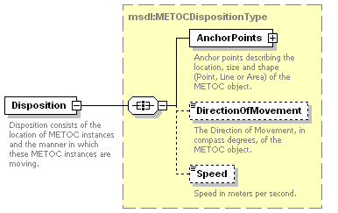
Figure 39: msdl:METOCGraphicType/Disposition Element Structure
- msdl:METOCDispositionType/AnchorPoints Element - For every msdl:METOCGraphicType complex type there shall be one AnchorPoints element. This element specifies the structure describing the location, size and shape (Point, Line or Area) of a specific METOC element. The shape for each specific METOC graphic is specified within Appendix C: METOC Symbology of MIL-STD-2525B w/Change 1. Area shapes will be interpreted to define a boundary in the sequence provided by the associated AnchorPoint elements. The AnchorPoints element is an xs:sequence compositor comprised of the elements shown in Figure 40 and described in the following subsections. The domain type is msdl:AnchorPointsType.
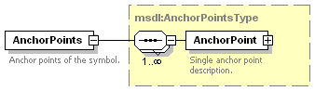
Figure 40: msdl:METOCGraphicType/AnchorPoints Element Structure
  - msdl:AnchorPointsType/AnchorPoint Element - For every msdl:AnchorPointsType complex type there shall be one or more Anchorpoint elements. The AnchorPoint element specifies a single anchor point. It is an xs:all compositor comprised of the elements shown in Figure 41 and described in the following subsections. The domain type is msdl:AnchorPointType.
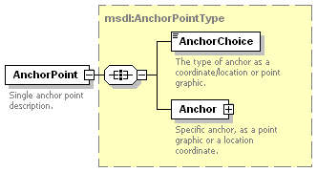
Figure 41: msdl:AnchorPointsType/AnchorPoint Element Structure
    - msdl:AnchorPointType/AnchorChoice Element - For every msdl:AnchorPointType complex type there shall be one AnchorChoice element. The AnchorChoice element specifies the type of anchor as a coordinate/location or a point graphic. The domain type is msdl:enumAnchorPointType.
    - msdl:AnchorPointType/Anchor Element - For every msdl:AnchorPointType complex type there shall be one Anchor elements. The Anchor element specifies a location for the anchor. It is an xs:choice compositor comprised of the elements shown in Figure 42 and described in the following subsections. The domain type is msdl:AnchorType.
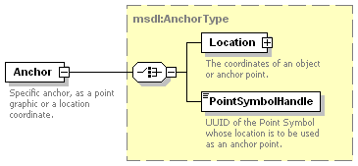
Figure 42: msdl:AnchorPointType/Anchor Element Structure
      - msdl:AnchorType/Location Element - For every msdl:AnchorType complex type there shall be one Location element. The Location element specifies the coordinates of the unit. The domain type is msdl:CoordinatesType as defined within section 6.3.2.2 for msdl:RectangleAreaType/UpperRight.
      - msdl:AnchorType/PointSymbolHandle Element - For every msdl:AnchorType complex type there shall be one PointSymbolHandle element. The PointSymbolHandle element specifies a UUID of the point symbol whose location is to be used as an anchor point. The domain type is msdl:patternUUIDRef32.
- msdl:METOCDispositionType/DirectionOfMovement Element - For every msdl:METOCGraphicType complex type there shall be zero or one DirectionOfMovement element. This element specifies the numerical value that denotes the horizontal direction of movement of a specific METOC Element. The unit is compass degrees measured relative to magnetic north 0 to 360 degrees clockwise. For reference trigonometric degrees = (90 – compass degrees). The domain type is msdl:floatCompassDegrees3_3.
- msdl:METOCDispositionType/Speed Element - For every msdl:METOCGraphicType complex type there shall be zero or one Speed element. This element specifies the numerical value that denotes the rate of movement of a specific METOC element in the direction of movement specified by the DirectionOfMovement element. The units are meters per second. The domain type is msdl:floatSpeed6_2.

msdl:MilitaryScenarioType/ForceSides Element
For every msdl:MilitaryScenarioType complex type there shall be one ForceSides element. The ForceSides element is used to specify the Forces and Sides and their associations within a military scenario. The ForceSides element, an xs:sequence compositor contains all the elements shown in Figure 43 and described in the subsequent subsections. The domain type is msdl:ForceSidesType.
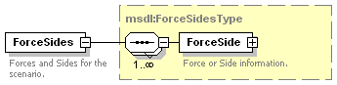
Figure 43: msdl:MilitaryScenarioType/ForceSides Element Structure

msdl:ForceSidesType/ForceSide Element
For every msdl:ForceSidesType element there shall be one or more ForceSide elements. The ForceSide element specifies the force or side information. It is an xs:all compositor and comprised of the elements shown in Figure 44 and described in the following subsections. The domain type is msdl:ForceSideType.
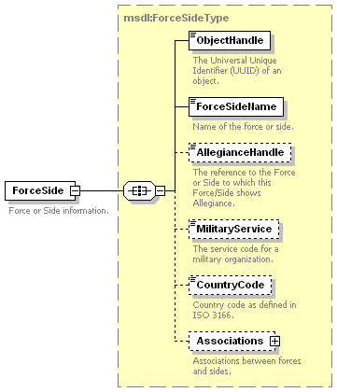
Figure 44: msdl:ForceSidesType/ForceSide Element Structure

msdl:ForceSideType/ObjectHandle Element
For every msdl:ForceSideType element there shall be one ObjectHandle element. The ObjectHandle element specifies the UUID of the ForceSide element. The domain type is msdl:patternUUID32.

msdl:ForceSideType/ForceSideName Element
For every msdl:ForceSideType element there shall be one ForceSideName element. The ForceSideName element specifies the name of the force or the side. The domain type is msdl:textName255.

msdl:ForceSideType/AllegianceHandle Element
For every msdl:ForceSideType element there shall be zero or one AllegianceHandle element. The AllegianceHandle element specifies a reference to the Force or Side that this ForceSide element shows allegiance to. This element allows the description of a hierarchical structure for the forces and sides whereas the first level (when this element is not specified) are the sides. Therefore Forces can have alliegiance to another Force or a Side but Sides are not intended to have allegiances to another Force or Side. The domain type is msdl:patternUUID32.

msdl:ForceSideType/MilitaryService Element
For every msdl:ForceSideType element there shall be zero or one MilitaryService element. The MilitaryService element specifies a Service code for a military organization. The domain type is jc3iedm:MilitaryOrganisationTypeServiceCode.

msdl:ForceSideType/CountryCode Element
For every msdl:ForceSideType element there shall be zero or one CountryCode element. The CountryCode element specifies a Country code for to which the organization belongs. The domain type is jc3iedm:AffiliationGeopoliticalCode.

msdl:ForceSideType/Associations Element
For every msdl:ForceSideType element there shall be zero or one Associations element. Sides shall have associations to all other Sides. Forces shall have associations to all other Forces that do not have allegiance to the same side as the current Force. All Force to Force and Side to Side relationships shall be explicity defined within the Associations structure. Because each Force or Side has its own list of associations the relationship between the forces or sides can be asymmetric. The Associations element, an xs:sequence compositor, specifies the associations between forces and sides and is shown in Figure 45. The domain type is msdl:AssociationsType.
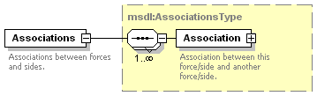
Figure 45: msdl:ForceSideType/Associations Element Structure

msdl:AssociationsType/Association Element
For every msdl:AssociationsType element there shall be one or more Association elements. The Association element specifies the relations ship between the current force or side and the other specified force or side. It is an xs:all compositor comprised of the elements shown in Figure 46 and described in the following subsections. The domain type is msdl:AssociationType.
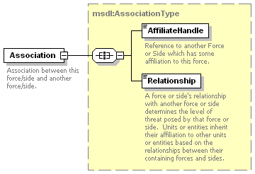
Figure 46: msdl:AssociationType/Association Element Structure
- msdl:AssociationType/AffiliateHandle Element - For every msdl:AssociationType complex type there shall be one AffiliateHandle element. The AffiliateHandle element specifies the reference to another ForceSide element which has a relationship to the current ForceSide element. The domain type is a msdl:patternUUIDRef32.
- msdl:AssociationType/Relationship Element - For every msdl:AssociationType complex type there shall be one Relationship element. The Relationship element specifies a Force or Side’s relationship with another Force or Side. It is to be used for determining the level of threat posed by that Force or Side. It is expected that units or entities inherit their affiliation to the other units or entities based on their relationships between their containing Force and Side. The domain type is jc3iedm:ObjectItemHostilityStatusCode.

msdl:MilitaryScenarioType/Organizations Element
For every msdl:MilitaryScenarioType complex type there shall be zero or one Organizations element. The Organizations element specifies the mission/scenario specific organizations and equipment within the military scenario document to include all military service, governmental, and nongovernmental organizations. Organizations in MSDL are comprised of Units and Equipment. Equipment generally equates to entities in the simulation. Whether Equipment is represented in the Organization depends on the planning model specified in the OrganizationDetail within the scenario’s Options element. The mapping of battle dimension instances other than ground into the unit and organization elements is application defined.
The information in the Organizations element describes the initialization data of each actual unit and equipement element in the scenario. This description does not specify how each unit and equipment instance is reported during intelligence gathering by the other unit and equipment instances. However, it is expected that each simulation application will be able to derive the applicable information during execution. The Organizations element is comprised of an xs:all compositor comprised the elements shown in Figure 47 and described in the subsequent subsections. The domain type is msdl:OrganizationsType.
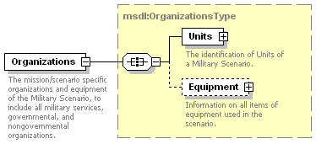
Figure 47: msdl:MilitaryScenarioType/Organizations Element Structure

msdl:OrganizationsType/Units Element
For every msdl:OrganizationsType element there shall be one Units element. The Units element, an xs:sequence compositor, specifies the units within the military scenario document and is shown in Figure 48. The domain type is msdl:UnitsType.
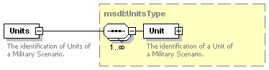
Figure 48: msdl:OrganizationsType/Units Element Structure

msdl:UnitsType/Unit Element
For every msdl:UnitsType element there shall be one or more Unit elements. The Unit element specifies a unit within the military scenario document. It is an xs:all compositor comprised of the elements shown in Figure 49 and described in the following subsections. The domain type is msdl:UnitType.
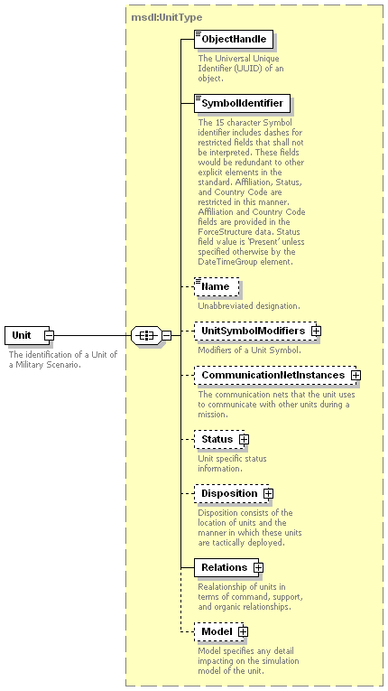
Figure 49: msdl:UnitsType/Unit Element Structure

msdl:UnitType/ObjectHandle Element
For every msdl:UnitType complex type there shall be one ObjectHandle element. The ObjectHandle element specifies the UUID of the Unit. The domain type is a msdl:patternUUID32.

msdl:UnitType/SymbolIdentifier Element
For every msdl:UnitType complex type there shall be one SymbolIdentifier element. The SymbolIdentifier element specifies the 15 character symbol identifier as specified by the Symbol Identification Coding scheme from the symbology set specified by the SymbologyDataStandard of the Options. The 15 character SymbolIdentifier includes dashes for restricted fields that shall not be interpreted. These fields would be redundant to other explicit elements in the standard. Affiliation, Status, and Country Code are restricted in this manner. Affiliation and Country Code fields are provided in the ForceSide structure data. Status field value is ‘Present’ unless specified otherwise by the DateTimeGroup element. The Coding Scheme shall be ‘S’ for unit symbol identification. The domain type is a msdl:patternForceSymbolID15.

msdl:UnitType/Name Element
For every msdl:UnitType complex type there shall be zero or one Name element. The Name element specifies the unabbreviated designation of the Unit. The domain type is msdl:textName255.

msdl:UnitType/UnitSymbolModifiers Element
For every msdl:UnitType complex type there shall be zero or one UnitSymbolModifiers element. The UnitSymbolModifiers element specifies the modifiers of unit symbol. It is an xs:all compositor comprised of the elements shown in Figure 50 and described in the following subsections. The domain type is msdl:UnitSymbolModifiersType.
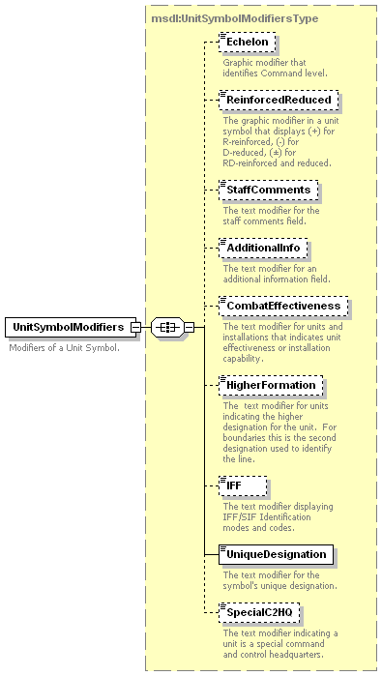
Figure 50: msdl:Unit/Type/UnitSymbolModifiers Element Structure
- msdl:UnitSymbolModifiersType/Echelon Element - For every msdl:UnitSymbolModifiersType complex type there shall be zero or one Echelon elements. The Echelon element specifies the graphic modifier that identifies the command level. The domain type is msdl:enumEchelon.
- msdl:UnitSymbolModifiersType/ReinforcedReduced Element - For every msdl:UnitSymbolModifiersType complex type there shall be zero or one ReinforcedReduced element. This element specifies, through an enumeration, whether a unit has been reinforced with assets from another organization, reduced by giving assets to another organization, or has received assets from another organization and has given some assets to another organization. The domain type is msdl:enumReinforcedReducedType.
- msdl:UnitSymbolModifiersType/StaffComments Element - For every msdl:UnitSymbolModifiersType complex type there shall be zero or one StaffComments element. The StaffComments element specifies the text modifier for staff comments field. The domain type is msdl:text20.
- msdl:UnitSymbolModifiersType/AdditionalInfo Element - For every msdl:UnitSymbolModifiersType complex type there shall be zero or one AdditionalInfo element. The AdditionalInfo element specifies the text modifier for an additional information field. The domain type is msdl:text20.
- msdl:UnitSymbolModifiersType/CombatEffectiveness Element - For every msdl:UnitSymbolModifiersType complex type there shall be zero or one CombatEffectiveness elements. The CombatEffectiveness element specifies the modifier that indicates the ability of a unit to perform its mission. Factors such as ammunition, personnel, status of fuel, and weapon systems may be included in the assessment. The domain type is msdl:enumCombatEffectivenessType.
- msdl:UnitSymbolModifiersType/HigherFormation Element - For every msdl:UnitSymbolModifiersType complex type there shall be zero or one HigherFormation element. The HigherFormation element specifies the text modifier that indicates the designation of the unit’s superior when the designation is different that the one specified by the Relations element. The domain type is msdl:text21.
- msdl:UnitSymbolModifiersType/IFF Element - For every msdl:UnitSymbolModifiersType complex type there shall be zero or one IFF element. The IFF element specifies the text modifier displaying IFF/SIF identification modes and codes. The domain type is msdl:textIFF5.
- msdl:UnitSymbolModifiersType/UniqueDesignation Element - For every msdl:UnitSymbolModifiersType complex type there shall be one UniqueDesignation element. The UniqueDesignation element specifies the text modifier for the symbol’s unique designation. The domain type is msdl:text21.
- msdl:UnitSymbolModifiersType/SpecialC2HQ Element - For every msdl:UnitSymbolModifiersType complex type there shall be zero or one SpecialC2HQ element. The SpecialC2HQ element specifies the text modifier for units indicating that a unit is a special command and control headquarters. The domain type is msdl:textSpecialC2HQ9.

msdl:UnitType/CommunicationNetInstances Element
For every msdl:UnitType complex type there shall be zero or one CommunicationNetInstances element. The CommunicationNetInstances element specifies the communication nets that the unit defines for communication with other units during a mission. It is an xs:sequence compositor comprised of the elements shown in Figure 51 and described in the following subsections. The domain type is msdl:CommunicationNetInstancesType.
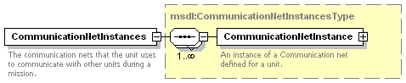
Figure 51: msdl:UnitType/CommunicationsNetInstances Element Structure
- msdl:CommunicationNetInstancesType/CommunicationNetInstance Element - For every msdl:CommunicationNetInstancesType element there shall be one or more CommunicationNetInstance elements. The CommunicationNetInstance element specifies an instance of a communication net defined for a unit. It is an xs:all compositor comprised of the elements shown in Figure 52 and described in the following subsections. The domain type is msdl:CommunicationNetInstanceType.
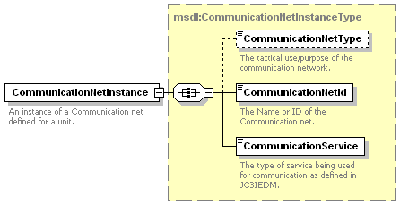
Figure 52: msdl:CommunicationNetInstancesType/CommunicationNetInstance Element Structure
  - msdl:CommunicationNetInstanceType/CommunicationNetType Element - For every msdl:CommunicationNetInstanceType complex type there shall be zero or one CommunicationNetType element. The CommunicationNetType element specifies the tactical use or purpose of the communication network. The domain type is msdl:enumCommunicationNetType.
  - msdl:CommunicationNetInstanceType/CommunicationNetId Element - For every msdl:CommunicationNetInstanceType complex type there shall be one CommunicationNetId element. The CommunicationNetId element specifies the name or ID of the communication network. The domain type is msdl:textIdentifier64.
  - msdl:CommunicationNetInstanceType/CommunicationService Element - For every msdl:CommunicationNetInstanceType complex type there shall be one CommunicationService element. The CommunicationService element specifies the type of service being used for communication. The domain type is a msdl:enumCommunicationServiceType.

msdl:UnitType/Status Element
For every msdl:UnitType complex type there shall be zero or one Status element. The Status element specifies unit specific status information. It is an xs:all compositor comprised of the elements shown in Figure 53 and described in the following subsections. The domain type is msdl:StatusType.
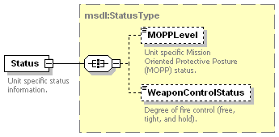
Figure 53: msdl:UnitType/Status Element Structure
- msdl:StatusType/MOPPLevel Element - For every msdl:StatusType complex type there shall be zero or one MOPPLevel elements. The MOPPLevel element specifies the status of the Mission-Oriented Protective Posture (MOPP). The domain type is msdl:enumMOPPLevelType.
- msdl:StatusType/WeaponControlStatus Element - For every msdl:StatusType complex type there shall be zero or one WeaponControlStatus element. The WeaponControlStatus element specifies the degree of fire control, values include free, tight, and hold. The domain type is msdl:enumWeaponControlStatusType.

msdl:UnitType/Disposition Element
For every msdl:UnitType complex type there shall be zero or one Disposition element. The Disposition element specifies the location of units and the manner in which these units are tactically deployed. It is an xs:all compositor comprised of the elements shown in Figure 54 and described in the following subsections. The domain type is msdl:UnitDispositionType.
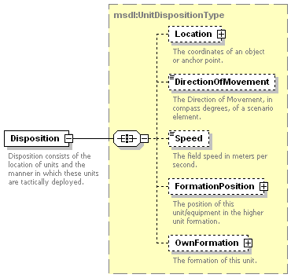
Figure 54: msdl:UnitType/Disposition Element Structure
- msdl:UnitDispositionType/Location Element - For every msdl:UnitDispositionType complex type there shall be zero or one Location element. The Location element specifies the coordinates of the unit. This shall either be the position of the lead element or the center of mass of the unit as specified in the msdl:OwnFormationType/FormationLocationType. It shall be center of mass when the msdl:OwnFormationType/FormationLocationType element is not specified. The domain type is msdl:CoordinatesType as defined within section 6.3.2.2 for msdl:RectangleAreaType/UpperRight.
- msdl:UnitDispositionType/DirectionOfMovement Element - For every msdl:UnitDispositionType complex type there shall be zero or one DirectionOfMovement element. The DirectionOfMovement element specifies the horizontal direction of movement in compass degrees, measured relative to magnetic north 0 to 360 degrees clockwise, of the formation as a whole. For reference trigonometric degrees = (90 – compass degrees). The domain type is msdl:floatCompassDegrees3_3.
- msdl:UnitDispositionType/Speed Element - For every msdl:UnitDispositionType complex type there shall be zero or one Speed element. The Speed element specifies the rate of movement of the unit in the direction specified by the DirectionOfMovement element. The domain type is msdl:floatSpeed6_2.
- msdl:UnitDispositionType/FormationPosition Element - For every msdl:UnitDispositionType complex type there shall be zero or one FormationPosition element. The FormationPosition element specifies the position of the specific unit with relation to the other units within the formation. It is an xs:all compositor comprised of the elements shown in Figure 55 and described in the following subsections. The domain type is msdl:FormationPositionType.
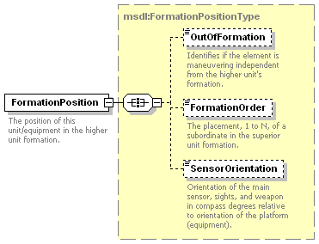
Figure 55: msdl:FormationPositionType/FormationPosition Element Structure
    - msdl:FormationPositionType/OutOfFormation Element - For every msdl:FormationPosition complex type there shall be zero or one OutOfFormation element. The OutOfFormation element specifies if the element is maneuvering independent of the higher unit’s formation. The domain type is msdl:boolean.
    - msdl:FormationPositionType/FormationOrder Element - For every msdl:FormationPosition complex type there shall be zero or one FormationOrder element. The FormationOrder element specifies the placement, 1 to N, of a subordinate in the superior unit’s formation. The domain type is msdl:integerSequence6.
    - msdl:FormationPositionType/SensorOrientation Element - For every msdl:FormationPosition complex type there shall be zero or one SensorOrientation element. The SensorOrientation element specifies the main sensor, sight, and weapon of the unit’s equipment. If a SensorOrientation is defined for both the unit and equipment, the equipment’s SensorOrientation shall be used. SensorOrientation is given in compass degrees and is relative to the orientation of the platform. The domain type is msdl:floatCompassDegrees3_3.
- msdl:UnitDispositionType/OwnFormation - For every msdl:UnitDispositionType complex type there shall be zero or one OwnFormation element. The OwnFormation element specifies the formation of the unit. It is an xs:all compositor comprised of the elements shown in Figure 56 and described in the following subsections. The domain type is msdl:OwnFormationType.
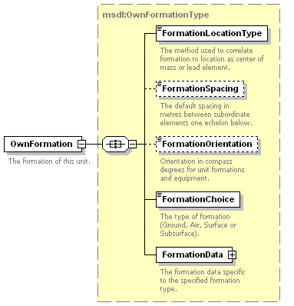
Figure 56: msdl:OwnFormationType/OwnFormation Element Structure
    - msdl:OwnFormationType/FormationLocationType Element - For every msdl:OwnFormationType complex type there shall be one FormationLocationType element. The FormationLocationType element specifies the method used to correlate the formation to a location as the center of mass or the lead element. The domain type is msdl:enumFormationLocationType.
    - msdl:OwnFormationType/FormationSpacing Element - For every msdl:OwnFormationType complex type there shall be zero or one FormationSpacing element. The FormationSpacing element specifies the default spacing in meters between subordinate elements. The domain type is msdl:floatSpacing4_3.
    - msdl:OwnFormationType/FormationOrientation Element - For every msdl:OwnFormationType complex type there shall be zero or one FormationOrientation element. The FormationOrientation element specifies the orientation in compass degrees, measured relative to magnetic north 0 to 360 degrees clockwise, of the formation as a whole. For reference trigonometric degrees = (90 – compass degrees). The domain type is a restricted msdl:floatCompassDegrees3_3.
    - msdl:OwnFormationType/FormationChoice Element - For every msdl:OwnFormationType complex type there shall be zero or one FormationChoice element. The FormationChoice element specifies the relative location from which subordinate elements are placed in the formation. The domain type is msdl:enumFormationType.
    - msdl:OwnFormationType/FormationData Element - For every msdl:OwnFormationType complex type there shall be one FormationData element. The FormationData element specifies the formation data specific to the formation type. It is an xs:choice compositor comprised of one and only one element shown in Figure 57 and described in the following subsections. The domain type is msdl:FormationDataType.
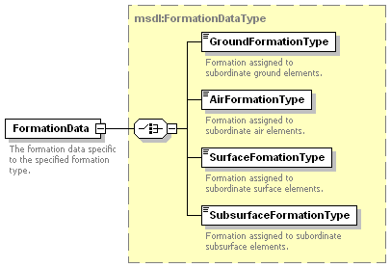
Figure 57: msdl:OwnFormationType/FormationData Element Structure
      - msdl:FormationDataType/GroundFormationType Element - For every msdl:FormationDataType complex type there shall be zero or one GroundFormationType element. The GroundFormationType element specifies the ground formation type used to place subordinate elements. The domain type is msdl:enumGroundFormationType.
      - msdl:FormationDataType/AirFormationType Element - For every msdl:FormationDataType complex type there shall be zero or one AirFormationType element. The AirFormationType element specifies the air formation type used to place subordinate elements. The domain type is msdl:enumAirFormationType.
      - msdl:FormationDataType/SurfaceFormationType Element - For every msdl:FormationDataType complex type there shall be zero or one SurfaceFormationType element. The SurfaceFormationType element specifies the surfance formation type used to place subordinate elements. The domain type is msdl:enumSurfaceFormationType.
      - msdl:FormationDataType/SubsurfaceFormationType Element - For every msdl:FormationDataType complex type there shall be zero or one SubsurfaceFormationType element. The SubsurfaceFormationType element specifies the subsurface formation type used to place subordinate elements. The domain type is msdl:enumSubsurfaceFormationType.

msdl:UnitType/Relations Element
For every msdl:UnitType complex type there shall be one Relations element. The Relations element specifies the relationship of units in terms of command, support, and organic relationships. It is an xs:all compositor comprised of the elements shown in Figure 58 and described in the following subsections. The domain type is msdl:UnitRelationsType.
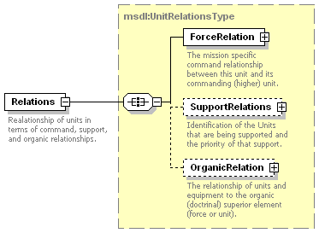
Figure 58: msdl:UnitType/Relations Element Structure
- msdl:UnitRelationsType/ForceRelation Element -For every msdl:UnitRelationsType complex type there shall be one ForceRelation element. The ForceRelation element specifies the mission specific command relationship between this unit and its commanding (higher) unit. The ForceRelation element either holds a relationship to a commanding unit defined by a Unit element, or to a commanding unit defined by a ForceSide element. It is an xs:all compositor comprised of the elements shown in Figure 59 and described in the following subsections. The domain type is msdl:ForceRelationType.
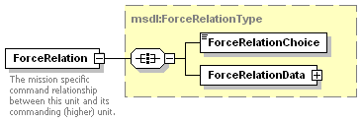
Figure 59: msdl:UnitRelationsType/ForceRelation Element Structure
  - msdl:ForceRelationType/ForceRelationChoice Element - For every msdl:ForceRelationType complex type there shall be one ForceRelationChoice element. The ForceRelationChoice element specifies either a unit, force/side, or not-specified relationship will be contained within the ForceRelationData element. The domain type is msdl:enumForceOwnerType.
  - msdl:ForceRelationType/ForceRelationData Element - For every msdl:ForceRelationType complex type there shall be one ForceRelationData element. The ForceRelationData element specifies the structure for holding command relationship between this unit/equipment and its commanding unit. It is an xs:choice compositor comprised of only one of the elements shown in Figure 60 and described in the following subsections. The domain type is msdl:ForceRelationDataType.
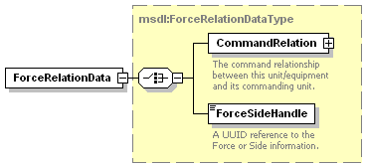
Figure 60: msdl:ForceRelationType/ForceRelationData Element Structure
    - msdl:ForceRelationDataType/CommandRelation Element - For every msdl:ForceRelationDataType complex type there shall be one CommandRelation element. The CommandRelation element specifies the structure for holding a reference to the superior unit and the type of command relationship between this unit and its superior. It is an xs:all compositor comprised of the elements shown in Figure 61 and described in the following subsections. The domain type is msdl:CommandRelationType.
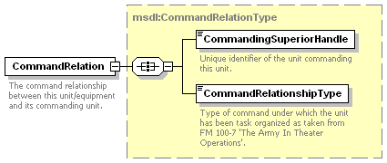
Figure 61: msdl:ForceRelationDataType/CommandRelation Element Structure
      - msdl:CommandRelationType/CommandingSuperiorHandle Element- For every msdl:CommandRelationType complex type there shall be one CommandingSuperiorHandle element. The CommandingSuperiorHandle element specifies a unique identifier of the commanding Unit. The domain type is msdl:patternUUIDRef32.
      - msdl:CommandRelationType/CommandRelationshipType Element- For every msdl:CommandRelationType complex type there shall be one CommandRelationshipType element. The CommandRelationshipType element specifies the type of command under which the unit has been task organized as described in FM 100-7. The domain type is msdl:enumCommandRelationshipType.
    - msdl:ForceRelationDataType/ForceSideHandle Element - For every msdl:ForceRelationDataType complex type there shall be zero or one ForceSideHandle element. The ForceSideHandle element specifies a UUID reference to the ForceSide for the Unit. The domain type is msdl:patternUUIDRef32.
- msdl:UnitRelationsType/SupportRelations Element - For every msdl:UnitRelationsType complex type there shall be zero or one SupportRelations element. The SupportRelations element specifies the identification of the units that are being supported and the priority of the support. It is an xs:sequence compositor comprised of the elements shown in Figure 62 and described in the following subsections. The domain type is msdl:SupportRelationsType.
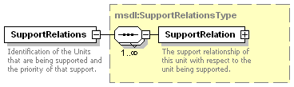
Figure 62: msdl:UnitRelationsType/SupportRelations Element Structure
  - msdl:/SupportRelationsType/SupportRelation Element - For every msdl:SupportRelationsTypes complex type there shall be one or more SupportRelation elements. The SupportRelation element specifies the support relationship of this unit with respect to the unit being supported. It is an xs:all compositor comprised of the elements shown in Figure 63 and described in the following subsections. The domain type is msdl:SupportRelationType.
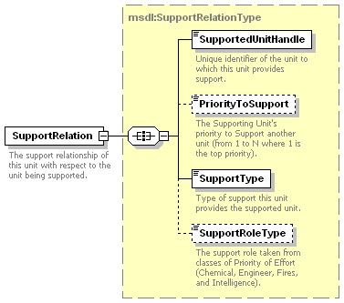
Figure 63: msdl:SupportRelationTypes/SupportRelation Element Structure
    - msdl:SupportRelationType/SupportedUnitHandle Element - For every msdl:SupportRelationType complex type there shall be one SupportedUnitHandle element. The SupportedUnitHandle element specifies the unique identifier of the unit to which this unit provides support. The domain type is msdl:patternUUIDREF32.
    - msdl:SupportRelationType/PriorityToSupport Element - For every msdl:SupportRelationType complex type there shall be zero or one PriorityToSupport element. The PriorityToSupport element specifies the supporting unit’s priority to support another unit from 1 to N where 1 is the top priority. The domain type is a msdl:integerPriorityToSupport1.
    - msdl:SupportRelationType/SupportType Element - For every msdl:SupportRelationType complex type there shall be one SupportType element. The SupportType element specifies the type of support this unit provides the supported unit. The domain type is a msdl:enumSupportRelationType.
    - msdl:SupportRelationType/SupportRoleType Element - For every msdl:SupportRelationType complex type there shall be zero or one SupportRoleType element. The SupportRoleType element specifies the support role taken from categories defining priority of effort including: Chemical, Engineer, Fires, Intelligence, etc. The domain type is a msdl:enumSupportRoleType.
- msdl:UnitRelationsType/OrganicRelation For every msdl:UnitRelationsType complex type there shall be zero or one OrganicRelation element. The OrganicRelation element specifies an association of the doctrine and other behavior detail that is followed independent of the mission specific organization. It is an xs:all compositor comprised the elements shown in Figure 64 and described in the following subsections. The domain type is msdl:OrganicRelationType.
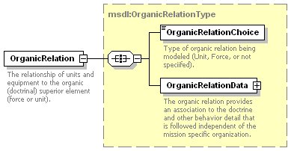
Figure 64: msdl:UnitRelationType/OrganicRelation Element Structure
  - msdl:OrganicRelationType/OrganicRelationChoice Element - For every msdl:OrganicRelationType complex type there shall be one OrganicRelationChoice element. The OrganicRelationChoice element specifies the type of organic relationship to the unit’s force or side. The domain type is msdl:enumForceOwnerType.
  - msdl:OrganicRelationType/OrganicRelationData Element - For every msdl:OrganicRelationType complex type there shall one OrganicRelationaData element. The OrganicRelationData element specifies the structure to hold a reference to the unit that is the unit’s organic superior and to the unit’s organic force or side. It is an xs:choice compositor comprised of one and only one of the elements shown in Figure 65 and described in the following subsections. The domain type is msdl:OrganicRelationDataType.
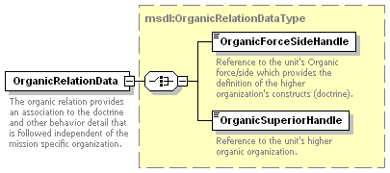
Figure 65: msdl:OrganicRelationType/OrganicRelationData Element Structure
    - msdl:OrganicRelationDataType/OrganicForceSideHandle Element - For every msdl:OrganicRelationDataType complex type there shall be zero or one OrganicForceSideHandle element. The OrganicForceSideHandle element specifies a reference to the unit’s organic ForceSide which provides the definition of the higher organization’s doctrine. The domain type is msdl:patternUUIDRef32.
    - msdl:OrganicRelationDataType/OrganicSuperiorHandle Element - For every msdl:OrganicRelationDataType complex type there shall be zero or one OrganicSuperiorHandle element. The OrganicSuperiorHandle element specifies a reference to the unit that is the unit’s higher organic organization. The domain type is msdl:patternUUIDRef32.

msdl:UnitType/Model Element
For every msdl:UnitType complex type there shall be one Model element. The Model element specifies the resolution and aggregation information impacting import of the military scenario. It is an xs:all compositor comprised of the elements shown in Figure 66 and described in the following subsections. The domain type is msdl:UnitModelType.
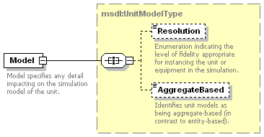
Figure 66: msdl:UnitType/Model Element Structure
- msdl:UnitModelType/Resolution Element - For every msdl:UnitModelType complex type there shall be zero or one Resolution element. The Resolution element specifies an enumeration indicating the level of fidelity appropriate for instancing the unit or equipment in the simulation. The domain type is msdl:enumModelResolutionType.
- msdl:UnitModelType/AggregateBased Element - For every msdl:UnitModelType complex type there shall be zero or one AggregateBased element. The AggregateBased element specifies a flag indicating that a unit’s underlying task organization is explicity repreresented using the Unit and Equipment constructs as appropriate. The domain type is msdl:boolean.

msdl:OrganizationsType/Equipment Element
For every msdl:OrganizationsType complex type there shall be zero or one Equipment element. The Equipment element, an xs:sequence compositor, specifies all of the equipment elements used within the military scenario and is shown in Figure 67. The domain type is msdl:EquipmentType.
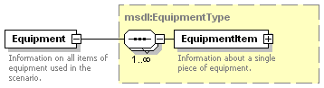
Figure 67: msdl:OrganizationsType/Equipment Element Structure

msdl:EquipmentType/EquipmentItem Element
For every msdl:EquipmentType complex type there shall be one or more EquipmentItem elements. The EquipmentItem element specifies a individual entity such as a vehicle, aircraft, or person within the military scenario document. It is an xs:all compositor comprised of the elements shown in Figure 68 and described in the following subsections. The domain type is msdl:EquipmentItemType.
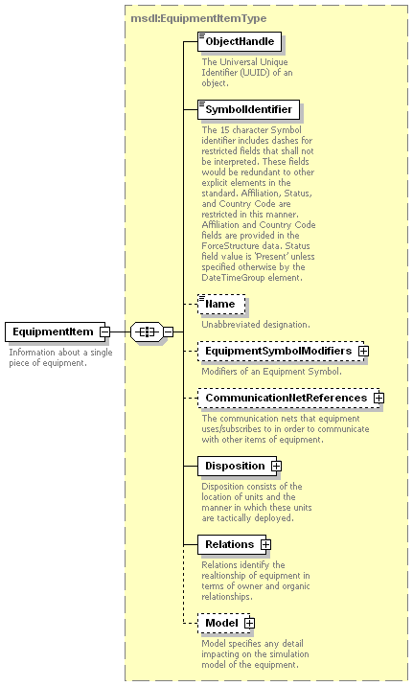
Figure 68: msdl:EquipmentType/EquipmentItem Element Structure

msdl:EquipmentItemType/ObjectHandle Element
For every msdl:EquipmentItemType complex type there shall be one ObjectHandle element. The ObjectHandle element specifies the UUID of the EquipmentItem. The domain type is a msdl:patternUUID32.

msdl:EquipmentItemType/SymbolIdentifier Element
For every msdl:EquipmentItemType complex type there shall be one SymbolIdentifier element. The SymbolIdentifier element specifies the 15 character symbol identifier as specified by the Symbol Identification Coding scheme within Mil Std 2525B. The 15 character SymbolIdentifier includes dashes for restricted fields that shall not be interpreted. These fields would be redundant to other explicit elements in the standard. Affiliation, Status, and Country Code are restricted in this manner. Affiliation and Country Code fields are provided in the ForceSide structure data. Status field value is ‘Present’ unless specified otherwise by the DateTimeGroup element. The Coding Scheme shall be ‘S’ for equipment symbol identification. The domain type is a msdl:patternForceSymbolID15.

msdl:EquipmentItemType/Name Element
For every msdl:EquipmentItemType complex type there shall be zero or one Name element. The Name element specifies the unabbreviated designation of the EquipmentItem. The domain type is msdl:textName255.

msdl:EquipmentItemType/EquipmentSymbolModifiers Element
For every msdl:EquipmentItemType complex type there shall be zero or one EquipmentSymbolModifiers element. The EquipmentSymbolModifiers element specifies the modifiers of an equipment symbol. It is an xs:all compositor comprised of the elements shown in Figure 69 and described in the following subsections. The domain type is msdl:EquipmentSymbolModifiersType.
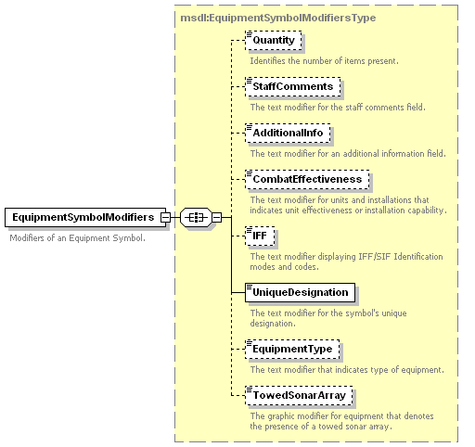
Figure 69: msdl:EquipmentItemType/EquipmentSymbolModifiers Element Structure
- msdl:EquipmentSymbolModifiersType/Quantity Element - For every msdl:EquipmentSymbolModifiersType complex type there shall be zero or one Quantity elements. The Quantity element specifies the modifier that identifies the number of items present. The domain type is msdl:integerQuantity9.
- msdl:EquipmentSymbolModifiersType/StaffComments Element - For every msdl:EquipmentSymbolModifiersType complex type there shall be zero or one StaffComments element. The StaffComments element specifies the text modifier for staff comments field. The domain type is msdl:text20.
- msdl:EquipmentSymbolModifiersType/AdditionalInfo Element - For every msdl:EquipmentSymbolModifiersType complex type there shall be zero or one AdditionalInfo element. The AdditionalInfo element specifies the text modifier for an additional information field. The domain type is msdl:text20.
- msdl:EquipmentSymbolModifiersType/CombatEffectiveness Element - For every msdl:EquipmentSymbolModifiersType complex type there shall be zero or one CombatEffectiveness element. The CombatEffectiveness element specifies the modifier that indicates the ability of the equipment to perform its mission. Factors such as ammunition, personnel, status of fuel, and weapon systems may be included in the assessment. The domain type is msdl:enumCombatEffectivenessType.
- msdl:EquipmentSymbolModifiersType/IFF Element - For every msdl:EquipmentSymbolModifiersType complex type there shall be zero or one IFF element. The IFF element specifies the text modifier displaying IFF/SIF identification modes and codes. The domain type is msdl:textIFF5.
- msdl:EquipmentSymbolModifiersType/UniqueDesignation Element - For every msdl:EquipmentSymbolModifiersType complex type there shall be one UniqueDesignation element. The UniqueDesignation element specifies the text modifier for the symbol’s unique designation. The domain type is msdl:text21.
- msdl:EquipmentSymbolModifiersType/EquipmentType Element - For every msdl:EquipmentSymbolModifiersType complex type there shall be zero or one EquipmentType element. The EquipmentType element specifies the modifier that identifies equipment type. The domain type is msdl:textEquipmentType24.
- msdl:EquipmentSymbolModifiersType/TowedSonarArray Element - For every msdl:EquipmentSymbolModifiersType complex type there shall be zero or one TowedSonarArray element. The TowedSonarArray element specifies a boolean modifier that denotes the presence of a towed sonar array. The domain type is msdl:boolean.

msdl:EquipmentItemType/CommunicationNetReferences Element
For every msdl:EquipmentItemType complex type there shall be zero or one CommunicationNetReferences element. The CommunicationNetReferences element specifies the communication nets that the equipment uses or subscribes to in order to communicate with other equipment items. It is an xs:sequence compositor comprised of the elements shown in Figure 70 and described in the following subsections. The domain type is msdl:CommunicationNetReferenceType.
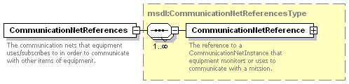
Figure 70: msdl:EquipmentItemType/CommunicationNetReferences Element Structure
- msdl:CommunicationNetReferencesType/CommunicationNetReference Element - For every msdl:CommunicationNetReferencesType complex type there shall be one or more msdl:CommunicationNetReference elements. The CommunicationNetReference element specifies a reference to a CommunicationNetInstance that the equipment monitors or uses to communicate mission information. It is an xs:sequence compositor comprised of the elements shown in Figure 71 and described in the following subsections. The domain type is msdl:CommunicationNetReferenceType.
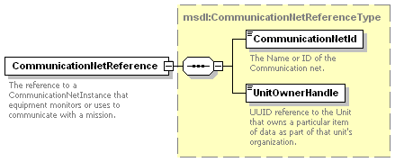
Figure 71: msdl:CommunicationNetReferencesType/CommunicationNetReference Element Structure
  - msdl:CommunicationNetReferenceType/CommunicationNetId Element - For every msdl:CommunicationNetReferenceType complex type there shall be one CommunicationNetId element. The CommunicationNetId element specifies the name or ID of the communication network. The domain type is msdl:textIdentifier64.
  - UnitOwnerHandle Element - For every msdl:CommunicationNetReferenceType complex type there shall be one UnitOwnerHandle element. The UnitOwnerHandle element specifies a UUID reference to the unit that owns a communication network. The domain type is msdl:patternUUIDRef32.

msdl:EquipmentItemType/Disposition Element
For every msdl:EquipmentItemType complex type there shall be one Disposition element. The Disposition element specifies the location of equipment items and the manner in which these equipment items are tactically deployed. It is an xs:all compositor comprised of the elements shown in Figure 72 and described in the following subsections. The domain type is msdl:EquipmentDispositionType.
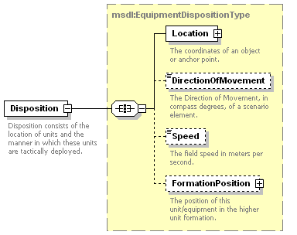
Figure 72: msdl:EquipmentItemType/Disposition Element Structure
- msdl:EquipmentDispositionType/Location Element - For every msdl:EquipmentDispositionType complex type there shall be one Location element. The Location element specifies the coordinates of the equipment. The domain type is msdl:CoordinatesType as defined within section 6.3.2.2 for msdl:RectangleAreaType/UpperRight.
- msdl:EquipmentDispositionType/DirectionOfMovement Element - For every msdl:EquipmentDispositionType complex type there shall be zero or one DirectionOfMovement element. The DirectionOfMovement element specifies the horizontal direction of movement in compass degrees, measured relative to magnetic north 0 to 360 degrees clockwise, of a military scenario element. For reference trigonometric degrees = (90 – compass degrees). The domain type is msdl:floatCompassDegrees3_3.
- msdl:EquipmentDispositionType/Speed Element - For every msdl:EquipmentDispositionType complex type there shall be zero or one Speed element. The Speed element specifies the equipment’s rate of movement in the direction as specified in the DirectionofMovement element. The domain type is msdl:floatSpeed6_2.
- msdl:EquipmentDispositionType/FormationPosition Element - For every msdl:EquipmentDispositionType complex type there shall be zero or one FormationPosition element. The FormationPosition element specifies the position of the specific EquipmentItem with relation to the other pieces of equipment within the formation. The Domain type is msdl:FormationPositionType as defined within section 6.5.1.1.7 for msdl:UnitDispositionType/FormationPosition.

msdl:EquipmentItemType/Relations Element
For every msdl:EquipmentItemType complex type there shall be one Relations element. The Relations element specifies the relationship of equipment items to units in terms of command, support, and organic relationships. It is an xs:all compositor comprised of the elements shown in Figure 73 and described in the following subsections. The domain type is msdl:EquipmentRelationsType.
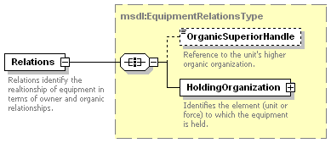
Figure 73: msdl:EquipmentItemType/Relations Element Structure
- msdl:EquipmentRelationsType/OrganicSuperiorHandle Element - For every msdl:EquipmentRelationsType complex type there shall be zero or one OrganicSuperiorHandle element. The OrganicSuperiorHandle element specifies a reference to the unit that is the equipment item’s higher organic organization. The domain type is msdl:patternUUIDRef32.
- msdl:EquipmentRelationsType/HoldingOrganization Element - For every msdl:EquipmentRelationsType complex type there shall be one HoldingOrganization element. The HoldingOrganization element specifies the unit that is the owner of the equipment item. The HoldingOrganization element, an xs:sequence compositor contains all the elements shown in Figure 74 and described in the subsequent subsections.The domain type is msdl:OwnerType.
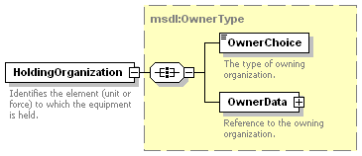
Figure 74: msdl:EquipementRelationsType/HoldingOrganization Element Structure
  - msdl:OwnerType/OwnerChoice Element - For every msdl:OwnerType complex type there shall be one OwnerChoice element. The OwnerChoice element specifies the type of owning organization. The domain type is msdl:enumForceOwnerType.
  - msdl:OwnerType/OwnerData Element - For each msdl:OwnerType complex type there shall be one OwnerData element. The OwnerData element, an xs:choice compositor, specifies the reference to the owning organization and is made up of one and only one of the child elements as shown in Figure 75. The domain type is msdl:OwnerDataType.
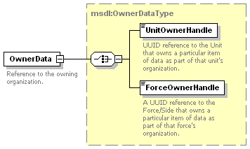
Figure 75: msdl:OwnerType/OwnerData Element Structure
    - msdl:OwnerDataType/UnitOwnerHandle Element - For each msdl:OwnerDataType complex type there shall be zero or one UnitOwnerHandle element. The UnitOwnerHandle element specifies the UUID reference to the unit that owns a particular item of data as part of the unit’s organization. The domain type is msdl:patternUUIDRef32.
    - msdl:OwnerDataType/ForceOwnerHandle Element - For each msdl:OwnerDataType complex type there shall be zero or one ForceOwnerHandle element. The ForceOwnerHandle element specifies the UUID reference to the Force/Side that owns a particular item of data as part of that forces organization. The domain type is msdl:patternUUIDRef32.

msdl:EquipmentItemType/Model Element
For every msdl:EquipmentItemType complex type there shall be zero or one Model element. The Model element specifies the information related to the appropriate representation of the equipment item in the military scenario. It is an xs:all compositor comprised of the elements shown in Figure 76 and described in the following subsections. The domain type is msdl:EquipmentModelType.
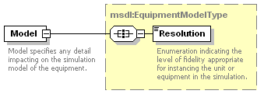
Figure 76: msdl:/EquipmentItemType/Model Element Structure
- msdl:EquipmentModelType/Resolution Element - For every msdl:EquipmentModelType complex type there shall be one Resolution element. The Resolution element specifies an enumeration indicating the level of fidelity appropriate for instancing the unit or equipment in the simulation. The domain type is msdl:enumModelResolutionType.

msdl:MilitaryScenarioType/Overlays Element
For every msdl:MilitaryScenarioType complex type there shall be zero or one Overlays element. The Overlays element is used to specify the overlays within the context of the military scenario. Ownership of a specific overlay is determined through the intelligence elements/instances it groups. The Overlays element is an xs:sequence compositor containing all the elements shown in Figure 77 and described in the subsequent subsections. The domain type is msdl:OverlaysType.
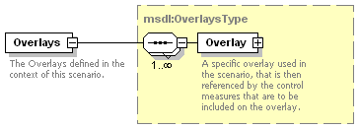
Figure 77: msdl:MilitaryScenarioType/Overlays Element Structure

msdl:OverlaysType/Overlay Element
For every msdl:OverlaysType complex type there shall be one or more Overlay element. Overlays are used to organize the intelligence information described by the control measures. It is expected that control measures owned by opposing forces, sides, or units will not appear in the same overlay. The Overlay element, an xs:all compositor, specifies an overlay used in the scenario that is then referenced by the control measures that are to be included on the overlay and is show in Figure 78. The domain type is msdl:OverlayType.
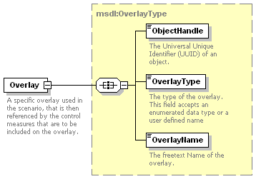
Figure 78: msdl:OverlaysType/Overlay Element Structure

msdl:OverlayType/ObjectHandle Element
For every msdl:OverlayType complex type there shall be one ObjectHandle element. The ObjectHandle element specifies the UUID of the Overlay. The domain type is a msdl:patternUUID32.

msdl:OverlayType/OverlayType Element
For every msdl:OverlayType complex type there shall be one OverlayType element. The OverlayType element specifies an enumerated type for the overlay. The domain type is a msdl:enumOverlayType.

msdl:OverlayType/OverlayName Element
For every msdl:OverlayType complex type there shall be one OverlayName element. The OverlayName element specifies the free text name of the overlay. The domain type is msdl:textName255.

msdl:MilitaryScenarioType/Installations Element
For every msdl:MilitaryScenarioType complex type there shall be zero or one Installations element. The Installations element is used to specify the mission/scenario specific installations within the military scenario document to include all military service, governmental, and nongovernmental organizations. The mapping of the battle dimension instances other than ground into the installation elements is application defined. The Installations element, an xs:sequence compositor, contains all the elements shown in Figure 79 and described in the subsequent subsections. The domain type is msdl:InstallationsType.
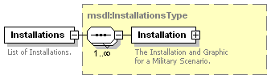
Figure 79: msdl:MilitaryScenarioType/Installations Element Structure

msdl:InstallationsType/Installation Element
For every msdl:InstallationsType complex type there shall be one or more Installation elements. An Installation description is tactical information that is part of the Common Operational Picture (COP) of the force, side, or unit specified in the Owner element. Its level of threat as determined through intelligence gathering is specified in the Affliation and FrameShapeModifier elements. The quality of the gathered intelligence used to create this tactical information is specified in the EvaluationRating element. The time when the information was gathered is specified in the DateTimeGroup element. This tactical information is organized within the COP through the overlays specified in the AssociatedOverlays element. Each COP (one or more per opposing side) may have its own Installation description for the same actual Installation. The Installation element, an xs:all compositor, specifies the installations within the military scenario document and is show in Figure 80. The domain type is msdl:InstallationType.
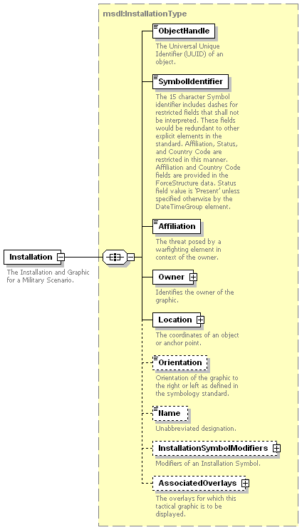
Figure 80: msdl:InstallationsType/Installation Element Structure

msdl:InstallationType/ObjectHandle Element
For every msdl:InstallationType complex type there shall be one ObjectHandle element. The ObjectHandle element specifies the UUID of the Installation. The domain type is a msdl:patternUUID32.

msdl:InstallationType/SymbolIdentifier Element
For every msdl:InstallationType complex type there shall be one SymbolIdentifier element. The SymbolIdentifier element specifies the 15 character symbol identifier as specified by the Symbol Identification Coding scheme within Mil Std 2525B. The 15 character SymbolIdentifier includes dashes for restricted fields that shall not be interpreted. These fields would be redundant to other explicit elements in the standard. Affiliation, Status, and Country Code are restricted in this manner. Affiliation and Country Code fields are provided in the ForceSide structure data. Status field value is ‘Present’ unless specified otherwise by the DateTimeGroup element. The Coding Scheme, position 1, shall be ‘S’ for installation symbol identification. The domain type is a msdl:patternInstallationSymbolID15.

msdl:InstallationType/Affiliation Element
For every msdl:InstallationType complex type there shall be one Affiliation element. The Affiliation element specifies the threat posed by a warfighting element being represented in context to the owner. The domain type is msdl:enumBaseAffiliation.

msdl:InstallationType/Owner Element
For every msdl:InstallationType complex type there shall be one Owner element. The Owner element specifies the owner of the graphic. The domain type is msdl:OwnerType as defined within section 6.5.2.1.7 for msdl:EquipmentRelationsType/HoldingOrganization.

msdl:InstallationType/Location Element
For every msdl:InstallationType complex type there shall be one Location element. The Location element specifies the coordinates of the unit. The domain type is msdl:CoordinatesType as defined within section 6.3.2.2 for msdl:RectangleAreaType/UpperRight.

msdl:InstallationType/Orientation Element
For every msdl:InstallationType complex type there shall be one Orientation element. The Orientation element specifies the orientation of the graphic to the right or left as defined in the symbology standard. The domain type is msdl:enumOrientationType.

msdl:InstallationType/Name Element
For every msdl:InstallationType complex type there shall be zero or one Name element. The Name element specifies the unabbreviated designation of the Installation. The domain type is msdl:textName255.

msdl:InstallationType/InstallationSymbolModifiers Element
For every msdl:InstallationType complex type there shall be zero or one InstallationSymbolModifiers element. The InstallationSymbolModifiers element specifies the modifiers of an equipment symbol. It is an xs:all compositor comprised of the elements shown in Figure 81 and described in the following subsections. The domain type is msdl:InstallationSymbolModifiersType.
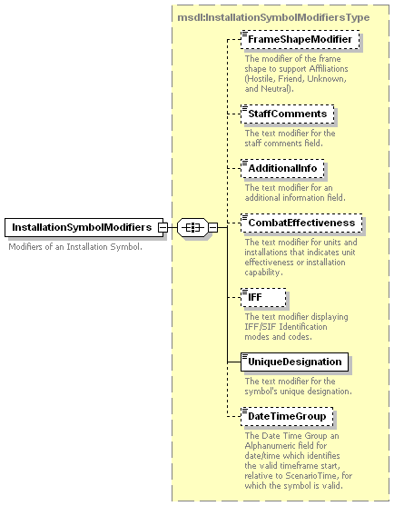
Figure 81: msdl:InstallationType/InstallationSymbolModifiers Element Structure

msdl:InstallationSymbolModifiersType/FrameShapeModifier Element
For every msdl:InstallationSymbolModifiersType complex type there shall be zero or one FrameShapeModifier element. The FrameShapeModifier element specifies the modifier of the frame shape to support affiliations beyond hostile, friend, unknown, and neutral. The domain type is a msdl:enumFrameShapeModifierType.

msdl:InstallationSymbolModifiersType/StaffComments Element
For every msdl:InstallationSymbolModifiersType complex type there shall be zero or one StaffComments element. The StaffComments element specifies the text modifier for staff comments field. The domain type is msdl:text20.

msdl:InstallationSymbolModifiersType/AdditionalInfo Element
For every msdl:InstallationSymbolModifiersType complex type there shall be zero or one AdditionalInfo element. The AdditionalInfo element specifies the text modifier for an additional information field. The domain type is msdl:text20.

msdl:InstallationSymbolModifiersType/CombatEffectiveness Element
For every msdl:InstallationSymbolModifiersType complex type there shall be zero or one CombatEffectiveness elements. The CombatEffectiveness element specifies the modifier that indicates the installation’s level of capability. The domain type is msdl:enumCombatEffectivenessType.

msdl:InstallationSymbolModifiersType/IFF Element
For every msdl:InstallationSymbolModifiersType complex type there shall be zero or one IFF element. The IFF element specifies the text modifier displaying IFF/SIF identification modes and codes. The domain type is msdl:textIFF5.

msdl:InstallationSymbolModifiersType/UniqueDesignation Element
For every msdl:InstallationSymbolModifiersType complex type there shall be one UniqueDesignation element. The UniqueDesignation element specifies the text modifier for the symbols unique designation. The domain type is msdl:text21.

msdl:InstallationSymbolModifiersType/DateTimeGroup Element
For every msdl:InstallationSymbolModifiersType complex type there shall be zero or one DateTimeGroup element. The DateTimeGroup element specifies the date time group relative to the ScenarioTime element from which a symbol is valid. The domain type is msdl:patternTimeDTGRelative20.

msdl:InstallationType/AssociatedOverlays Element
For every msdl:InstallationType complex type there shall be one AssociatedOverlays element. The AssociatedOverlays element specifies the overlays for which this tactical graphic is to be displayed. It is an xs:all compositor comprised of the elements shown in Figure 82 and described in the following subsections. The domain type is msdl:AssociatedOverlaysType.
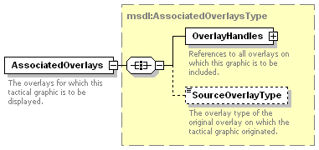
Figure 82: msdl:InstallationType/AssociatedOverlays Element Structure

msdl:AssociatedOverlaysType/OverlayHandles Element
For every msdl:AssociatedOverlaysType complex type there shall be one OverlayHandles elements. The OverlayHandles element specifies a reference to all overlays which this graphic is to be included on. It is an xs:sequence compositor comprised of the elements shown in Figure 83 and described in the following subsections. The domain type is msdl:OverlayHandlesType.
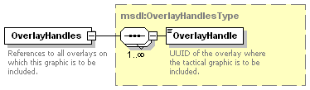
Figure 83: msdl:AssociatedOverlaysType/OverlayHandles Element Structure
- msdl:OverlayHandlesType/OverlayHandle Element - For every msdl:OverlayHandlesType complex type there shall be one or more OverlayHandle element. The OverlayHandle element specifies the UUID of the overlay where the tactical graphic is to be included. The domain type is msdl:patternUUIDRef32.

msdl:AssociatedOverlaysType/SourceOverlayType Element
For every msdl:AssociatedOverlaysType complex type there shall be zero or one SourceOverlayType elements. The SourceOverlayType element specifies the overlay type of the original overlay on which the tactical graphic originated. The domain type is msdl:enumOverlayType.

msdl:MilitaryScenarioType/TacticalGraphics Element
For every msdl:MilitaryScenarioType complex type there shall be zero or one TacticalGraphics element. The TacticalGraphics element is used to specify the control measures for the military scenario. The TacticalGraphics element, an xs:sequence compositor, contains all the elements shown in Figure 84 and described in the subsequent subsections. The domain type is msdl:TacticalGraphicsType.
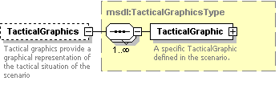
Figure 84: msdl:MilitaryScenarioType/TacticalGraphics Element Structure

msdl:TacticalGraphicsType/TacticalGraphic Element
For every msdl:TacticalGraphicsType complex type there shall be one or more TacticalGraphic elements. The TacticalGraphic element is used to specify the mission/scenario specific control measures within the military scenario. A tactical graphic description is tactical information that is part of the COP of the force, side or unit specified in the Owner element. Its level of threat as determined through intelligence gathering is specified in the Affiliation and FrameShapeModifier elements. The quality of the gathered intelligence used to create this tactical information is specified in the EvaluationRating element. The time when the information was gathered is specified in the DateTimeGroup element.This tactical information is organized within the COP through the overlays specified in the AssociatedOverlays element. The TacticalGraphic element, an xs:all compositor, is comprised of an xs:sequence structure containing all the elements shown in Figure 85 and described in the subsequent subsections. The domain type is msdl:TacticalGraphicType.
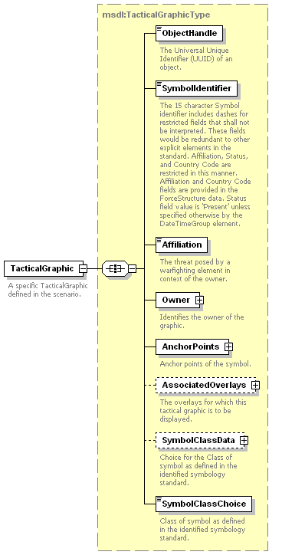
Figure 85: msdl:TacticalGraphicsType/TacticalGraphic Element Structure

msdl:TacticalGraphicType/ObjectHandle Element
For every msdl:TacticalGraphicType complex type there shall be one ObjectHandle element. The ObjectHandle element specifies the UUID of the TacticalGraphic. The domain type is a msdl:patternUUID32.

msdl:TacticalGraphicType/SymbolIdentifier Element
For every msdl:TacticalGraphicType complex type there shall be one SymbolIdentifier element. The SymbolIdentifier element specifies the 15 character symbol identifier as specified by the Symbol Identification Coding scheme within Mil Std 2525B. The 15 character SymbolIdentifier includes dashes for restricted fields that shall not be interpreted. These fields would be redundant to other explicit elements in the standard. Affiliation, Status, and Country Code are restricted in this manner. Affiliation and Country Code fields are provided in the ForceSide structure data. Status field value is ‘Present’ unless specified otherwise by the DateTimeGroup element. The Coding Scheme, position 1, shall be ‘G’ for tactical graphic symbol identification. The domain type is a msdl:patternTacticalGraphicSymbolID15.

msdl:TacticalGraphicType/Affiliation Element
For every msdl:TacticalGraphicType complex type there shall be one Affiliation element. The Affiliation element specifies the threat posed by a warfighting element being represented in context to the owner. The domain type is msdl:enumBaseAffiliation.

msdl:TacticalGraphicType/Owner Element
For every msdl:TacticalGraphicType complex type there shall be one Owner element. The Owner element specifies the owner of the graphic. The domain type is msdl:OwnerType as defined within section 6.5.2.1.7 for msdl:EquipmentRelationsType/HoldingOrganization.

msdl:TacticalGraphicType/AnchorPoints Element
For every msdl:TacticalGraphicType complex type there shall be one AnchorPoints element. The AnchorPoints element specifies the anchor points for the tactical graphic. The shape for each specific tactical graphic is specified within Appendix B: C2 Symbology: Military Operations of MIL-STD-2525B w/Change 1. Area shapes will be interpreted to define a boundary in the sequence provided by the associated AnchorPoint elements. The domain type is msdl:AnchorPointsType as defined within section 6.3.4.1.8 for msdl:METOCDispositionType/AnchorPoints.

msdl:TacticalGraphicType/AssociatedOverlays Element
For every msdl:TacticalGraphicType complex type there shall be zero or one AssociatedOverlays element. The AssociatedOverlays element specifies the overlays for which this tactical graphic is to be displayed. The domain type is msdl:AssociatedOverlaysType as defined within section 6.7.1.9 for msdl:InstallationType/AssociatedOverlays.

msdl:TacticalGraphicType/SymbolClassData Element
For every msdl:TacticalGraphicType complex type there shall be zero or one SymbolClassData element. The SymbolClassData element characterizes the class of symbol as defined in the selected symbology standard. The selection is derived from the value of position 1 and position 5 to 10 in the SymbolIdentifier element. It is an xs:choice compositor comprised one and only one of the elements shown in Figure 86 and described in the following subsections. The domain type is msdl:SymbolClassDataType.
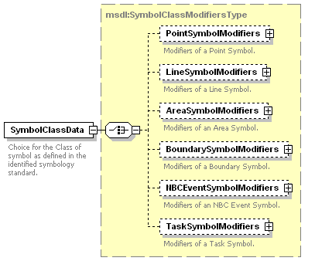
Figure 86: msdl:TacticalGraphicType/SymbolClassData Element Structure

msdl:SymbolClassDataType/PointSymbolModifiers Element
For every msdl:SymbolClassDataType complex type there shall be zero or one PointSymbolModifiers element. The PointSymbolModifiers element specifies the modifiers for a point symbol. It is an xs:all compositor comprised of the elements shown in Figure 87 and described in the following subsections. The domain type is msdl:PointSymbolModifiersType.
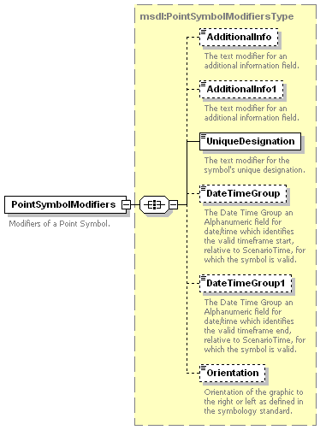
Figure 87: msdl:SymbolClassDataType/PointSymbolModifiers Element Structure
- msdl:PointSymbolModifiersType/AdditionalInfo Element - For every msdl:PointSymbolModifiersType complex type there shall be zero or one AdditionalInfo element. The AdditionalInfo element specifies the text modifier for an additional information field. The domain type is msdl:text20.
- msdl:PointSymbolModifiersType/AdditionalInfo1 Element - For every msdl:PointSymbolModifiersType complex type there shall be zero or one AdditionalInfo element. The AdditionalInfo1 element specifies the text modifier for an additional information field. The domain type is msdl:text20.
- msdl:PointSymbolModifiersType/UniqueDesignation Element - For every msdl:PointSymbolModifiersType complex type there shall be one UniqueDesignation element. The UniqueDesignation element specifies the text modifier for the symbols unique designation. The domain type is msdl:text21.
- msdl:PointSymbolModifiersType/DateTimeGroup Element - For every msdl:PointSymbolModifiersType complex type there shall be zero or one DateTimeGroup element. This element provides the character string representing the time frame start, relative to the ScenarioTime, for which the TacticalGraphic element is valid. The DateTimeGroup element allows multiple stages of a phenomenon to be specified. The UniqueDesignation element is used to link together these different stages. The ObjectHandle of the stages will be different but the UniqueDesignation will be the same. Because DateTimeGroup and DateTimeGroup1 represent the time frame of existance for the specific TacticalGraphic element if either one is specified the other shall also be included in the instance document. The domain type is msdl:patternTimeDTGRelative20.
- msdl:PointSymbolModifiersType/DateTimeGroup1 Element - For every msdl:PointSymbolModifiersType complex type there shall be zero or one DateTimeGroup1 element. This element provides the character string representing the time frame end, relative to the ScenarioTime, for which the TacticalGraphic element is valid. The DateTimeGroup1 element allows multiple stages of a phenomenon to be specified. The UniqueDesignation element is used to link together these different stages. The ObjectHandle of the stages will be different but the UniqueDesignation will be the same. Because DateTimeGroup and DateTimeGroup1 represent the time frame of existance for the specific TacticalGraphic element if either one is specified the other shall also be included in the instance document. The domain type is msdl:patternTimeDTGRelative20.
- msdl:PointSymbolModifiersType/Orientation Element - For every msdl:PointSymbolModifiersType complex type there shall be zero or one Orientation element. The Orientation element specifies the orientation of the graphic to the right or left as defined in the symbology standard. The domain type is msdl:enumOrientationType.

msdl:SymbolClassDataType/LineSymbolModifiers Element
For every msdl:SymbolClassDataType complex type there shall be zero or one LineSymbolModifiers element. The LineSymbolModifiers element specifies the modifiers for a line symbol. It is an xs:all compositor comprised of the elements shown in Figure 88 and described in the following subsections. The domain type is msdl:LineSymbolModifiersType.
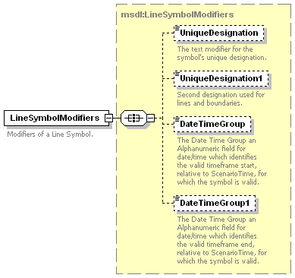
Figure 88: msdl:SymbolClassDataType/LineSymbolModifiers Element Structure
- msdl:LineSymbolModifiersType/UniqueDesignation Element - For every msdl:LineSymbolModifiersType complex type there shall be zero or one UniqueDesignation element. The UniqueDesignation element specifies the text modifier for the symbols unique designation. The domain type is msdl:text21.
- msdl:LineSymbolModifiersType/UniqueDesignation1 Element - For every msdl:LineSymbolModifiersType complex type there shall be be zero or one UniqueDesignation1 element. The UniqueDesignation1 element specifies a second text modifier for the symbol’s unique designation for lines and boundaries. The domain type is msdl:text21.
- msdl:LineSymbolModifiersType/DateTimeGroup Element - For every msdl:LineSymbolModifiersType complex type there shall be zero or one DateTimeGroup element. This element provides the character string representing the time frame start, relative to the ScenarioTime, for which the TacticalGraphic element is valid. The DateTimeGroup element allows multiple stages of a phenomenon to be specified. The UniqueDesignation element is used to link together these different stages. The ObjectHandle of the stages will be different but the UniqueDesignation will be the same. Because DateTimeGroup and DateTimeGroup1 represent the time frame of existance for the specific TacticalGraphic element if either one is specified the other shall also be included in the instance document. The domain type is msdl:patternTimeDTGRelative20.
- msdl:LineSymbolModifiersType/DateTimeGroup1 Element - For every msdl:LineSymbolModifiersType complex type there shall be zero or one DateTimeGroup1 element. This element provides the character string representing the time frame end, relative to the ScenarioTime, for which the TacticalGraphic element is valid. The DateTimeGroup1 element allows multiple stages of a phenomenon to be specified. The UniqueDesignation element is used to link together these different stages. The ObjectHandle of the stages will be different but the UniqueDesignation will be the same. Because DateTimeGroup and DateTimeGroup1 represent the time frame of existance for the specific TacticalGraphic element if either one is specified the other shall also be included in the instance document. The domain type is msdl:patternTimeDTGRelative20.

msdl:SymbolClassDataType/AreaSymbolModifiers Element
For every msdl:SymbolClassDataType complex type there shall be zero or one AreaSymbolModifiers element. The AreaSymbolModifiers element specifies the modifiers for an area symbol. It is an xs:all compositor comprised of the elements shown in Figure 89 and described in the following subsections. The domain type is msdl:AreaSymbolModifiersType.
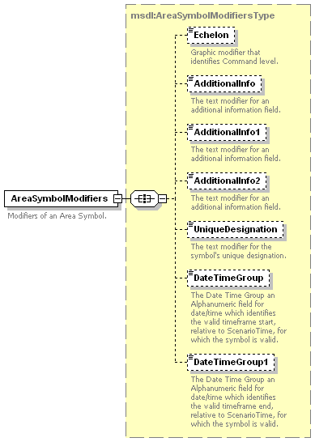
Figure 89: msdl:SymbolClassDataType/AreaSymbolModifiers Element Structure
- msdl:AreaSymbolModifiersType/Echelon Element - For every msdl:AreaSymbolModifiersType complex type there shall be zero or one Echelon elements. The Echelon element specifies the graphic modifier that identifies command level. The domain type is msdl:enumEchelon.
- msdl:AreaSymbolModifiersType/AdditionalInfo Element - For every msdl:AreaSymbolModifiersType complex type there shall be zero or one AdditionalInfo element. The AdditionalInfo element specifies the text modifier for an additional information field. The domain type is msdl:text20.
- msdl:AreaSymbolModifiersType/AdditionalInfo1 Element - For every msdl:AreaSymbolModifiersType complex type there shall be zero or one AdditionalInfo1 element. The AdditionalInfo1 element specifies the text modifier for an additional information field. The domain type is msdl:text20.
- msdl:AreaSymbolModifiersType/AdditionalInfo2 Element - For every msdl:AreaSymbolModifiersType complex type there shall be zero or one AdditionalInfo2 element. The AdditionalInfo2 element specifies the text modifier for an additional information field. The domain type is msdl:text20.
- msdl:AreaSymbolModifiersType/UniqueDesignation Element - For every msdl:AreaSymbolModifiersType complex type there shall be zero or one UniqueDesignation element. The UniqueDesignation element specifies the text modifier for the symbols unique designation. The domain type is msdl:text21.
- msdl:AreaSymbolModifiersType/DateTimeGroup Element - For every msdl:AreaSymbolModifiersType complex type there shall be zero or one DateTimeGroup element. This element provides the character string representing the time frame start, relative to the ScenarioTime, for which the TacticalGraphic element is valid. The DateTimeGroup element allows multiple stages of a phenomenon to be specified. The UniqueDesignation element is used to link together these different stages. The ObjectHandle of the stages will be different but the UniqueDesignation will be the same. Because DateTimeGroup and DateTimeGroup1 represent the time frame of existance for the specific TacticalGraphic element if either one is specific the other shall also be included in the instance document. The domain type is msdl:patternTimeDTGRelative20.
- msdl:AreaSymbolModifiersType/DateTimeGroup1 Element - For every msdl:AreaSymbolModifiersType complex type there shall be zero or one DateTimeGroup1 element. This element provides the character string representing the time frame end, relative to the ScenarioTime, for which the TacticalGraphic element is valid. The DateTimeGroup1 element allows multiple stages of a phenomenon to be specified. The UniqueDesignation element is used to link together these different stages. The ObjectHandle of the stages will be different but the UniqueDesignation will be the same. Because DateTimeGroup and DateTimeGroup1 represent the time frame of existance for the specific TacticalGraphic element if either one is specified the other shall also be included in the instance document. The domain type is msdl:patternTimeDTGRelative20.

msdl:SymbolClassDataType/BoundarySymbolModifiers Element
For every msdl:SymbolClassDataType complex type there shall be zero or one BoundarySymbolModifiers element. The BoundarySymbolModifiers element specifies the modifiers for a boundary symbol. It is an xs:all compositor comprised of the elements shown in Figure 90 and described in the following subsections. The domain type is msdl:BoundaySymbolModifiersType.
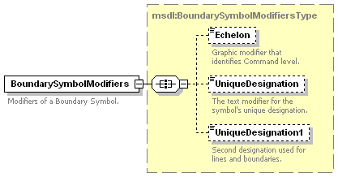
Figure 90: msdl:SymbolClassDataType/BoundarySymbolModifiers Element Structure
- msdl:BoundarySymbolModifiersType/Echelon Element - For every msdl:BoundarySymbolModifiersType complex type there shall be zero or one Echelon elements. The Echelon element specifies the graphic modifier that identifies command level. The domain type is msdl:enumEchelon.
- msdl:BoundarySymbolModifiersType/UniqueDesignation Element - For every msdl:BoundarySymbolModifiersType complex type there shall be zero or one UniqueDesignation element. The UniqueDesignation element specifies the text modifier for the symbols unique designation. The domain type is msdl:text21.
- msdl:BoundarySymbolModifiersType/UniqueDesignation1 Element - For every msdl:BoundarySymbolModifiersType complex type there shall be zero or one UniqueDesignation1 element. The UniqueDesignation1 element specifies the text modifier for the symbols unique designation. The domain type is msdl:text21.

msdl:SymbolClassDataType/NBCEventSymbolModifiers Element
For every msdl:SymbolClassDataType complex type there shall be zero or one NBCEventSymbolModifiers element. The NBCEventSymbolModifiers element specifies the modifiers for a NBC Event symbol. It is an xs:all compositor comprised of the elements shown in Figure 91 and described in the following subsections. The domain type is msdl:NBCEventSymbolModifiersType.
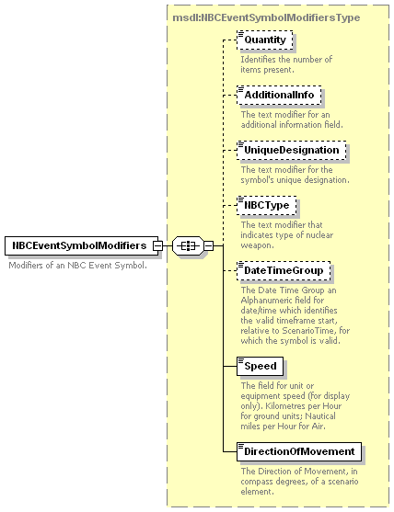
Figure 91: msdl:SymbolClassModifierType/NBCEventSymbolModifiers Element Structure
- msdl:NBCEventSymbolModifiersType/Quantity Element - For every msdl:NBCEventSymbolModifiersType complex type there shall be zero or one Quantity elements. The Quantity element specifies the modifier that identifies the number of items present. The domain type is msdl:integerQuantity9.
- msdl:NBCEventSymbolModifiersType/AdditionalInfo Element - For every msdl:NBCEventSymbolModifiersType complex type there shall be zero or one AdditionalInfo element. The AdditionalInfo element specifies the text modifier for an additional information field. The domain type is msdl:text20.
- msdl:NBCEventSymbolModifiersType/UniqueDesignation Element - For every msdl:NBCEventSymbolModifiersType complex type there shall be zero or one UniqueDesignation element. The UniqueDesignation element specifies the text modifier for the symbols unique designation. The domain type is msdl:text21.
- msdl:NBCEventSymbolModifiersType/NBCType Element - For every msdl:NBCEventSymbolModifiersType complex type there shall be zero or one NBCType element. The NBCType element specifies the text for the type of nuclear, biological, or chemical weapon. The domain type is msdl:text20.
- msdl:NBCEventSymbolModifiersType/DateTimeGroup Element - For every msdl:NBCEventSymbolModifiersType complex type there shall be zero or one DateTimeGroup element. The DateTimeGroup element specifies the date time group start time relative to the ScenarioTime from which a symbol is valid. The domain type is msdl:patternTimeDTGRelative20.
- msdl:NBCEventSymbolModifiersType/Speed Element - For every msdl:NBCEventSymbolModifiersType complex type there shall be zero or one Speed element. The Speed element specifies the rate of movement of the item represented by the graphic in the direction specified by the DirectionOfMovement element. The domain type is msdl:floatSpeed6_2.
- msdl:NBCEventSymbolModifiersType/DirectionOfMovement Element - For every msdl:NBCEventSymbolModifiersType complex type there shall be one DirectionOfMovement element. The DirectionOfMovement element specifies the horizontal direction of movement or intended direction of horizontal movement in compass degrees measured relative to magnetic north 0 to 360 degrees clockwise. For reference trigonometric degrees = (90 – compass degrees). The domain type is msdl:floatCompassDegrees3_3.

msdl:SymbolClassDataType/TaskSymbolModifiers Element
For every msdl:SymbolClassDataType complex type there shall be zero or one TaskSymbolModifiers element. The TaskSymbolModifiers element specifies the modifiers for a task symbol. It is an xs:all compositor comprised of the elements shown in Figure 92 and described in the following subsections. The domain type is msdl:TaskSymbolModifiersType.
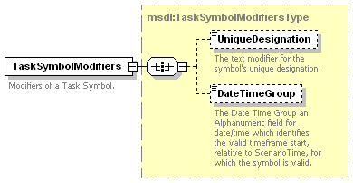
Figure 92: msdl:SymbolClassDataType/TaskSymbolModifiers Element Structure
- msdl:TaskSymbolModifiersType/UniqueDesignation Element - For every msdl:TaskSymbolModifiersType complex type there shall be be zero or one UniqueDesignation element. The UniqueDesignation element specifies the text modifier for the symbols unique designation. The domain type is msdl:text21.
- msdl:TaskSymbolModifiersType/DateTimeGroup Element - For every msdl:TaskSymbolModifiersType complex type there shall be zero or one DateTimeGroup element. The DateTimeGroup element specifies the date time group start time relative to the ScenarioTime from which a symbol is valid. The domain type is msdl:patternTimeDTGRelative20.

msdl:TacticalGraphicType/SymbolClassChoice Element
For every msdl:TacticalGraphicType complex type there shall be one SymbolClassChoice element. The SymbolClassChoice element specifies the class of symbol as defined in the identified symbology standard. The domain type is msdl:enumSymbolClassType.

msdl:MilitaryScenarioType/MOOTWGraphics Element
For every msdl:MilitaryScenarioType complex type there shall be one MOOTWGraphics element. The MOOTWGraphics element is used to specify the MOOTW graphics for the military scenario. The MOOTWGraphics element, an xs:sequence compositor, contains all the elements shown in Figure 93 and described in the subsequent subsections. The domain type is msdl:MOOTWGraphicsType.
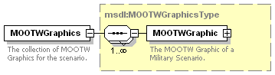
Figure 93: msdl:MilitaryScenarioType/MOOTWGraphics Element Structure

msdl:MOOTWGraphicsType/MOOTWGraphic Element
For every msdl:MOOTWGraphicsType complex type there shall be one or more MOOTWGraphic elements. The MOOTWGraphic element is used to specify the MOOTW graphics within the military scenario. A MOOTW graphic description is tactical information that is part of the COP of the force, side or unit specified in the owner element. Its level of threat as determined through intelligence gathering is specified in the Affiliation and FrameShapeModifier elements. The quality of the gathered intelligence used to create this tactical information is specified in the EvaluationRating element. The time when the information was gathered is specified in the DateTimeGroup element. This tactical information is organized within the COP through the overlays specified in the AssociatedOverlays element. Each COP (one or more per opposing sides) may have its own MOOTW instance description for the same actual MOOTW instance. The MOOTWGraphic element, an xs:sequence compositor, contains all the elements shown in Figure 94 and described in the subsequent subsections. The domain type is msdl:MOOTWGraphicType.
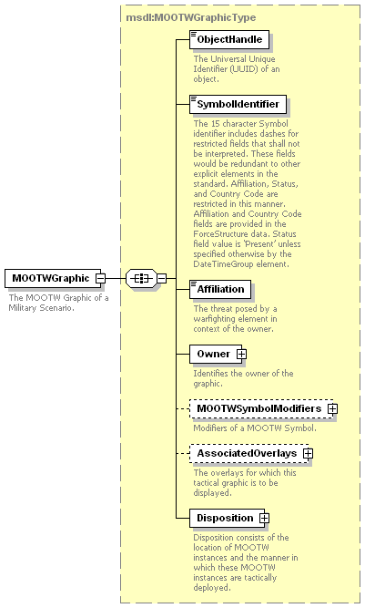
Figure 94: msdl:MOOTWGraphicsType/MOOTWGraphic Element Structure

msdl:MOOTWGraphicType/ObjectHandle Element
For every msdl:MOOTWGraphicType complex type there shall be one ObjectHandle element. The ObjectHandle element specifies the UUID of the MOOTWGraphic. The domain type is a msdl:patternUUID32.

msdl:MOOTWGraphicType/SymbolIdentifier Element
For every msdl:MOOTWGraphicType complex type there shall be one SymbolIdentifier element The SymbolIdentifier element specifies the 15 character symbol identifier as specified by the Symbol Identification Coding scheme within Mil Std 2525B. The 15 character SymbolIdentifier includes dashes for restricted fields that shall not be interpreted. These fields would be redundant to other explicit elements in the standard. Affiliation, Status, and Country Code are restricted in this manner. Affiliation and Country Code fields are provided in the ForceSide structure data. Status field value is ‘Present’ unless specified otherwise by the DateTimeGroup element. The Coding Scheme, position 1, shall be ‘O’ form MOOTW symbol identification. The domain type is a msdl:patternMOOTWSymbolID15.

msdl:MOOTWGraphicType/Affiliation Element
For every msdl:MOOTWGraphicType complex type there shall be one Affiliation element. The Affiliation element specifies the threat posed by a warfighting element being represented in context to the owner. The domain type is msdl:enumBaseAffiliation.

msdl:MOOTWGraphicType/Owner Element
For every msdl:MOOTWGraphicType complex type there shall be one Owner element. The Owner element specifies the owner of the graphic. The domain type is msdl:OwnerType as defined within section 6.5.2.1.7 for msdl:EquipmentRelationsType/HoldingOrganization.

msdl:MOOTWGraphicType/MOOTWsymbolModifiers Element
For every msdl:MOOTWGraphicType complex type there shall be zero or one MOOTWSymbolModifiers element. The MOOTWSymbolModifiers element specifies the modifiers of a MOOTW symbol. It is an xs:all compositor comprised of the elements shown in Figure 95 and described in the following subsections. The domain type is msdl:MOOTWSymbolModifiersType.

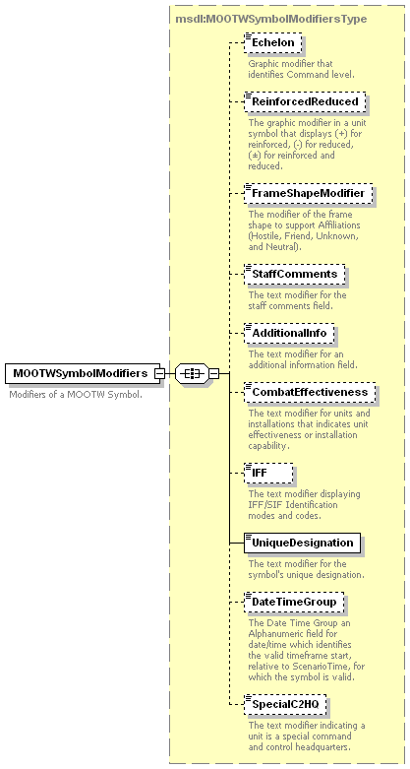
Figure 95: msdl:MOOTWGraphicType/MOOTWSymbolModifiers Element Structure

msdl:MOOTWSymbolModifiersType/Echelon Element
For every msdl:MOOTWSymbolModifiersType complex type there shall be zero or one Echelon elements. The Echelon element specifies the graphic modifier that identifies command level. The domain type is msdl:enumEchelon.

msdl:MOOTWSymbolModifiersType/ReinforcedReduced Element
For every msdl:MOOTWSymbolModifiersType complex type there shall be zero or one ReinforcedReduced element. This element specifies, through an enumeration, whether a unit has been reinforced with assets from another organization, reduced by giving assets to another organization, or has received assets from another organization and has given some assets to another organization. The domain type is msdl:enumReinforcedReducedType.

msdl:MOOTWSymbolModifiersType/FrameShapeModifier Element
For every msdl:MOOTWSymbolModifiersType complex type there shall be zero or one FrameShapeModifier element. The FrameShapeModifier element specifies the modifier of the frame shape to support affiliations beyond hostile, friend, unknown, and neutral. The domain type is msdl:enumFrameShapeModifierType.

msdl:MOOTWSymbolModifiersType/StaffComments Element
For every msdl:MOOTWSymbolModifiersType complex type there shall be zero or one StaffComments element. The StaffComments element specifies the text modifier for staff comments field. The domain type is msdl:text20.

msdl:MOOTWSymbolModifiersType/AdditionalInfo Element
For every msdl:MOOTWSymbolModifiersType complex type there shall be zero or one AdditionalInfo element. The AdditionalInfo element specifies the text modifier for an additional information field. The domain type is msdl:text20.

msdl:MOOTWSymbolModifiersType/CombatEffectiveness Element
For every msdl:MOOTWSymbolModifiersType complex type there shall be zero or one CombatEffectiveness elements. The CombatEffectiveness element specifies the text modifier that indicates the ability of a MOOTW instance to perform its mission. Factors such as ammunition, personnel, status of fuel, and weapons systems may be included in the assessment. The domain type is msdl:enumCombatEffectivenessType.

msdl:MOOTWSymbolModifiersType/IFF Element
For every msdl:MOOTWSymbolModifiersType complex type there shall be zero or one IFF element. The IFF element specifies the text modifier displaying IFF/SIF identification modes and codes. The domain type is msdl:textIFF5.

msdl:MOOTWSymbolModifiersType/UniqueDesignation Element
For every msdl:MOOTWSymbolModifiersType complex type there shall be one UniqueDesignation element. The UniqueDesignation element specifies the text modifier for the symbols unique designation. The domain type is msdl:text21.

msdl:MOOTWSymbolModifiersType/DateTimeGroup Element
For every msdl:MOOTWSymbolModifiersType complex type there shall be zero or one DateTimeGroup element. The DateTimeGroup element specifies the date time group start time relative to the ScenarioTime from which a symbol is valid. The domain type is msdl:patternTimeDTGRelative20.

msdl:MOOTWSymbolModifiersType/SpecialC2HQ Element
For every msdl:MOOTWSymbolModifiersType complex type there shall be zero or one SpecialC2HQ element. The SpecialC2HQ element specifies the text modifier for units, that indicates a unit is a special command and control headquarters. The domain type is msdl:textSpecialC2HQ9.

msdl:MOOTWGraphicType/AssociatedOverlays Element
For every msdl:MOOTWGraphicType complex type there shall be zero or one AssociatedOverlays element. The AssoicatedOverlays element specifies the overlays to which the tactical graphic is to be displayed. The domain type is msdl:AssociatedOverlaysType as defined within section 6.7.1.9 for msdl:InstallationType/AssociatedOverlays.

msdl:MOOTWGraphicType/Disposition Element
For every msdl:MOOTWGraphicType complex type there shall be one Disposition element. The Disposition element specifies the location of MOOTW instances and the manner in which these MOOTW instances are tactically deployed. It is an xs:all compositor comprised of the elements shown in Figure 96 and described in the following subsections. The domain type is msdl:MOOTWDispositionType.
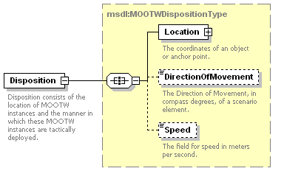
Figure 96: msdl:MOOTWGraphicType/Disposition Element Structure

msdl:MOOTWDispositionType/Location
For every msdl:MOOTWDispositionType complex type there shall be one Location element. This element provides the coordinates of the MOOTWGraphic. The domain type is msdl:CoordinatesType as defined within section 6.3.2.2 for msdl:RectangleAreaType/UpperRight.

msdl:MOOTWDispositionType/DirectionOfMovement
For every msdl:MOOTWDispositionType complex type there shall be zero or one DirectionOfMovement element. The DirectionOfMovement element specifies the horizontal direction of movement in compass degrees, measured relative to magnetic north 0 to 360 degrees clockwise, of the item identified by the MOOTW graphic. For reference trigonometric degrees = (90 – compass degrees). The domain type is msdl:floatCompassDegrees3_3.

msdl:MOOTWDispositionType/Speed
For every msdl:MOOTWDispositionType complex type there shall be zero or one Speed element. The Speed element specifies the rate of movement of the item identified by the MOOTW graphic in the direction specified by the msdl:DirectionOfMovement element. The domain type is msdl:floatSpeed6_2.

Data Types
Within MSDL reuseable simple and complex data types are offered through the use of XML data type declarations. This section specifies the current set of complex and simple data types that have not already been defined in use by the previously defined element declarations. Additional data types will be added as MSDL is extended through active use as will specific element declarations that extend or restrict specific data types. Restricting or extending data types will enable configuration management to control and integrate extensions to the MSDL specification.

Simple Type msdl:enumAirFormationType
namespace | urn:sisostds:scenario:military:data:draft:msdl:1
type | restriction of xs:string
used by
  element | msdl:FormationDataType/AirFormationType
facets
  enumeration | NOT_SPECIFIED
annotation
  documentation | The formation of air (aviation) elements. Additional enumerations will be added as MSDL evolves.

Simple Type msdl:enumAnchorPointType
namespace | urn:sisostds:scenario:military:data:draft:msdl:1
type | restriction of xs:string
used by
  element | msdl:AnchorPointType/AnchorChoice
facets
  enumeration | COORDINATE
  enumeration | POINT_TACTICAL_GRAPHIC
annotation
  documentation | Enumerated choice of an absolute Coordinate or point graphic as a location reference

Simple Type msdl:enumBaseAffiliation
namespace | urn:sisostds:scenario:military:data:draft:msdl:1
type | restriction of xs:string
used by
  elements | msdl:InstallationType/Affiliation  msdl:TacticalGraphicType/Affiliation
Facets
  enumeration | HOSTILE
  enumeration | FRIEND
  enumeration | NEUTRAL
  enumeration | UNKNOWN
Annotation
  documentation | Enumerated values for the base affiliation..

Simple Type msdl:enumCombatEffectivenessType
namespace | urn:sisostds:scenario:military:data:draft:msdl:1
type | restriction of xs:string
used by
  elements | msdl:EquipmentSymbolModifiersType/CombatEffectiveness msdl:InstallationSymbolModifiersType/CombatEffectiveness msdl:MOOTWSymbolModifiersType/CombatEffectiveness msdl:UnitSymbolModifiersType/CombatEffectiveness
facets
  enumeration | GREEN
  enumeration | AMBER
  enumeration | RED
  enumeration | BLACK
  enumeration | WHITE
annotation
  documentation | The text modifier for units and installations that indicates unit effectiveness or installation  capability. The color to percent strength association is as follows:  GREEN: 85 percent strength (combat capable);  AMBER: 70 to 84 percent strength (combat capable with minor deficiencies);  RED: 50 to 69 percent strength (combat ineffective, unit has major losses or deficiencies);  BLACK: Less that 50 percent strength (requires reconstitution before next mission);  WHITE: Not applicable or no information available.

Simple Type msdl:enumCommandRelationshipType
namespace | urn:sisostds:scenario:military:data:draft:msdl:1
type | restriction of xs:string
used by
  element | msdl:CommandRelationType/CommandRelationshipType
facets
  enumeration | ORGANIC
  enumeration | ATTACHED
  enumeration | OPCON
  enumeration | TACON
  enumeration | ADCON
  enumeration | NONE
annotation
  documentation | Enumerated choice for the type of command under which the unit has been task organized as taken from FM 100-7 'The Army In Theater Operations'

Simple Type msdl:enumCommunicationNetType
namespace | urn:sisostds:scenario:military:data:draft:msdl:1
type | restriction of xs:string
used by
  element | msdl:CommunicationNetInstanceType/CommunicationNetType
facets
  enumeration | OTHER
  enumeration | COMMAND_NET
  enumeration | OPERATIONS_INTELLIGENCE_NET
  enumeration | ADMIN_LOGISTICS_NET
  enumeration | FIRE_SUPPORT_NET
annotation
  documentation | The typical list of Communications Net Types for Army Units.

Simple Type msdl:enumCommunicationServiceType
namespace | urn:sisostds:scenario:military:data:draft:msdl:1
type | restriction of xs:string
used by
  element | msdl:CommunicationNetInstanceType/CommunicationService
facets
  enumeration | DATTRF
  enumeration | FAX
  enumeration | IIF
  enumeration | IMAGE
  enumeration | MCI
  enumeration | MHS
  enumeration | TDL
  enumeration | VIDSVC
  enumeration | VOCSVC
  enumeration | NOS
annotation
  documentation | The typical list of Communications Net Types for Army Units. The enumerations are defined as follows:  DATTRF: Data transfer  FAX: Facsimile  IFF: Identify Friend or Foe  IMAGE: Image  MCI: Multilateral Interoperability Programme (MIP) Common Interface Service  MHS: Message Handling Service  TDL: Tactical Data Link  VIDSVC: Video Service  VOCSVC:Voice Service  NOS: Not Otherwise Specified

Simple Type msdl:enumCoordinateSystemType
namespace | urn:sisostds:scenario:military:data:draft:msdl:1
type | restriction of xs:string
used by
  elements | msdl:CoordinatesType/CoordinateChoice msdl:CoordinateDataStandardType/CoordinateSystemType
facets
  enumeration | MGRS
  enumeration | GDC
  enumeration | UTM
  enumeration | GCC
annotation
  documentation | Enumerated choice for the type of coordinate as MGRS, GDC, UTM, and GCC.

Simple Type msdl:enumEchelon
namespace | urn:sisostds:scenario:military:data:draft:msdl:1
type | restriction of xs:string
used by
  elements | msdl:OrganizationDetailType/AggregateEchelon msdl:AreaSymbolModifiersType/Echelon msdl:BoundarySymbolModifiersType/Echelon msdl:MOOTWSymbolModifiersType/Echelon msdl:UnitSymbolModifiersType/Echelon
facets
  enumeration | NONE
  enumeration | TEAM
  enumeration | CREW
  enumeration | SQUAD
  enumeration | SECTION
  enumeration | PLATOON
  enumeration | DETACHMENT
  enumeration | COMPANY
  enumeration | BATTERY
  enumeration | TROOP
  enumeration | BATTALION
  enumeration | SQUADRON
  enumeration | REGIMENT
  enumeration | GROUP
  enumeration | BRIGADE
  enumeration | DIVISION
  enumeration | CORPS
  enumeration | ARMY
  enumeration | ARMYGROUP
  enumeration | FRONT
  enumeration | REGION
annotation
  documentation | Graphic modifier that identifies Command level.

Simple Type msdl:enumForceOwnerType
namespace | urn:sisostds:scenario:military:data:draft:msdl:1
type | restriction of xs:string
used by
  elements | msdl:ForceRelationType/ForceRelationChoice msdl:OrganicRelationType/OrganicRelationChoice msdl:OwnerType/OwnerChoice
facets
  enumeration | UNIT
  enumeration | FORCE_SIDE
annotation
  documentation | Enumerated choice for the type of owning organization as a force or unit.

Simple Type msdl:enumFormationLocationType
namespace | urn:sisostds:scenario:military:data:draft:msdl:1
type | restriction of xs:string
used by
  element | msdl:OwnFormationType/FormationLocationType
facets
  enumeration | LEAD_ELEMENT
  enumeration | CENTER_OF_MASS
annotation
  documentation | Enumerated choice for the method used to correlate formation to location as center of mass or lead element. The enumerations are defined as follows:  LEAD_ELEMENT:The unit location represents the location of the formation's lead element, identified by a formation order of 1.  CENTER_OF_MASS: The unit location represents the location of the geographical center.

Simple Type msdl:enumFormationType
namespace | urn:sisostds:scenario:military:data:draft:msdl:1
type | restriction of xs:string
used by
  element | msdl:OwnFormationType/FormationChoice
facets
  enumeration | GROUND
  enumeration | AIR
  enumeration | SURFACE
  enumeration | SUBSURFACE
annotation
  documentation | Enumerated choice for The type of formation being Ground, Air, Surface or Subsurface

Simple Type msdl:enumFrameShapeModifierType
namespace | urn:sisostds:scenario:military:data:draft:msdl:1
type | restriction of xs:string
used by
  element | msdl:InstallationSymbolModifiersType/FrameShapeModifier
  element | msdl:MOOTWSymbolModifiersType/FrameShapeModifier
facets
  enumeration | PENDING
  enumeration | ASSUMED_FRIEND
  enumeration | SUSPECT
  enumeration | EXERCISE_PENDING
  enumeration | EXERCISE_UNKNOWN
  enumeration | EXERCISE_FRIEND
  enumeration | EXERCISE_NEUTRAL
  enumeration | EXERCISE_ASSUMED_FRIEND
  enumeration | JOKER
  enumeration | FAKER
annotation
  documentation | Enumeration values:  PENDING - A unit/system/platform which has not been subjected to the identification process.  ASSUMED_FRIEND - A unit/system/platform assumed to be friendly as a result of the identification process.  SUSPECT - A unit/system/platform suspected to be hostile as a result of the identification process.  EXERCISE_PENDING - unit/system/platform pending the identification process.  EXERCISE_UNKNOWN – A unit/system/platform of unknown affiliation within the context of an exercise.  EXERCISE-FRIEND – A unit/system/platform of friendly affiliation within the context of an exercise.  EXERCISE-NEUTRAL – A unit/system/platform of neutral affiliation within the context of an exercise.  EXERCISE_ASSUMED_FRIEND – A unit/system/platform assumed to be frienldy within the context of an exercise.  JOKER – A friendly unit/system/platform acting as a suspect for exercise purposes.  FAKER - A friendly unit/system/platform acting as hostlie for exercise purposes.

Simple Type msdl:enumGroundFormationType
namespace | urn:sisostds:scenario:military:data:draft:msdl:1
type | restriction of xs:string
used by
  element | msdl:FormationDataType/GroundFormationType
facets
  enumeration | COLUMN
  enumeration | STAGGERED_COLUMN
  enumeration | ECHELON_LEFT
  enumeration | ECHELON_RIGHT
  enumeration | LINE
  enumeration | WEDGE
  enumeration | VEE
  enumeration | ASSAULT_VEE
  enumeration | FSE_COLUMN
  enumeration | STACK
  enumeration | NONE
annotation
  documentation | This is the ground formation from which subordinate elements are placed in formation.

Simple Type msdl:enumModelResolutionType
namespace | urn:sisostds:scenario:military:data:draft:msdl:1
type | restriction of xs:string
used by
  elements | msdl:EquipmentModelType/Resolution msdl:UnitModelType/Resolution
facets
  enumeration | NONE
  enumeration | MINIMAL
  enumeration | STANDARD
  enumeration | ENHANCED
  enumeration | HIGH
  enumeration | NOT_SPECIFIED
annotation
  documentation | Enumeration indicating the level of fidelity appropriate for instancing the unit or equipment in the simulation. The enumerations are defined as follows:  NONE: No resolution/representation of the unit or equipment is neccesary to achieve scenario objectives.  MINIMAL: Minimal resolution representation (graphical display only, no behaviors) of the unit or equipment is necessary to achieve scenario objectives. This resolution typically applies to elements that are displayed as part of the common operating picture, but have no direct impact on scenario objectives.  STANDARD: Standard (low) resolution representation of the unit or equipment necessary to achieve scenario objectives. This resolution typically applies to elements that are two or more echelons above, below or adjacient to the principal planning unit.  ENHANCED: Enhanced (medium) resolution representation of the unit or equipment necessary to achieve scenario objectives. This resolution typically applies to elements that are within two echelons of the principal planning unit.  HIGH: High resolution representation of the unit or equipment necessary to achieve scenario objectives. This resolution typically applies to elements that are within one echelon of the principal planning unit.

Simple Type msdl:enumMOPPLevelType
namespace | urn:sisostds:scenario:military:data:draft:msdl:1
type | restriction of xs:string
used by
  element | msdl:StatusType/MOPPLevel
facets
  enumeration | LEVEL_0
  enumeration | LEVEL_1
  enumeration | LEVEL_2
  enumeration | LEVEL_3
  enumeration | LEVEL_4
annotation
  documentation | Unit specific status of Mission Oriented Protective Posture. The enumerations are defined as follows:  LEVEL_0: None of the protective clothing and equipment is worn, but it is readily available.  LEVEL_1: The overgarment and helmet cover are worn.  LEVEL_2: TBD.  LEVEL_3: Chemical protective mask and hood are added. At this point personnel are completely encapsulated.  LEVEL_4: Butyl rubber gloves are added.

Simple Type msdl:enumOrientationType
namespace | urn:sisostds:scenario:military:data:draft:msdl:1
type | restriction of xs:string
used by
  elements | msdl:InstallationType/Orientation msdl:PointSymbolModifiersType/Orientation
facets
  enumeration | ORIENT_RIGHT
  enumeration | ORIENT_LEFT
annotation
  documentation | Orientation of the graphic to the right or left as defined in the symbology standard. The enumerations are defined as follows:  ORIENT_RIGHT: Orientation of the point graphic is 90 degrees to the right.  ORIENT_LEFT: Orientation of the point graphic is 90 degrees to the left.

Simple Type msdl:enumOverlayType
namespace | urn:sisostds:scenario:military:data:draft:msdl:1
type | restriction of xs:string
used by
  elements | msdl:OverlayType/OverlayType msdl:AssociatedOverlaysType/SourceOverlayType
facets
  enumeration | OPERATIONS
  enumeration | FIRE_SUPPORT
  enumeration | MODIFIED_COMBINED_OBSTACLES
  enumeration | INTEL
  enumeration | RECON_SURVEILLANCE
  enumeration | OBSTACLE
  enumeration | AIR_DEFENSE
  enumeration | LOGISTICS
  enumeration | A2C2
  enumeration | USER_DEFINED
annotation
  documentation | A specific overlay used in the scenario, that is then referenced by the control measures that are to be included on the overlay. A2C2 – Army Airspace Command and Control.

Simple Type msdl:enumReinforcedReducedType
namespace | urn:sisostds:scenario:military:data:draft:msdl:1
type | restriction of xs:string
used by
  elements | msdl:MOOTWSymbolModifiersType/ReinforcedReduced msdl:UnitSymbolModifiersType/ReinforcedReduced
facets
  enumeration | R
  enumeration | D
  enumeration | RD
annotation
  documentation | The graphic modifier in a unit symbol that displays (+) for “R” or reinforced, (-) for “D” or reduced, (±) for “RD” or reinforced and reduced.

Simple Type msdl:enumSubsurfaceFormationType
namespace | urn:sisostds:scenario:military:data:draft:msdl:1
type | restriction of xs:string
used by
  element | msdl:FormationDataType/SubsurfaceFormationType
facets
  enumeration | NOT_SPECIFIED
annotation
  documentation | This is the subsurface formation from which subordinate elements are placed in formation. Additional enumerations will be added as MSDL evolves.

Simple Type msdl:enumSupportRelationType
namespace | urn:sisostds:scenario:military:data:draft:msdl:1
type | restriction of xs:string
used by
  element | msdl:SupportRelationType/SupportType
facets
  enumeration | GS
  enumeration | DS
  enumeration | R
  enumeration | GSR
  enumeration | NOT_SPECIFIED
annotation
  documentation | The support relationship of this unit with respect to the unit being supported:  GS – General Support (Ref Army FM 3-0)  DS – Direct Support (Ref Army FM 3-0)  R – Reinforcing (Ref Army FM 3-0)  GSR – General Support Reinforcing (Ref Army FM 3-0)  NOT_SPECIFIED – Not specified

Simple Type msdl:enumSupportRoleType
namespace | urn:sisostds:scenario:military:data:draft:msdl:1
type | restriction of xs:string
used by
  element | msdl:SupportRelationType/SupportRoleType
facets
  enumeration | FIRES
  enumeration | INTELLIGENCE
  enumeration | ENGINEER
  enumeration | CHEMICAL
  enumeration | NOT_SPECIFIED
annotation
  documentation | The support role taken from classes of Priority of Effort being Chemical, Engineer, Fires, and Intelligence

Simple Type msdl:enumSurfaceFormationType
namespace | urn:sisostds:scenario:military:data:draft:msdl:1
type | restriction of xs:string
used by
  element | msdl:FormationDataType/SurfaceFomationType
facets
  enumeration | NOT_SPECIFIED
annotation
  documentation | This is the surface formation from which subordinate elements are placed in formation. Additional enumerations will be added as MSDL evolves.

Simple Type msdl:enumSymbolClassType
namespace | urn:sisostds:scenario:military:data:draft:msdl:1
type | restriction of xs:string
used by
  element | msdl:TacticalGraphicType/SymbolClassChoice
facets
  enumeration | POINT
  enumeration | LINE
  enumeration | AREA
  enumeration | BOUNDARY
  enumeration | NBC_EVENT
  enumeration | TASK
annotation
  documentation | Enumerated choice for the class of symbology modifiers.

Simple Type msdl:enumSymbologyStandardType
namespace | urn:sisostds:scenario:military:data:draft:msdl:1
type | restriction of xs:string
used by
  element | msdl:SymbologyDataStandardType/StandardName
facets
  enumeration | MILSTD_2525B
  enumeration | NATO_APP-6
annotation
  documentation | Enumerated choice for the type of symbology standard.

Simple Type msdl:enumWeaponControlStatusType
namespace | urn:sisostds:scenario:military:data:draft:msdl:1
type | restriction of xs:string
used by
  element | msdl:StatusType/WeaponControlStatus
facets
  enumeration | WEAPONS_FREE
  enumeration | WEAPONS_TIGHT
  enumeration | WEAPONS_HOLD
annotation
  documentation | Degree of fire control, values include free, tight, and hold. The enumerations are defined as follows:  WEAPONS_FREE: Weapons systems may be fired at any target not positively recognized as friendly.  WEAPONS_TIGHT: Weapons systems may only be fired in self-defense or in response to a formal order.  WEAPONS_HOLD: Weapons systems may be fired only at targets recognized as hostile.

Simple Type msdl:boolean
namespace | urn:sisostds:scenario:military:data:draft:msdl:1
type | xs:boolean
used by
  elements | msdl:OrganizationDetailType/AggregateBased msdl:UnitModelType/AggregateBased msdl:EquipmentSymbolModifiersType/AuxiliaryEquipment msdl:FormationPositionType/OutOfFormation
annotation
  documentation | The MSDL base type for boolean values.

Simple Type msdl:floatCartesianValue9_3
namespace | urn:sisostds:scenario:military:data:draft:msdl:1
type | xs:double
used by
  elements | msdl:GCCType/X msdl:GCCType/Y msdl:GCCType/Z
annotation
  documentation | The double precision X component of the Geocentric coordinate.

Simple Type msdl:floatCompassDegrees3_3
namespace | urn:sisostds:scenario:military:data:draft:msdl:1
type | restriction of xs:float
used by
  elements | msdl:EquipmentDispositionType/DirectionOfMovement msdl:METOCDispositionTypeDirectionOfMovement msdl:MOOTWDispositionType/DirectionOfMovement msdl:NBCEventSymbolModifiersType/DirectionOfMovement msdl:UnitDispositionType/DirectionOfMovement msdl:OwnFormationType/FormationOrientation msdl:FormationPositionType/SensorOrientation
facets
  minInclusive | 0.00
  maxInclusive | 360.00
annotation
  documentation | The unit is compass degrees measured relative to magnetic north 0 to 360 degrees clockwise. For reference trigonometric degrees = (90 – compass degrees).

Simple Type msdl:floatElevationAGL6_2
namespace | urn:sisostds:scenario:military:data:draft:msdl:1
type | restriction of xs:float
used by
  elements | msdl:GDCType/ElevationAGL msdl:MGRSType/ElevationAGL msdl:UTMType/ElevationAGL
facets
  minInclusive | -999999.0
  maxInclusive | 999999.0
annotation
  documentation | Altitude or height relative to ground level in meters.

Simple Type msdl:floatLatitudeLongitude3_3
namespace | urn:sisostds:scenario:military:data:draft:msdl:1
type | restriction of xs:float
used by
  elements | msdl:GDCType/Latitude msdl:GDCType/Longitude
facets
  minInclusive | -180.0
  maxInclusive | 180.0
annotation
  documentation | Decimal degrees of longitude/latitude.

Simple Type msdl:floatSpacing4_3
namespace | urn:sisostds:scenario:military:data:draft:msdl:1
type | restriction of xs:float
used by
  element | msdl:OwnFormationType/FormationSpacing
facets
  minInclusive | 1.
  maxExclusive | 9999.999
annotation
  documentation | The default spacing in meters between subordinate elements one echelon below.

Simple Type msdl:floatSpeed6_2
namespace | urn:sisostds:scenario:military:data:draft:msdl:1
type | restriction of xs:float
used by
  elements | msdl:EquipmentDispositionType/Speed msdl:METOCDispositionType/Speed msdl:MOOTWDispositionType/Speed msdl:NBCEventSymbolModifiersType/Speed msdl:UnitDispositionType/Speed
facets
  minInclusive | 0.0
  maxInclusive | 999999.0
annotation
  documentation | The field for unit or equipment speed in meters per second.

Simple Type msdl:floatUTMEasting9_2
namespace | urn:sisostds:scenario:military:data:draft:msdl:1
type | restriction of xs:float
used by
  element | msdl:UTMType/UTMEasting
facets
  minInclusive | 0.0
annotation
  documentation | The easting component of the UTM coordinate.

Simple Type msdl:floatUTMNorthing9_2
namespace | urn:sisostds:scenario:military:data:draft:msdl:1
type | restriction of xs:float
used by
  element | msdl:UTMType/UTMNorthing
facets
  minInclusive | 0.0
annotation
  documentation | The northing component of the UTM coordinate.

Simple Type msdl:integerMGRSEasting5
namespace | urn:sisostds:scenario:military:data:draft:msdl:1
type | restriction of xs:long
used by
  element | msdl:MGRSType/MGRSEasting
facets
  minInclusive | 0
  maxInclusive | 99999
annotation
  documentation | The easting component of the MGRS coordinate.

Simple Type msdl:integerMGRSNorthing5
namespace | urn:sisostds:scenario:military:data:draft:msdl:1
type | restriction of xs:long
used by
  element | msdl:MGRSType/MGRSNorthing
facets
  minInclusive | 0
  maxInclusive | 99999
annotation
  documentation | The northing component of the MGRS coordinate.

Simple Type msdl:integerMGRSPrecision1
namespace | urn:sisostds:scenario:military:data:draft:msdl:1
type | restriction of xs:int
used by
  element | msdl:MGRSType/MGRSPrecision
facets
  minInclusive | 2
  maxInclusive | 5
annotation
  documentation | The precision is defined by assigning a value of 2 to define a number using kilometers as its units of measure; a value of 3 to define a number using 100 meters as its units of measure, a value of 4 to define a number using 10 meters as its units of measure, or a value of 5 to define a number using meters as its units of measure. The precision determines how the MGRS value is encoded (padded with leading zeros) in a fixed length string.

Simple Type msdl:integerPriorityToSupport1
namespace | urn:sisostds:scenario:military:data:draft:msdl:1
type | restriction of xs:integer
used by
  element | msdl:SupportRelationType/PriorityToSupport
facets
  minInclusive | 1
  maxInclusive | 9
annotation
  documentation | The Supporting Unit's priority to support another unit from 1 to 9 where 1 is the top priority.

Simple Type msdl:integerQuantity9
namespace | urn:sisostds:scenario:military:data:draft:msdl:1
type | restriction of xs:int
used by
  elements | msdl:EquipmentSymbolModifiersType/Quantity msdl:METOCGraphicType/Quantity msdl:NBCEventSymbolModifiersType/Quantity
facets
  minInclusive | 0
  maxInclusive | 999999999
annotation
  documentation | The text modifier of a symbol that identifies the number of items present.

Simple Type msdl:integerSequence6
namespace | urn:sisostds:scenario:military:data:draft:msdl:1
type | restriction of xs:integer
used by
  element | msdl:FormationPositionType/FormationOrder
facets
  minInclusive | 1
  maxInclusive | 999999
annotation
  documentation | The sequence or order of elements.

Simple Type msdl:patternForceSymbolID15
namespace | urn:sisostds:scenario:military:data:draft:msdl:1
type | restriction of xs:string
used by
  elements | msdl:EquipmentItemType/SymbolIdentifier msdl:UnitType/SymbolIdentifier
facets
  length | 15
  pattern | [S]{1}[\-]{1}[PAGMOSTUFVXLIZ\-]{1}[\-]{1}[A-Z\-]{6}[A-Z\-\*]{1}[A-Z\-\*]{1}[\-]{2}[AECGNSX\-\*]{1}
annotation
  documentation | The 15 character Symbol identifier with fields that shall not be interpreted restricted using dashes. These fields would be redundant to other explicit elements in the standard. Affiliation, Status, and Country Code are restricted in this manner. Affiliation and Country Code values are provided in the ForceSide structure data. Status is to be interpreted as Present until such time as a separate element is created to distinguish truth values from perceived values. The coding scheme, position 1, shall be ‘S’ for unit and equipment symbol identification. The elements in the force symbol are defined in MIL STD 2525B.

Simple Type msdl:patternInstallationSymbolID15
namespace | urn:sisostds:scenario:military:data:draft:msdl:1
type | restriction of xs:string
used by
  element | msdl:InstallationType/SymbolIdentifier
facets
  length | 15
  pattern | [S]{1}[\-]{1}[G]{1}[AP\-]{1}[I]{1}[A-Z\-]{5}[A-Z\-\*]{1}[A-Z\-\*]{1}[\-]{2}[AECGNSX\-\*]{1}
annotation
  documentation | The 15 character Symbol identifier with fields that shall not be interpreted restricted using dashes. These fields would be redundant to other explicit elements in the standard. Affiliation, Status, and Country Code are restricted in this manner. Affiliation and Country Code values are provided in the ForceSide structure data. Status is to be interpreted as ‘Present’ until such time as a separate element is created to distinguish truth values from perceived values. The coding scheme, position 1, shall be ‘S’ for installation symbol identification. The elements in the installation symbol are defined in MIL STD 2525B.

Simple Type msdl:patternMETOCSymbolID15
namespace | urn:sisostds:scenario:military:data:draft:msdl:1
type | restriction of xs:string
used by
  element | msdl:METOCGraphicType/SymbolIdentifier
facets
  length | 15
  pattern | [W]{1}[AOS]{1}\-\-[BCGHILMOPTW\-]{1}[ABCDEFHIJLMNOPRSTX\-]{1}[ABCDFGHILMNOPQRSTUVW\-]{1}[ABCDEFGHIKLMOPQRSTUVWZ\-]{1}[ABCDEFGHILMNOPRSTVW\-]{1}[ABCEFGHILMOPQSTUVWYZ\-]{1}\-\-\-\-\-
annotation
  documentation | The 15 character METOC Symbol identifier with fields that shall not be interpreted restricted using dashes. These fields would be redundant to other explicit elements in the standard. Affiliation, Status, and Country Code are restricted in this manner. Affiliation and Country Code values are provided in the ForceSide structure data. Status is to be interpreted as ‘Present’ until such time as a separate element is created to distinguish truth values from perceived values. The coding scheme, position 1, shall be ‘W’ METOC symbol identification. The elements in the METOC symbol are defined in MIL STD 2525B.

Simple Type msdl:patternMGRSGridSquare2
namespace | urn:sisostds:scenario:military:data:draft:msdl:1
type | restriction of xs:string
used by
  elements | msdl:MGRSType/MGRSGridSquare msdl:MGRSType/MGRSGridZone
facets
  length | 2
  pattern | [ABCDEFGHJKLMNPQRSTUVWXYZ]{2}
annotation
  documentation | The MGRS one hundred thousand meter grid square designator, as defined by NIMA TM 8358.1.

Simple Type msdl:patternMOOTWSymbolID15
namespace | urn:sisostds:scenario:military:data:draft:msdl:1
type | restriction of xs:string
used by
  element | msdl:MOOTWGraphicType/SymbolIdentifier
facets
  length | 15
  pattern | [O]{1}[\-]{1}[VXLIZ\-]{1}[AP\-]{1}[A-Z\-]{6}[A-Z\-\*]{1}[A-Z\-\*]{1}[\-]{2}[AECGNSX\-\*]{1}
annotation
  documentation | The 15 character Symbol identifier with fields that shall not be interpreted restricted using dashes. These fields would be redundant to other explicit elements in the standard. Affiliation, Status, and Country Code are restricted in this manner. Affiliation and Country Code values are provided in the ForceSide structure data. Status is to be interpreted as ‘Present’ until such time as a separate element is created to distinguish truth values from perceived values. The coding scheme, position 1, shall be ‘O’ for MOOTW symbol identification. The elements in the MOOTW symbol are defined in MIL STD 2525B.

Simple Type msdl:patternTacticalGraphicSymbolId15
namespace | urn:sisostds:scenario:military:data:draft:msdl:1
type | restriction of xs:string
used by
  element | msdl:TacticalGraphicType/SymbolIdentifier
facets
  length | 15
  pattern | [G]{1}[\-]{1}[PAGMOSTUFVXLIZ\-]{1}[AP\-]{1}[A-Z\-]{6}[A-Z\-\*]{1}[A-Z\-\*]{1}[\-]{2}[AECGNSX\-\*]{1}
annotation
  documentation | The 15 character Symbol identifier with fields that shall not be interpreted restricted using dashes. These fields would be redundant to other explicit elements in the standard. Affiliation, Status, and Country Code are restricted in this manner. Affiliation and Country Code values are provided in the ForceSide structure data. Status is to be interpreted as ‘Present’ until such time as a separate element is created to distinguish truth values from perceived values. The coding scheme, position 1, shall be ‘G’ for tactical graphic symbol identification. The elements in the tactical graphic symbol are defined in MIL STD 2525B.

Simple Type msdl:patternTimeDTG20
namespace | urn:sisostds:scenario:military:data:draft:msdl:1
type | restriction of xs:string
used by
  element | msdl:EnvironmentType/ScenarioTime
facets
  length | 20
  pattern | [0-9]{4}-[0-9]{2}-[0-9]{2}[T]{1}[0-9]{2}:[0-9]{2}:[0-9]{2}:[Z]{1}
annotation
  documentation | The ISO 8601:2000 DateTime Group format yyyy-mm-ddThh:mm:ssZ e.g. 1998-05-12T14:15:00Z.

Simple Type msdl:patternTimeDTGRelative20
namespace | urn:sisostds:scenario:military:data:draft:msdl:1
type | restriction of xs:string
used by
  elements | msdl:AreaSymbolModifiersType/DateTimeGroup msdl:InstallationSymbolModifiersType/DateTimeGroup msdl:LineSymbolModifiersType/DateTimeGroup msdl:METOCGraphicType/DateTimeGroup msdl:MOOTWSymbolModifiersType/DateTimeGroup msdl:NBCEventSymbolModifiersType/DateTimeGroup msdl:PointSymbolModifiersType/DateTimeGroup msdl:TaskSymbolModifiersType/DateTimeGroup msdl:AreaSymbolModifiersType/DateTimeGroup1 msdl:LineSymbolModifiersType/DateTimeGroup1 msdl:METOCGraphicType/DateTimeGroup1 msdl:PointSymbolModifiersType/DateTimeGroup1
facets
  length | 20
  pattern | [P]{1}[0-9]{2}[Y]{1}[M]{1}[0-9]{2}[D]{1}[0-9]{2}[H]{1}[0-9]{2}[M]{1}[0-9]{2}[S]{1}
annotation
  documentation | The ISO 8601:2000 time interval by duration format PnYnMnDTnHnMnS e.g. P00Y00M00DT00H00M00S relative to ScenarioTime when n is a two digit number padded with 0.

Simple Type msdl:patternUTMGridZone3
namespace | urn:sisostds:scenario:military:data:draft:msdl:1
type | restriction of xs:string
used by
  element | msdl:UTMType/UTMGridZone
facets
  length | 3
  pattern | [0-9]{2}[ABCDEFGHJKLMNPQRSTUVWXYZ]{1}
annotation
  documentation | The UTM Grid Zone designator, to include the number and letter as defined by NIMA TM 8358.1.

Simple Type msdl:patternUUID32
namespace | urn:sisostds:scenario:military:data:draft:msdl:1
type | restriction of xs:string
used by
  elements | msdl:ForceSideType/AllegianceHandle msdl:EquipmentItemType/ObjectHandle msdl:ForceSideType/ObjectHandle msdl:InstallationType/ObjectHandle msdl:METOCGraphicType/ObjectHandle msdl:MOOTWGraphicType/ObjectHandle msdl:OverlayType/ObjectHandle msdl:TacticalGraphicType/ObjectHandle msdl:UnitType/ObjectHandle
facets
  pattern | [0-9a-z]{8}\-[0-9a-z]{4}\-[0-9a-z]{4}\-[0-9a-z]{4}\-[0-9a-z]{12}
annotation
  documentation | The Universal Unique Identifier (UUID) of an object as defined in ISO/IEC 11578:1996 Information technology - Open Systems Interconnection - Remote Procedure Call (RPC).

Simple Type msdl:patternUUIDRef32
namespace | urn:sisostds:scenario:military:data:draft:msdl:1
type | restriction of xs:string
used by
  elements | msdl:AssociationType/AffiliateHandle msdl:CommandRelationType/CommandingSuperiorHandle msdl:OwnerDataType/ForceOwnerHandle msdl:ForceRelationDataType/ForceSideHandle msdl:OrganicRelationDataType/OrganicForceSideHandle msdl:EquipmentRelationsType/OrganicSuperiorHandle msdl:OrganicRelationDataType/OrganicSuperiorHandle msdl:OverlayHandlesType/OverlayHandle msdl:AnchorType/PointSymbolHandle msdl:SupportRelationType/SupportedUnitHandle msdl:CommunicationNetReferenceType/UnitOwnerHandle msdl:OwnerDataType/UnitOwnerHandle
facets
  pattern | [0-9a-z]{8}\-[0-9a-z]{4}\-[0-9a-z]{4}\-[0-9a-z]{4}\-[0-9a-z]{12}
annotation
  documentation | Reference to a Universal Unique Identifier (UUID) of an object as defined in ISO/IEC 11578:1996 Information technology - Open Systems Interconnection - Remote Procedure Call (RPC).

Simple Type msdl:text20
namespace | urn:sisostds:scenario:military:data:draft:msdl:1
type | restriction of xs:string
used by
  elements | msdl:AreaSymbolModifiersType/AdditionalInfo msdl:EquipmentSymbolModifiersType/AdditionalInfo msdl:InstallationSymbolModifiersType/AdditionalInfo msdl:METOCGraphicType/AdditionalInfo msdl:MOOTWSymbolModifiersType/AdditionalInfo msdl:NBCEventSymbolModifiersType/AdditionalInfo msdl:PointSymbolModifiersType/AdditionalInfo msdl:UnitSymbolModifiersType/AdditionalInfo msdl:AreaSymbolModifiersType/AdditionalInfo1 msdl:PointSymbolModifiersType/AdditionalInfo1 msdl:AreaSymbolModifiersType/AdditionalInfo2 msdl:NBCEventSymbolModifiersType/NBCType msdl:EquipmentSymbolModifiersType/StaffComments msdl:InstallationSymbolModifiersType/StaffComments msdl:MOOTWSymbolModifiersType/StaffComments msdl:UnitSymbolModifiersType/StaffComments
facets
  minLength | 0
  maxLength | 20
  pattern | ([ -z]{1})*
annotation
  documentation | General text of length 20 characters.

Simple Type msdl:text21
namespace | urn:sisostds:scenario:military:data:draft:msdl:1
type | restriction of xs:string
used by
  elements | msdl:UnitSymbolModifiersType/HigherFormation msdl:AreaSymbolModifiersType/UniqueDesignation msdl:BoundarySymbolModifiersType/UniqueDesignation msdl:EquipmentSymbolModifiersType/UniqueDesignation msdl:InstallationSymbolModifiersType/UniqueDesignation msdl:LineSymbolModifiersType/UniqueDesignation msdl:METOCGraphicType/UniqueDesignation msdl:MOOTWSymbolModifiersType/UniqueDesignation msdl:NBCEventSymbolModifiersType/UniqueDesignation msdl:PointSymbolModifiersType/UniqueDesignation msdl:TaskSymbolModifiersType/UniqueDesignation msdl:UnitSymbolModifiersType/UniqueDesignation msdl:BoundarySymbolModifiersType/UniqueDesignation1 msdl:LineSymbolModifiersType/UniqueDesignation1 msdl:PointSymbolModifiersType/UniqueDesignation1
facets
  minLength | 0
  maxLength | 21
  pattern | ([ -z]{1})*
annotation
  documentation | General text of length 21 characters.

Simple Type msdl:textDatum8
namespace | urn:sisostds:scenario:military:data:draft:msdl:1
type | restriction of xs:string
used by
  element | msdl:CoordinateDataStandardType/CoordinateSystemDatum
facets
  minLength | 0
  maxLength | 8
  pattern | ([ -z]{1})*
annotation
  documentation | The Datum used to calculate coordinates.

Simple Type msdl:textEquipmentType24
namespace | urn:sisostds:scenario:military:data:draft:msdl:1
type | restriction of xs:string
used by
  element | msdl:EquipmentSymbolModifiersType/EquipmentType
facets
  minLength | 0
  maxLength | 24
  pattern | ([ -z]{1})*
annotation
  documentation | The text modifier that indicates type of equipment.

Simple Type msdl:textIdentifier64
namespace | urn:sisostds:scenario:military:data:draft:msdl:1
type | restriction of xs:string
used by
  elements | msdl:CommunicationNetInstanceType/CommunicationNetId msdl:CommunicationNetReferenceType/CommunicationNetId  msdl:OptionsType/MSDLVersion
facets
  minLength | 0
  maxLength | 64
  pattern | ([ -z]{1})*
annotation
  documentation | The general text identifier.

Simple Type msdl:textIFF5
namespace | urn:sisostds:scenario:military:data:draft:msdl:1
type | restriction of xs:string
used by
  elements | msdl:EquipmentSymbolModifiersType/IFF msdl:InstallationSymbolModifiersType/IFF msdl:MOOTWSymbolModifiersType/IFF msdl:UnitSymbolModifiersType/IFF
facets
  minLength | 0
  maxLength | 5
  pattern | ([ -z]{1})*
annotation
  documentation | Text modifier for identification friend or foe (IFF).

Simple Type msdl:textName255
namespace | urn:sisostds:scenario:military:data:draft:msdl:1
type | restriction of xs:string
used by
  elements | msdl:ForceSideType/ForceSideName msdl:EquipmentItemType/Name msdl:InstallationType/Name msdl:RectangleAreaType/Name msdl:UnitType/Name msdl:OverlayType/OverlayName
facets
  minLength | 0
  maxLength | 255
  pattern | ([ -z]{1})*
annotation
  documentation | A character string (i.e. a finite set of characters) generally in the form of words of a language.

Simple Type msdl:textSpecialC2HQ9
namespace | urn:sisostds:scenario:military:data:draft:msdl:1
type | restriction of xs:string
used by
  elements | msdl:MOOTWSymbolModifiersType/SpecialC2HQ msdl:UnitSymbolModifiersType/SpecialC2HQ
facets
  minLength | 0
  maxLength | 9
  pattern | ([ -z]{1})*
annotation
  documentation | The name of the special C2 headquarters.

Complex Type modelID:securityClassificationType
diagram
namespace | http://www.sisostds.org/schemas/modelID
type | extension of modelID:SecurityClassificationUnion
used by
  element | modelID:modelIdentificationType/securityClassification
attributes
  Name | Type | Use | Default | Fixed | Annotation
  notes | xs:IDREFS | optional
  idtag | xs:ID | optional

Complex Type modelID:String
diagram
namespace | http://www.sisostds.org/schemas/modelID
type | extension of xs:string
used by
  elements | modelID:modelIdentificationType/other modelID:pocType/pocEmail modelID:pocType/pocName modelID:pocType/pocOrg modelID:pocType/pocTelephone modelID:modelIdentificationType/purpose modelID:modelIdentificationType/releaseRestriction modelID:keywordType/taxonomy modelID:modelIdentificationType/useHistory modelID:modelIdentificationType/useLimitation
attributes
  Name | Type | Use | Default | Fixed | Annotation
  notes | xs:IDREFS | optional
  idtag | xs:ID | optional

Simple Type modelID:ApplicationDomainEnumerations
namespace | http://www.sisostds.org/schemas/modelID
type | restriction of xs:string
used by
  simpleType | modelID:ApplicationDomainUnion
facets
  enumeration | Analysis
  enumeration | Training
  enumeration | Test and Evaluation
  enumeration | Engineering
  enumeration | Acquisition

Simple Type modelID:ApplicationDomainUnion
namespace | http://www.sisostds.org/schemas/modelID
type | union of (modelID:ApplicationDomainEnumerations, xs:string)
used by
  complexType | modelID:applicationDomainType

Simple Type modelID:glyphTypeEnumerations
namespace | http://www.sisostds.org/schemas/modelID
type | restriction of xs:string
used by
  simpleType | glyphTypeUnion
facets
  enumeration | BITMAP
  enumeration | JPG
  enumeration | GIF
  enumeration | PNG
  enumeration | TIFF

Simple Type modelID:glyphTypeUnion
namespace | http://www.sisostds.org/schemas/modelID
type | union of (modelID:glyphTypeEnumerations, xs:string)
used by
  attribute | modelID:glyphType/type

Simple Type modelID:nonEmptyString
namespace | http://www.sisostds.org/schemas/modelID
type | restriction of xs:string
used by
  complexType | modelID:NonEmptyString
  simpleTypes | modelID:OMTypeUnion modelID:POCTypeUnion modelID:SecurityClassificationUnion
facets
  minLength | 1

Simple Type modelID:OMTypeEnumerations
namespace | http://www.sisostds.org/schemas/modelID
type | restriction of xs:string
used by
  simpleType | modelID:OMTypeUnion
facets
  enumeration | FOM
  enumeration | SOM
  enumeration | BOM
annotation
  documentation | FOM = Federation Object Model; SOM = Simulation Object Model; BOM = Base Object Model

Simple Type modelID:OMTypeUnion
namespace | http://www.sisostds.org/schemas/modelID
type | union of (modelID:OMTypeEnumerations, modelID:nonEmptyString)
used by
  complexType | modelID:modelType

Simple Type modelID:POCTypeEnumeration
namespace | http://www.sisostds.org/schemas/modelID
type | restriction of xs:string
used by
  simpleType | modelID:POCTypeUnion
facets
  enumeration | Primary author
  enumeration | Contributor
  enumeration | Proponent
  enumeration | Sponsor
  enumeration | Release authority
  enumeration | Technical POC

Simple Type modelID:POCTypeUnion
namespace | http://www.sisostds.org/schemas/modelID
type | union of (modelID:POCTypeEnumeration, modelID:nonEmptyString)
used by
  complexType | modelID:pocTypeType

Simple Type modelID:referenceTypeEnumerations
namespace | http://www.sisostds.org/schemas/modelID
type | restriction of xs:string
used by
  simpleType | modelID:referenceTypeUnion
facets
  enumeration | Source Material
  enumeration | Conceptual Model
  enumeration | Related BOM

Simple Type modelID:referenceTypeUnion
namespace | http://www.sisostds.org/schemas/modelID
type | union of (modelID:referenceTypeEnumerations, xs:string)
used by
  element | modelID:referenceType/type

Simple Type modelID:SecurityClassificationEnumeration
namespace | http://www.sisostds.org/schemas/modelID
type | restriction of xs:string
used by
  simpleType | modelID:SecurityClassificationUnion
facets
  enumeration | Unclassified
  enumeration | Confidential
  enumeration | Secret
  enumeration | Top Secret

Simple Type modelID:SecurityClassificationUnion
namespace | http://www.sisostds.org/schemas/modelID
type | union of (modelID:SecurityClassificationEnumeration, modelID:nonEmptyString)
used by
  complexType | modelID:securityClassificationType

Simple Type jc3iedm:AngleOptionalTypeRangeAngle7_4
namespace | urn:int:nato:standard:mip:jc3iedm:3.1:oo:2.0
type | restriction of xs:decimal
used by
  elements | jc3iedm:Wind/DirectionAngle jc3iedm:Wind/EffectiveDownwindDirectionAngle
facets
  minInclusive | 0.0000
  maxInclusive | 360.0000
  totalDigits | 7
  fractionDigits | 4

Simple Type jc3iedm:DatetimeOptionalTypeFix18
namespace | urn:int:nato:standard:mip:jc3iedm:3.1:oo:2.0
type | restriction of xs:string
used by
  elements | jc3iedm:Light/DownDatetime jc3iedm:Light/UpDatetime
facets
  minLength | 18
  maxLength | 18
annotation
  documentation | A designation of a specified chronological point measured using Coordinated Universal Time (UTC) ISO 8601:2000 as a standard of reference, constrained to "zero meridian" i.e. ‘Zulu’ time zone only. This is expressed as a composite field using a compacted ISO notation YYYYMMDDHHMMSS.SSS where YYYY represents a year, MM represents a month in values from 00 to 12, and DD represents a day in values from 00 to 31, HH represents an hour, MM represents a minute, and SS.SSS represents the number of seconds and milliseconds. (Optional)

Simple Type jc3iedm:DimensionMandatoryType12_3
namespace | urn:int:nato:standard:mip:jc3iedm:3.1:oo:2.0
type | restriction of xs:decimal
used by
  element | jc3iedm:Visibility/RangeDimension
facets
  minInclusive | -999999999.999
  maxInclusive | 999999999.999
  totalDigits | 12
  fractionDigits | 3
annotation
  documentation | A non-negative one-dimensional linear distance measure. This will be expressed in meters. (Mandatory)

Simple Type jc3iedm:DimensionOptionalType12_3
namespace | urn:int:nato:standard:mip:jc3iedm:3.1:oo:2.0
type | restriction of xs:decimal
used by
  elements | jc3iedm:CloudCover/BaseDimension jc3iedm:CloudCover/TopDimension
facets
  minInclusive | -999999999.999
  maxInclusive | 999999999.999
  totalDigits | 12
  fractionDigits | 3
annotation
  documentation | A non-negative one-dimensional linear distance measure. This will be expressed in meters. (Optional)

Simple Type jc3iedm:QuantityOptionalType8_4
namespace | urn:int:nato:standard:mip:jc3iedm:3.1:oo:2.0
type | restriction of xs:decimal
used by
  element | jc3iedm:Atmosphere/PressureQuantity
facets
  minInclusive | -9999.9999
  maxInclusive | 9999.9999
  totalDigits | 8
  fractionDigits | 4
annotation
  documentation | A numeric value that denotes a measure of the physical property of an object. Class word quantity has a fixed unit of measure that shall be specified on an attribute-by-attribute basis. Class word quantity is not to be used where class words angle, coordinate, count, dimension, and rate apply. (Optional)

Simple Type jc3iedm:RateOptional4_1
namespace | urn:int:nato:standard:mip:jc3iedm:3.1:oo:2.0
type | restriction of xs:decimal
used by
  element | jc3iedm:Precipitation/Rate
facets
  minInclusive | -999.9
  maxInclusive | 999.9
  totalDigits | 4
  fractionDigits | 1
annotation
  documentation | A numeric value that denotes a physical property of an object expressed as a proportion of a physical property with respect to a unit of time.The unit of measure for class word rate shall be specified on an attribute-by-attribute basis. (Optional)

Simple Type jc3iedm:RateOptional8_4
namespace | urn:int:nato:standard:mip:jc3iedm:3.1:oo:2.0
type | restriction of xs:decimal
used by
  element | jc3iedm:Wind/SpeedRate
facets
  minInclusive | -9999.9999
  maxInclusive | 9999.9999
  totalDigits | 8
  fractionDigits | 4
annotation
  documentation | A numeric value that denotes a physical property of an object expressed as a proportion of a physical property with respect to a unit of time.The unit of measure for class word rate shall be specified on an attribute-by-attribute basis. (Optional)

Simple Type jc3iedm:RatioOptionalTypeRangeRatio6_5
namespace | urn:int:nato:standard:mip:jc3iedm:3.1:oo:2.0
type | restriction of xs:decimal
used by
  element | jc3iedm:Atmosphere/HumidityRatio
facets
  minInclusive | 0.00000
  maxInclusive | 1.00000
  totalDigits | 6
  fractionDigits | 5
annotation
  documentation | A numeric value representing the quotient of two values that have the same unit of measurement, i.e., ratio has no units of measure. May be used to express a percentage. The allowable range shall be specified on an attribute-by-attribute basis. (Optional)

Simple Type jc3iedm:RatioOptionalTypeRangeRatio7_6
namespace | urn:int:nato:standard:mip:jc3iedm:3.1:oo:2.0
type | restriction of xs:decimal
used by
  element | jc3iedm:CloudCover/LightRefractionRatio
facets
  minInclusive | 0.000000
  maxInclusive | 1.000000
  totalDigits | 7
  fractionDigits | 6
annotation
  documentation | A numeric value representing the quotient of two values that have the same unit of measurement, i.e., ratio has no units of measure. May be used to express a percentage. The allowable range shall be specified on an attribute-by-attribute basis. (Optional)

Simple Type jc3iedm:TemperatureTypeRangeTemperature5_1
namespace | urn:int:nato:standard:mip:jc3iedm:3.1:oo:2.0
type | restriction of xs:decimal
used by
  element | jc3iedm:Atmosphere/Temperature
facets
  minInclusive | -273.2
  maxInclusive | 9999.9
  totalDigits | 5
  fractionDigits | 1
annotation
  documentation | A measure of degree of hotness or coldness in an object or in space. This will be expressed in degrees Celsius.

Simple Type jc3iedm:AffiliationGeopoliticalCode
namespace | urn:int:nato:standard:mip:jc3iedm:3.1:oo:2.0
type | restriction of xs:token
used by
  element | msdl:ForceSideType/CountryCode
facets
  enumeration | ABW
  enumeration | AFG
  enumeration | AGO
  enumeration | AIA
  enumeration | ALB
  enumeration | AND
  enumeration | ANT
  enumeration | ARE
  enumeration | ARG
  enumeration | ARM
  enumeration | ASM
  enumeration | ATA
  enumeration | ATF
  enumeration | ATG
  enumeration | AUS
  enumeration | AUT
  enumeration | AZE
  enumeration | BDI
  enumeration | BEL
  enumeration | BEN
  enumeration | BFA
  enumeration | BGD
  enumeration | BGR
  enumeration | BHR
  enumeration | BHS
  enumeration | BIH
  enumeration | BLR
  enumeration | BLZ
  enumeration | BMU
  enumeration | BOL
  enumeration | BRA
  enumeration | BRB
  enumeration | BRN
  enumeration | BTN
  enumeration | BVT
  enumeration | BWA
  enumeration | CAF
  enumeration | CAN
  enumeration | CCK
  enumeration | CHE
  enumeration | CHL
  enumeration | CHN
  enumeration | CIV
  enumeration | CMR
  enumeration | COD
  enumeration | COG
  enumeration | COK
  enumeration | COL
  enumeration | COM
  enumeration | CPV
  enumeration | CRI
  enumeration | CSHH
  enumeration | CUB
  enumeration | CXR
  enumeration | CYM
  enumeration | CYP
  enumeration | CZE
  enumeration | DDDE
  enumeration | DEU
  enumeration | DJI
  enumeration | DMA
  enumeration | DNK
  enumeration | DOM
  enumeration | DZA
  enumeration | ECU
  enumeration | EGY
  enumeration | ERI
  enumeration | ESH
  enumeration | ESP
  enumeration | EST
  enumeration | ETH
  enumeration | FIN
  enumeration | FJI
  enumeration | FLK
  enumeration | FRA
  enumeration | FRO
  enumeration | FSM
  enumeration | FXX
  enumeration | GAB
  enumeration | GBR
  enumeration | GEO
  enumeration | GHA
  enumeration | GIB
  enumeration | GIN
  enumeration | GLP
  enumeration | GMB
  enumeration | GNB
  enumeration | GNQ
  enumeration | GRC
  enumeration | GRD
  enumeration | GRL
  enumeration | GTM
  enumeration | GUF
  enumeration | GUM
  enumeration | GUY
  enumeration | HKG
  enumeration | HMD
  enumeration | HND
  enumeration | HRV
  enumeration | HTI
  enumeration | HUN
  enumeration | IDN
  enumeration | IND
  enumeration | IOT
  enumeration | IRL
  enumeration | IRN
  enumeration | IRQ
  enumeration | ISL
  enumeration | ISR
  enumeration | ITA
  enumeration | JAM
  enumeration | JOR
  enumeration | JPN
  enumeration | KAZ
  enumeration | KEN
  enumeration | KGZ
  enumeration | KHM
  enumeration | KIR
  enumeration | KNA
  enumeration | KOR
  enumeration | KWT
  enumeration | LAO
  enumeration | LBN
  enumeration | LBR
  enumeration | LBY
  enumeration | LCA
  enumeration | LIE
  enumeration | LKA
  enumeration | LSO
  enumeration | LTU
  enumeration | LUX
  enumeration | LVA
  enumeration | MAC
  enumeration | MAR
  enumeration | MCO
  enumeration | MDA
  enumeration | MDG
  enumeration | MDV
  enumeration | MEX
  enumeration | MHL
  enumeration | MKD
  enumeration | MLI
  enumeration | MLT
  enumeration | MMR
  enumeration | MNG
  enumeration | MNP
  enumeration | MOZ
  enumeration | MRT
  enumeration | MSR
  enumeration | MTQ
  enumeration | MUS
  enumeration | MWI
  enumeration | MYS
  enumeration | MYT
  enumeration | NAM
  enumeration | NCL
  enumeration | NER
  enumeration | NFK
  enumeration | NGA
  enumeration | NIC
  enumeration | NIU
  enumeration | NLD
  enumeration | NOR
  enumeration | NOS
  enumeration | NPL
  enumeration | NRU
  enumeration | NZL
  enumeration | OMN
  enumeration | PAK
  enumeration | PAN
  enumeration | PCN
  enumeration | PER
  enumeration | PHL
  enumeration | PLW
  enumeration | PNG
  enumeration | POL
  enumeration | PRI
  enumeration | PRK
  enumeration | PRT
  enumeration | PRY
  enumeration | PSE
  enumeration | PYF
  enumeration | QAT
  enumeration | REU
  enumeration | ROU
  enumeration | RUS
  enumeration | RWA
  enumeration | SAU
  enumeration | SCG
  enumeration | SDN
  enumeration | SEN
  enumeration | SGP
  enumeration | SGS
  enumeration | SHN
  enumeration | SJM
  enumeration | SLB
  enumeration | SLE
  enumeration | SLV
  enumeration | SMR
  enumeration | SOM
  enumeration | SPM
  enumeration | STP
  enumeration | SUHH
  enumeration | SUR
  enumeration | SVK
  enumeration | SVN
  enumeration | SWE
  enumeration | SWZ
  enumeration | SYC
  enumeration | SYR
  enumeration | TCA
  enumeration | TCD
  enumeration | TGO
  enumeration | THA
  enumeration | TJK
  enumeration | TKL
  enumeration | TKM
  enumeration | TLS
  enumeration | TON
  enumeration | TTO
  enumeration | TUN
  enumeration | TUR
  enumeration | TUV
  enumeration | TWN
  enumeration | TZA
  enumeration | UGA
  enumeration | UKR
  enumeration | UMI
  enumeration | URY
  enumeration | USA
  enumeration | UZB
  enumeration | VAT
  enumeration | VCT
  enumeration | VEN
  enumeration | VGB
  enumeration | VIR
  enumeration | VNM
  enumeration | VUT
  enumeration | WLF
  enumeration | WSM
  enumeration | YEM
  enumeration | YUCS
  enumeration | ZAF
  enumeration | ZMB
  enumeration | ZWE
annotation
  documentation | The specific value that represents the identification of the independent first-level geographic-political area and its dependencies, areas of quasi-independence, and areas with special unrecognised sovereignty, including outlying and disputed areas. Description of enumerations can be found in Domain List of JC3IEDM under affiliation-geopolitical-code.

Simple Type jc3iedm:AtmosphereInversionLayerCode
namespace | urn:int:nato:standard:mip:jc3iedm:3.1:oo:2.0
type | restriction of xs:token
used by
  element | jc3iedm:Atmosphere/InversionLayerCode
facets
  enumeration | A
  enumeration | B
  enumeration | C
annotation
  documentation | The specific value that represents the height of the inversion layer in the atmosphere. The stability class describes the degree of mixing of released material in the atmosphere. . Description of enumerations can be found in Domain List of JC3IEDM under atmosphere-inversion-layer-code.

Simple Type jc3iedm:AtmosphereTemperatureGradientCode
namespace | urn:int:nato:standard:mip:jc3iedm:3.1:oo:2.0
type | restriction of xs:token
used by
  element | jc3iedm:Atmosphere/TemperatureGradientCode
facets
  enumeration | NEUTRL
  enumeration | NKN
  enumeration | STABLE
  enumeration | UNSTAB
annotation
  documentation | The specific value that represents heat change with respect to the ground and 100 m in elevation in a certain area. Acts as an indication of vertical air movement between the ground and higher elevations.

Simple Type jc3iedm:CloudCoverAverageCoverageCode
namespace | urn:int:nato:standard:mip:jc3iedm:3.1:oo:2.0
type | restriction of xs:token
used by
  element | jc3iedm:CloudCover/AverageCoverageCode
facets
  enumeration | 0
  enumeration | 1
  enumeration | 2
  enumeration | 3
  enumeration | 4
  enumeration | 5
  enumeration | 6
  enumeration | 7
  enumeration | 78
  enumeration | 8
annotation
  documentation | The specific value that represents the average density of a specific CLOUD-COVER as fractional coverage. . Description of enumerations can be found in Domain List of JC3IEDM under cloud-cover-average-coverage-code.

Simple Type jc3iedm:CloudcoverCategoryCode
namespace | urn:int:nato:standard:mip:jc3iedm:3.1:oo:2.0
type | restriction of xs:token
used by
  element | jc3iedm:CloudCover/CategoryCode
facets
  enumeration | C
  enumeration | RDACCL
  enumeration | SMOKE
annotation
  documentation | The specific value that represents the prevailing class of a specific CLOUD-COVER . Description of enumerations can be found in Domain List of JC3IEDM under cloud-cover-category-code.

Simple Type jc3iedm:IcingCategoryCode
namespace | urn:int:nato:standard:mip:jc3iedm:3.1:oo:2.0
type | restriction of xs:token
used by
  element | jc3iedm:Icing/CategoryCode
facets
  enumeration | CLRICE
  enumeration | MIXICE
  enumeration | RIMICE
annotation
  documentation | The specific value that represents the class of a particular ICING.

Simple Type jc3iedm:IcingSeverityQualifierCode
namespace | urn:int:nato:standard:mip:jc3iedm:3.1:oo:2.0
type | restriction of xs:token
used by
  element | jc3iedm:Icing/SeverityQualifierCode
facets
  enumeration | LIGHT
  enumeration | MODER
  enumeration | SEVERE
annotation
  documentation | The specific value that represents the severity of a particular ICING.

Simple Type jc3iedm:LightCategoryCode
namespace | urn:int:nato:standard:mip:jc3iedm:3.1:oo:2.0
type | restriction of xs:token
used by
  element | jc3iedm:Light/CategoryCode
facets
  enumeration | CIVIL
  enumeration | DARK
  enumeration | DAY
  enumeration | MOON
  enumeration | NAUTIC
annotation
  documentation | The specific value that represents the class of LIGHT.

Simple Type jc3iedm:LightMoonPhaseCode
namespace | urn:int:nato:standard:mip:jc3iedm:3.1:oo:2.0
type | restriction of xs:token
used by
  element | jc3iedm:Light/MoonPhaseCode
facets
  enumeration | FUL
  enumeration | NEW
  enumeration | WAN
  enumeration | WAX
annotation
  documentation | The specific value that represents the phase of the moon for a specific LIGHT.

Simple Type jc3iedm:MilitaryOrganisationTypeServiceCode
namespace | urn:int:nato:standard:mip:jc3iedm:3.1:oo:2.0
type | restriction of xs:token
used by
  element | msdl:ForceSideType/MilitaryService
facets
  enumeration | AIRFRC
  enumeration | ARMY
  enumeration | BRDRGD
  enumeration | COASTG
  enumeration | COMBND
  enumeration | CVLSVC
  enumeration | GUERLL
  enumeration | JOINT
  enumeration | LCLDFF
  enumeration | LCLMLT
  enumeration | MARINE
  enumeration | NAVY
  enumeration | NKN
  enumeration | NOS
  enumeration | PAR
  enumeration | SPFRC
  enumeration | TERFRC
annotation
  documentation | The specific value that represents a military, paramilitary, irregular force, force or group, capable of functioning as an offensive or defensive combat or support organisation. Description of enumerations can be found in Domain List of JC3IEDM under military-organisation-type-service-code.

Simple Type jc3iedm:NuclearYieldGroupCode
namespace | urn:int:nato:standard:mip:jc3iedm:3.1:oo:2.0
type | restriction of xs:token
used by
  element | jc3iedm:Wind/NuclearYieldQualifierCode
facets
  enumeration | ALFA
  enumeration | BRAVO
  enumeration | CHARLI
  enumeration | DELTA
  enumeration | ECHO
  enumeration | FOXTRT
  enumeration | GOLF
  enumeration | NKN
  enumeration | NOS
annotation
  documentation | The specific value that represents the explosive yield of a nuclear weapon that is the amount of energy discharged when the weapon is detonated, expressed in the equivalent mass of trinitrotoluene (TNT), either in kilotons (thousands of tons of TNT) or megatons (millions of tons of TNT). Description of enumerations can be found in Domain List of JC3IEDM under nuclear-yield-group-code.

Simple Type jc3iedm:ObjectItemHostilityStatusCode
namespace | urn:int:nato:standard:mip:jc3iedm:3.1:oo:2.0
type | restriction of xs:token
used by
  element | msdl:AssociationType/Relationship
facets
  enumeration | AFR
  enumeration | AHO
  enumeration | AIV
  enumeration | ANT
  enumeration | FAKER
  enumeration | FR
  enumeration | HO
  enumeration | IV
  enumeration | JOKER
  enumeration | NEUTRL
  enumeration | PENDNG
  enumeration | SUSPCT
  enumeration | UNK
annotation
  documentation | The specific value that represents the perceived hostility status of a specific OBJECT-ITEM. Description of enumerations can be found in Domain List of JC3IEDM under object-item-hostility-status-code.

Simple Type jc3iedm:PrecipitationCategoryCode
namespace | urn:int:nato:standard:mip:jc3iedm:3.1:oo:2.0
type | restriction of xs:token
used by
  element | jc3iedm:Precipitation/CategoryCode
facets
  enumeration | DRZLE
  enumeration | FDRZLE
  enumeration | FRAIN
  enumeration | HAIL
  enumeration | ICECRY
  enumeration | ICEPLT
  enumeration | NPR
  enumeration | RAIN
  enumeration | RAINSR
  enumeration | SLEET
  enumeration | SNOW
  enumeration | SNWGRN
  enumeration | SNWSHR
annotation
  documentation | The specific value that represents the prevailing class of a specific PRECIPITATION. Description of enumerations can be found in Domain List of JC3IEDM under precipitation-category-code.

Simple Type jc3iedm:VisibilityCategoryCode
namespace | urn:int:nato:standard:mip:jc3iedm:3.1:oo:2.0
type | restriction of xs:token
used by
  element | jc3iedm:Visibility/CategoryCode
facets
  enumeration | BLWSNW
  enumeration | DSTDVL
  enumeration | DSTSND
  enumeration | DSTSTR
  enumeration | FOG
  enumeration | FRZFOG
  enumeration | HAZE
  enumeration | NKN
  enumeration | NOS
  enumeration | SMOKE
  enumeration | SNDSTR
annotation
  documentation | The specific value that represents the class of obscurant that governs a particular VISIBILITY. Description of enumerations can be found in Domain List of JC3IEDM under visibility-category-code.

Simple Type jc3iedm:WindAirStabilityCategoryCode
namespace | urn:int:nato:standard:mip:jc3iedm:3.1:oo:2.0
type | restriction of xs:token
used by
  element | jc3iedm:Wind/AirStabilityCategoryCode
facets
  enumeration | 1
  enumeration | 2
  enumeration | 3
  enumeration | 4
  enumeration | 5
  enumeration | 6
  enumeration | 7
  enumeration | N
  enumeration | S
  enumeration | U
annotation
  documentation | The specific value used to indicate the class of air stability. Description of enumerations can be found in Domain List of JC3IEDM under wind-air-stability-category-code. The enumeration values map to the following descriptive labels:  1 – Detailed, very unstable  2 – Detailed, unstable  3 – Detailed, slightly unstable  4 – Detailed, neutral  5 – Detailed, slightly stable  6 – Detailed, stable  7 – Detailed, very stable  N – Simplified, neutral  S – Simplified, stable  U – Simplified, unstable

Simple Type jc3iedm:WindAltitudeLayerCode
namespace | urn:int:nato:standard:mip:jc3iedm:3.1:oo:2.0
type | restriction of xs:token
used by
  element | jc3iedm:Wind/AltitudeLayerCode
facets
  enumeration | 10
  enumeration | 12
  enumeration | 14
  enumeration | 16
  enumeration | 18
  enumeration | 2
  enumeration | 20
  enumeration | 22
  enumeration | 24
  enumeration | 26
  enumeration | 28
  enumeration | 30
  enumeration | 4
  enumeration | 6
  enumeration | 8
annotation
  documentation | The specific value used to indicate the class of the altitude for a specific set of reported wind data. Description of enumerations can be found in Domain List of JC3IEDM under wind-altitude-layer-code. The enumeration values map to the following descriptive labels:  10 – 10,000 meters  12 – 12,000 meters  14 – 14,000 meters  16 – 16,000 meters  18 – 18,000 meters  2 – 2,000 meters  20 – 20,000 meters  24 – 24,000 meters  26 – 26,000 meters  28 – 28,000 meters  30 – 30,000 meters  4 – 4,000 meters  6 – 6,000 meters  8 – 8,000 meters

Simple Type jc3iedm:WindCategoryCode
namespace | urn:int:nato:standard:mip:jc3iedm:3.1:oo:2.0
type | restriction of xs:token
used by
  element | jc3iedm:Wind/CategoryCode
facets
  enumeration | CONST
  enumeration | GUST
  enumeration | NKN
  enumeration | SQUAL
  enumeration | TRBLEX
  enumeration | TRBLLI
  enumeration | TRBLMO
  enumeration | TRBLSE
  enumeration | VRB
  enumeration | WSHEAR
annotation
  documentation | The specific value that represents the class of WIND. Description of enumerations can be found in Domain List of JC3IEDM under wind-category-code.

The definitions for intelligence have been modified to allow information and knowledge concerning friendly forces and the environment. The kind of information and knowledge is unspecified in the definition and as such could include COA-relevant data.
The term “element” in this section describes battlespace and scenario things and does not equate to the XML “element“ definition as in the rest of the specification.
XMLSpy in a registered commerical product and is trademarked by Altova, Inc.

